Activity (ii): Using a potential divider network and a voltmeter
T2.2A

With the thermistor temperature sensor arranged in a potential divider network, a change in its resistance produces a change in the output voltage either across it, or across the other resistance section of the potential divider. It is the most common arrangement used with sensors.

Procedure

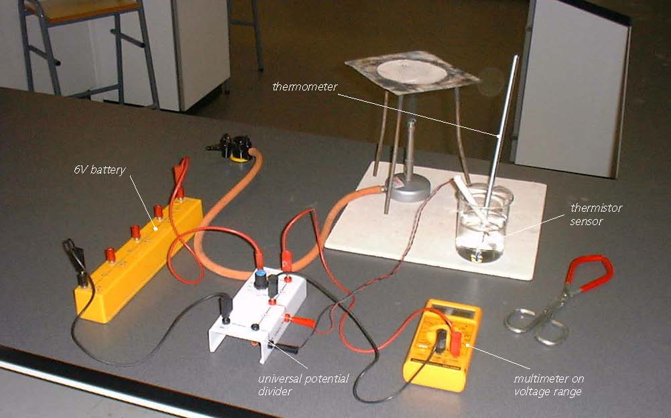

Thermistor set up in a potential divider network


SAFETY NOTE: Safety goggles need to be worn whilst you are conducting these activities. It is also much safer to stand alongside a beaker of water being heated as, if the hot water was knocked over, you would be able to move out of the way more quickly than if seated.

Calibration

- Set the universal potential divider unit to 47kΩ.
- Connect the 6V battery so that its +6V socket is connected to the red+6V socket of the potential divider unit and its 0V socket to the black 0V socket of the potential divider unit.
- Connect the thermistor so that its black and red plugs are connected to the black and red sensor sockets on the side of the potential divider unit. Finally, connect a multimeter on its voltage range (or a voltmeter) to the upper pair of red output sockets on the potential divider unit.

- Set up a bunsen burner, tripod, gauze and heat-proof mat, or other form of appropriate heating.

Activity (ii): Using a potential divider network and a voltmeter
T2.2B

- Place melting ice into a beaker and insert the thermistor sensor together with a thermometer, gently giving the melting ice a stir. After a minute or so give the melting ice another gentle stir and note its temperature and the voltage output in your table.

- Remove the thermistor sensor and thermometer and empty out the ice. Two-thirds fill the beaker with water from the tap. Put the thermistor sensor and thermometer back into the beaker, give the water a stir and leave for about a minute. Stir the water again, note its temperature and the voltage output in your table.

- Remove the thermistor sensor from the beaker. Place the beaker, together with the thermometer, on the tripod and heat gently for a few minutes until the water has reached a temperature of around 40°C.

- Remove the beaker with the beaker tongs and place it on the heat-proof mat. Put the thermistor sensor into the heated water and stir gently. Leave it for a minute or so, stir gently again and record the temperature and the voltage output in your table.

- Repeat this process to obtain another three sets of readings of temperature and voltage output, the last near or at the boiling point of water. Turn off the bunsen burner if it is no longer needed.

- Now plot a graph of voltage output from the potential divider unit (Y-axis) against temperature (X-axis) and incorporate a best-fit line.

You will now have calibrated the thermistor temperature sensor, producing a graph or calibration ‘curve’ which you will be able to use to help you find the value of an unknown temperature.

Using the calibrated thermistor temperature sensor

- Place the thermistor temperature sensor into a beaker of water of unknown temperature (do not insert a thermometer) and record the voltage output. Using your calibration ‘curve’, note down what you think its temperature must be.

- Now measure the unknown temperature using the thermometer.

Activity (ii): Using a potential divider network and a voltmeter
T2.2C

Results

Temperature (°C) | Voltage output from potential divider (V)

Questions

Does your graph show the voltage output from the potential divider unit to be
(a) linearly related to the temperature
and
(b) directly proportional to the temperature? Explain.

How close was your estimate of the water’s temperature?

Why wouldn’t a prediction of an unknown temperature be so reliable if the voltage output obtained for it was way beyond those used to produce the calibration ‘curve’?

