T2.3A
Activity (iii): Using a potential divider network and PicoScope on DrDAQ

This equipment allows you to have the digital meter reading directly as a thermometer, giving a temperature in degrees Celsius. (This is not possible with an ordinary multimeter or millivoltmeter).

Procedure

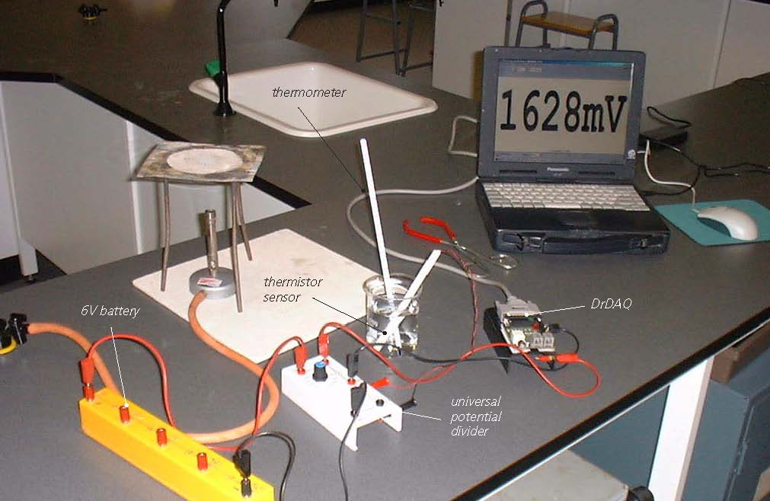
Set up of apparatus to measure temperature with a potential divider network, a thermistor and DrDAQ


SAFETY NOTE: Safety goggles need to be worn whilst you are conducting these activities. It is also much safer to stand alongside a beaker of water being heated as, if the hot water was knocked over, you would be able to move out of the way more quickly than if seated.

Calibration

Note: If you are connected via a network you may need to obtain additional instructions.

- Before the computer is switched on check that DrDAQ has been plugged into the computer.

- Set the universal potential divider unit to 47kΩ.
- Connect the 6V battery so that its +6V socket is connected to the red +6V socket of the potential divider unit and its 0V socket to the black 0V socket of the potential divider unit.
- Connect the thermistor so that its black and red sockets are connected to the black and red sensor sockets on the side of the potential divider unit. Connect the upper red output voltage socket of the potential divider unit to the V socket on DrDAQ and the lower red output voltage socket to the GND socket on DrDAQ.

Activity (iii): Using a potential divider network and PicoScope on DrDAQ
T2.3B

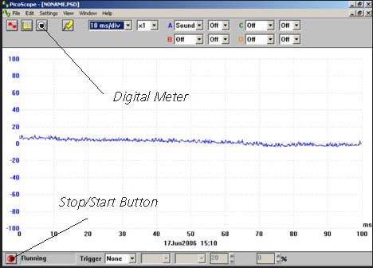  DrDAQ opening screen | - Switch on and load the PicoScope software. If necessary, enlarge by clicking the in the top right-hand corner of the screen to provide a full screen display as shown with the program already running.  Note: If the program appears to have frozen at any time then it can usually be unfrozen by pressing the F10 function key. If this does not succeed then close down the program by pressing the Ctrl, Alt and Delete keys simultaneously, and then restart the program.
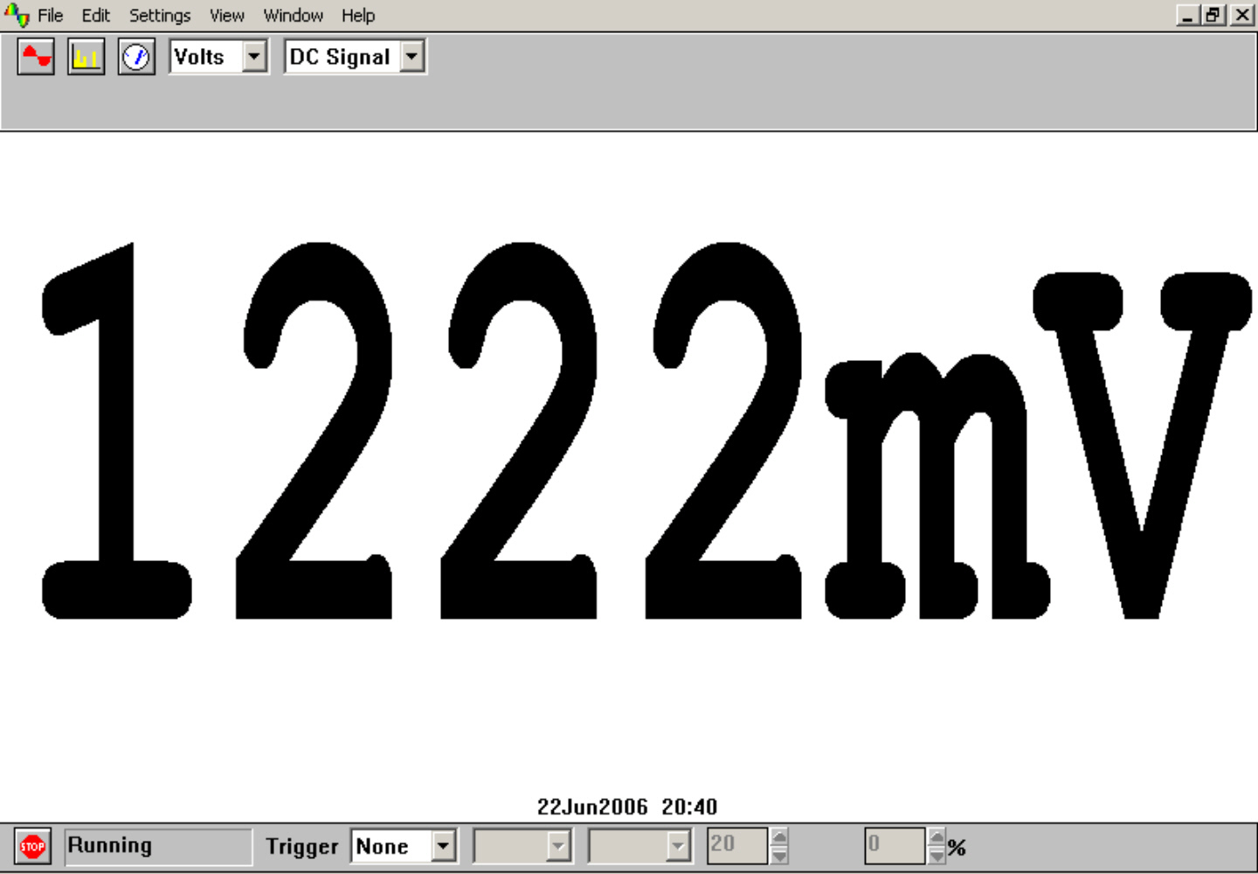  Digital Voltmeter display | - Click the STOP button in the bottom left-hand corner of the screen. Close down the Oscilloscope mode by clicking the lower of the two Xs in the top right-hand corner of the screen. Now click on the Digital Meter icon in the Toolbar, select Volts and DC Signal and then click the GO button to put PicoScope into Display Voltmeter mode. You should now see a small voltage reading on the screen similar to that shown.

- Set up a bunsen burner, tripod, gauze and heat-proof mat, or other form of appropriate heating.
- Place melting ice into a beaker and insert the thermistor temperature sensor together with a thermometer, gently giving the melting ice a stir. After a minute or so give the melting ice another gentle stir and note its temperature and the voltage output in your table.
- Remove the thermistor temperature sensor and thermometer and empty out the ice. Two-thirds fill the beaker with water from the tap. Put the thermistor temperature sensor and thermometer back into the beaker, give the water a stir and leave for about a minute. Stir the water again, and note its temperature and the voltage output in your table.
- Remove the thermistor temperature sensor from the beaker. Place the beaker, together with the thermometer, on the tripod and heat gently for a few minutes until the water has reached a temperature of around 40°C.
- Remove the beaker with the beaker tongs and place it on the heat-proof mat. Put the thermistor temperature sensor into the heated water and stir gently. Leave it for a minute or so, stir gently again and record the temperature and the voltage output in your table.
- Repeat this process to obtain another three sets of readings of temperature and voltage output, the last near or at the boiling point of water. Turn off the Bunsen burner if it is no longer needed.
- Now plot a graph of voltage output (Y-axis) against temperature (X-axis), and incorporate a best-fit line. You could do this manually or by entering your results into a graphing package or a spreadsheet.

Activity (iii): Using a potential divider network and PicoScope on DrDAQ
T2.3C

Using the calibrated thermistor temperature sensor

You will now have calibrated the thermistor temperature sensor, producing a graph or calibration ‘curve’ which you will be able to use to help you find the value of an unknown temperature.

- Place the thermistor temperature sensor into a beaker of water of unknown temperature (do not insert a thermometer) and record the voltage output. Using your calibration ‘curve’ note down what you think its temperature must be.

- Now measure the unknown temperature using the thermometer.

In everyday life, it would be unusual to find an instrument which had not been calibrated for direct use. With a computer-based device it is often possible to calibrate it so that it automatically displays the quantity you wish to measure directly on the screen. In this case you would want to get the computer to ‘convert’ the voltage input to give a temperature display on the screen. With PicoScope this is easily done by setting up a Custom Range:

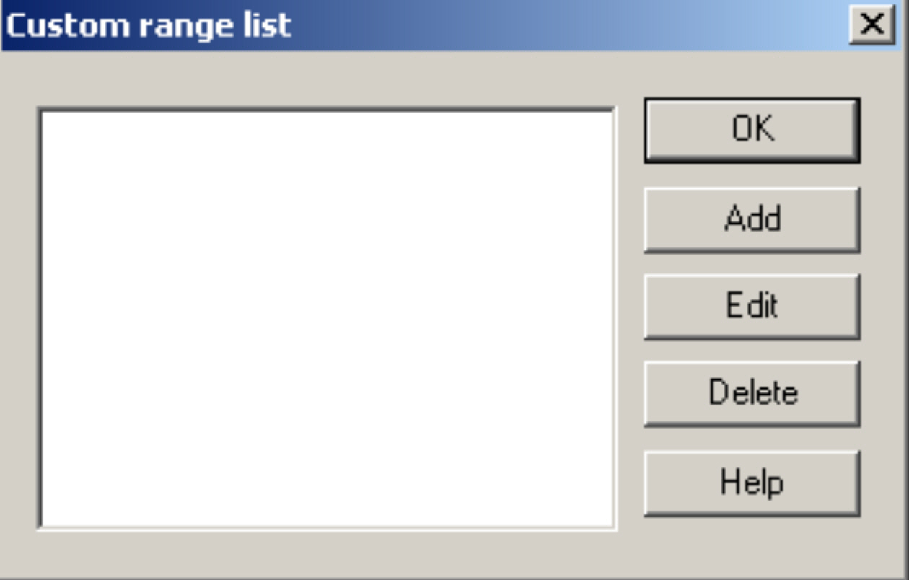  Custom range list | - Click the STOP button. Now click on Settings in the Menu bar and then on Custom ranges in the drop-down menu to display the Custom range list.

Activity (iii): Using a potential divider network and PicoScope on DrDAQ
T2.3D

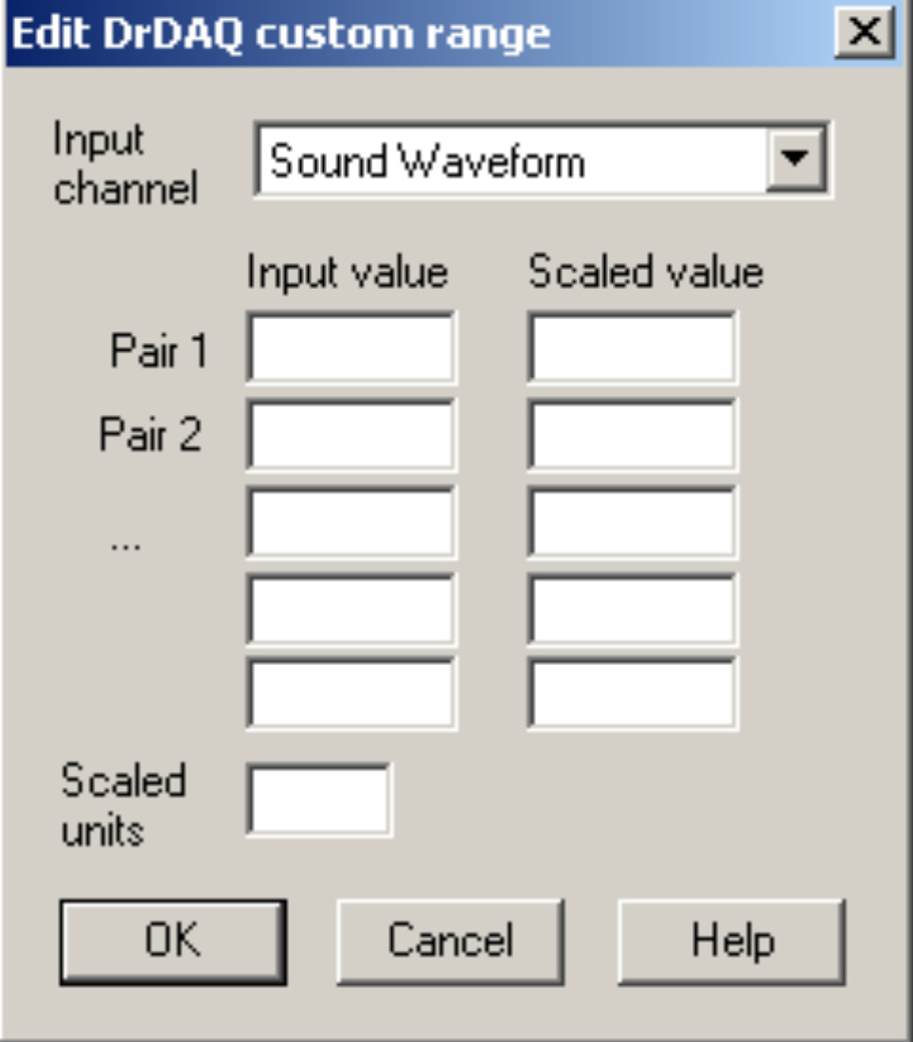  Edit DrDAQ Custom range box | - Click on Add to display the Edit DrDAQ custom range box as shown.  - Select the Input channel ‘Voltage’ by clicking on the down arrow alongside.
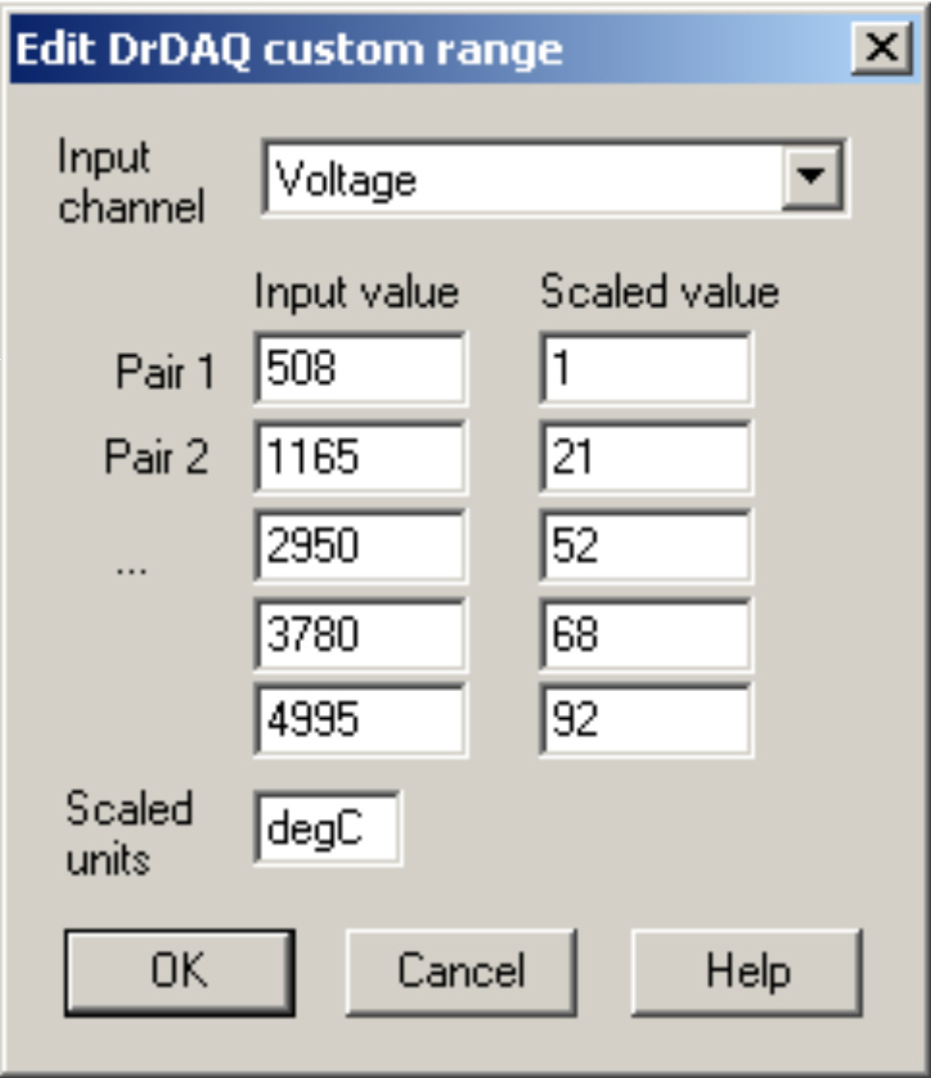  Add values and scaled units | - Now type in your pairs of data into the two columns – output voltages into the Input value column and the temperatures into the Scaled value column. Ensure that you input the lowest output voltage and its matching temperature as Pair 1. Make the last pair the highest output voltage obtained and its corresponding temperature. Type ‘degC’ into the Scaled units box. It should appear something like that shown on the left.

Activity (iii): Using a potential divider network and PicoScope on DrDAQ
T2.3E

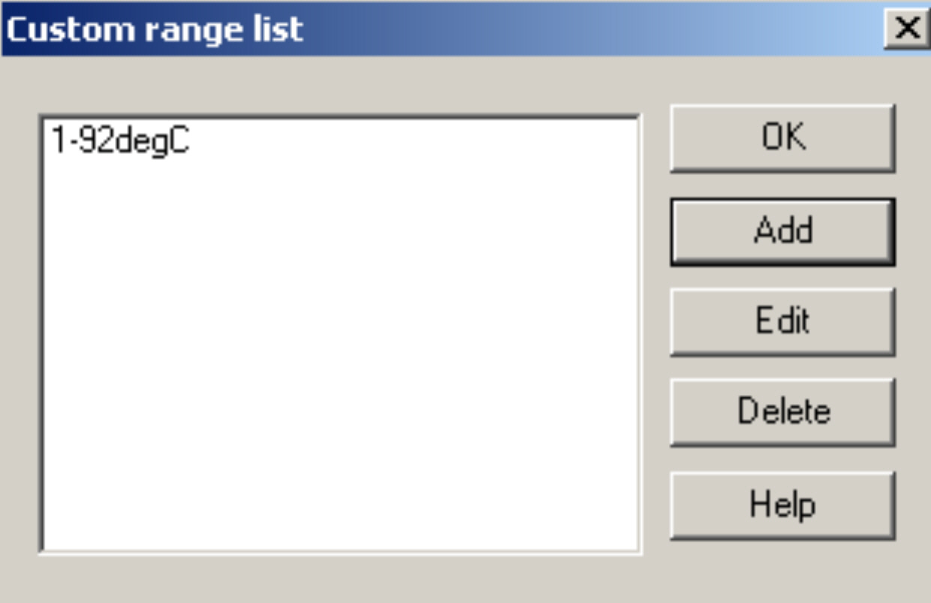  Custom range list with new range added | - Click the OK button. You should now see a ‘1-92degC’ (or to whatever your highest temperature was) range appear in the Custom range list.  - Highlight this new range and click the OK button.
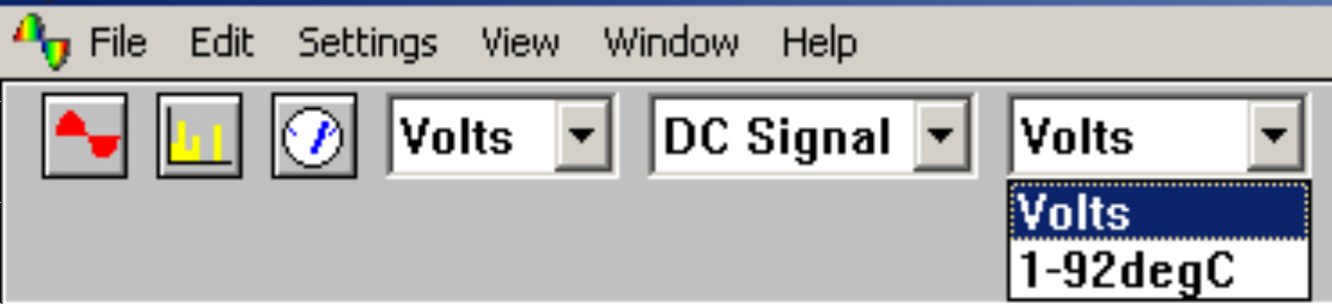  New range to select | - Click on the down-arrow next to the right-hand ‘Volts’: you should see an extra box for this new range.
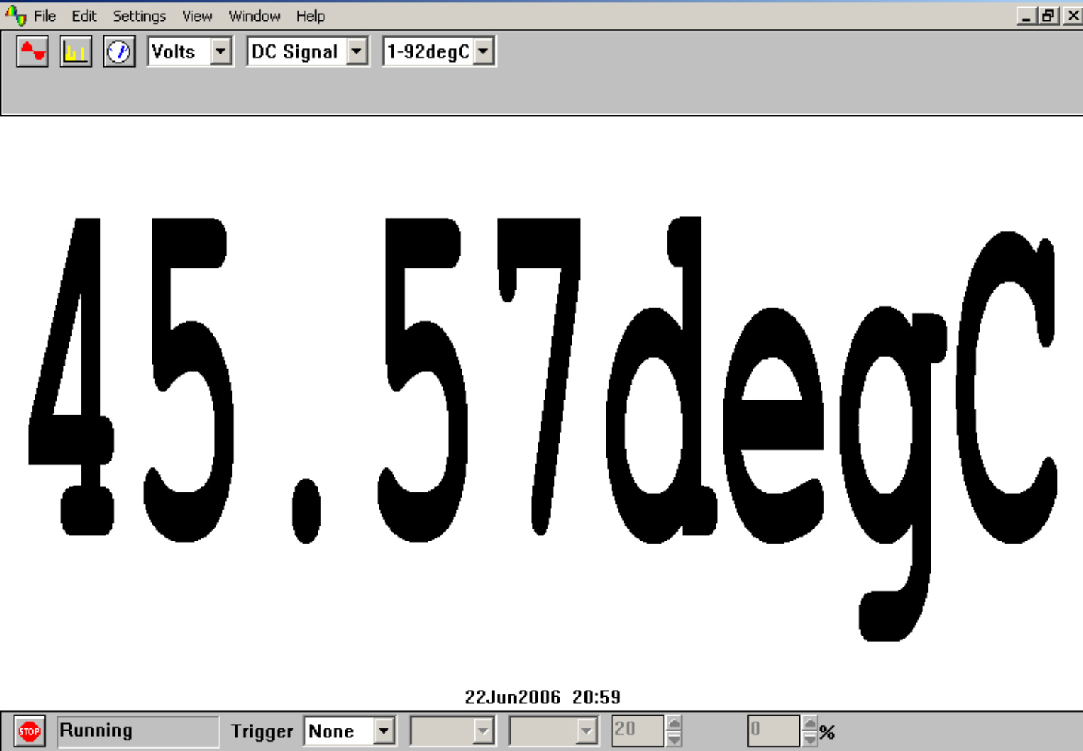  Unknown temperature displayed in degrees Celsius | - Select this new range, place the temperature sensor into a beaker of water of unknown temperature (do not use a thermometer) and then click the GO button. You should now see a digital meter reading displayed directly as a temperature (not necessarily the value shown here).  - Compare the displayed temperature to the temperature obtained with a thermometer.  - Click the STOP button. Turn off the Bunsen burner if it is no longer needed.

To return the program to its original state, first click the down arrow alongside ‘1-92degC’ and reset on ‘Volts’. Now click on Settings in the Menu bar and then on Custom ranges in the drop-down menu to display the Custom range list. Highlight the newly added range and click the Delete button to remove it. Now click the OK button.

To finish with the program click File on the Menu bar and Exit in its drop-down menu to leave the program.

Note: When you keyed your data into the ‘Input value’ and ‘Scaled value’ columns you were giving the computer information from which it could estimate other values that occur in between – it interpolates. It is doing the same job that you do with a graph and best-fit line. If the relationship between the data is a linear one, then only two pairs of data items are needed, but otherwise a spread of data pairs across the range is needed.

Activity (iii): Using a potential divider network and PicoScope on DrDAQ
T2.3F

Results

Temperature /°C | Voltage output from potential divider into DrDAQ /mV

Table of data

Questions
Does your graph show the voltage output to be
(a) linearly related to the temperature
and
(b) directly proportional to the temperature? Explain.

How close was your estimate of the water’s temperature?

Why wouldn’t a prediction of an unknown temperature be so reliable if the voltage output obtained for it was way beyond those used to produce the calibration ‘curve’?

What value is displayed for the temperature when you use a calibrated sensor?

How well does this value match with the actual value?

