Activity (i): Using the LM35DZ with a multimeter
T1.1A

Procedure

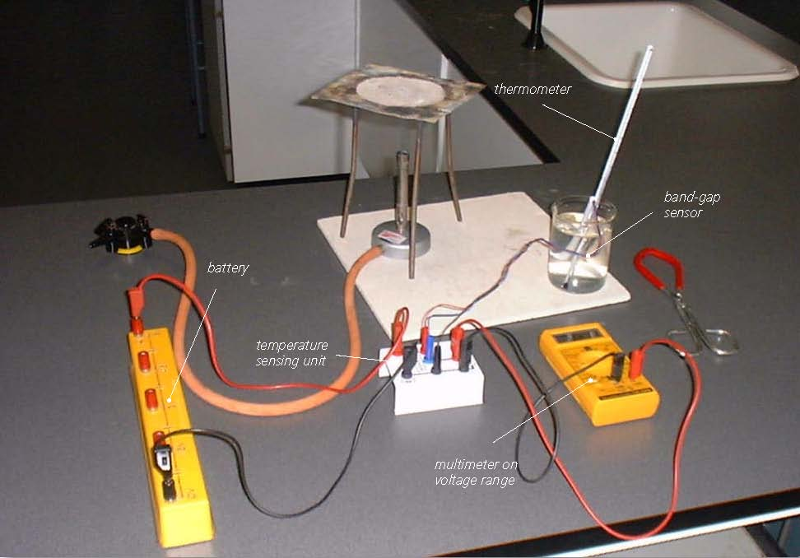

The LM35DZ connected to a multimeter


SAFETY NOTE: Safety goggles need to be worn whilst you are conducting these activities. It is also much safer to stand alongside a beaker of water being heated As, if the hot water was knocked over, you would be able to move out of the way more quickly than if seated.

Calibration

- Connect the red +6 to 12V socket of the temperature sensor unit to the +6V socket of the battery and the black 0V socket of the unit to the 0V socket of the battery.
- Plug the band-gap temperature sensor’s three coloured leads/plugs into their respective coloured sockets on the temperature sensing unit.
- Finally, connect the multimeter (or voltmeter) set to a 2V range to the voltage output sockets of the temperature sensing unit. It should appear as shown above.
- Set up a bunsen burner, tripod, gauze and heat-proof mat, or other form of appropriate heating.
- Place melting ice into a beaker and insert the temperature sensor together with a thermometer, gently give the melting ice a stir. After a minute or so give the melting ice another gentle stir and note its temperature and the voltage output in your table.

Activity (i): Using the LM35DZ with a multimeter
T1.1B

- Remove the temperature sensor and thermometer and empty out the ice. Two-thirds fill the beaker with water from the tap. Put the temperature sensor and thermometer back into the beaker, give the water a stir and leave for about a minute. Stir the water again, note its temperature and the voltage output in your table.
- Remove the temperature sensor from the beaker. Place the beaker, together with the thermometer, on the tripod and heat gently for a few minutes until the water has reached a temperature of around 40°C.
- Remove the beaker with the beaker tongs and place it on the heat-proof mat. Put the temperature sensor into the heated water and stir gently. Leave it for a minute or so, stir gently again and record the temperature and the voltage output in your table.
- Repeat this process to obtain another three sets of readings of temperature and voltage output, the last near or at the boiling point of water. Turn off the Bunsen burner if it is no longer needed.
- Now plot a graph of voltage output (Y-axis) against temperature (X-axis) and incorporate a best-fit line. You could do this manually or by entereing your results into a graphing package or spreadsheet.

You will now have calibrated the temperature sensor, producing a graph or calibration ‘curve’ which you will be able to use to help you find the value of an unknown temperature.

Using the calibrated temperature sensor

- Place the temperature sensor into a beaker of water of unknown temperature (do not insert a thermometer) and record the voltage output. Using your calibration ‘curve’, note down what you think its temperature must be.
- Now measure the unknown temperature using the thermometer.

Activity (i): Using the LM35DZ with a multimeter
T1.1C

Results

Temperature /°C | Voltage output /V

Questions

What do you notice about the voltage output values and the related temperatures? Look carefully.

Does your graph show the voltage output to be
(a) linearly related to the temperature
and
(b) directly proportional to the temperature? Explain.

How close was your estimate of the water’s temperature?

Why wouldn’t a prediction of an unknown temperature be so reliable if the voltage output obtained for it was way beyond those used to produce the calibration ‘curve’?

