Activity (i): Using a microphone to investigate crispness with Multimedia Sound
S2.1A

With this computer program you can record and display sound files and analyse and display the frequencies within them. This will let you compare a range of sounds.

Procedure

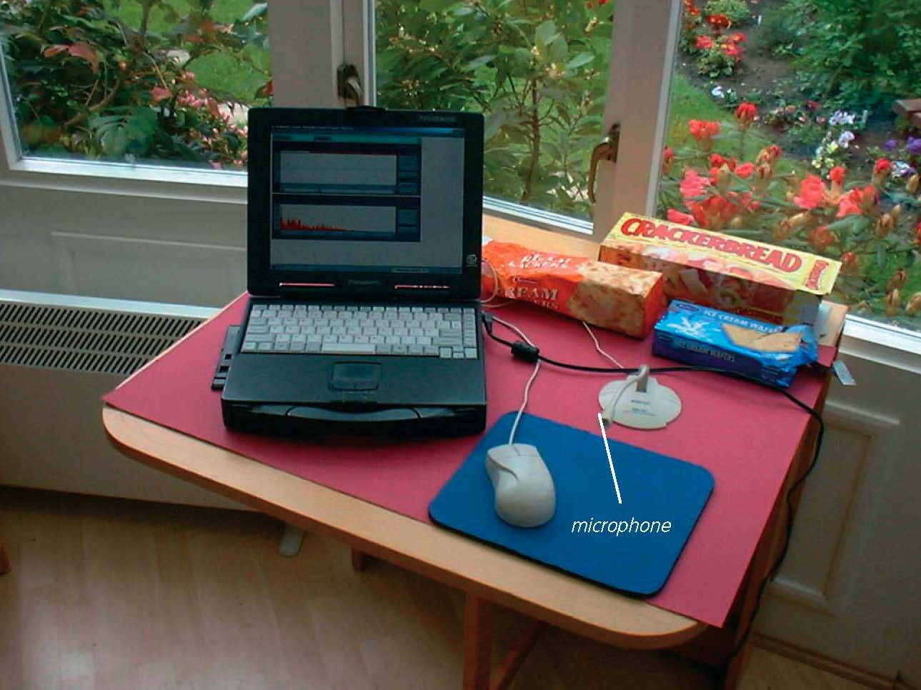

Computer set up to examine crispness

Activity (i): Using a microphone to investigate crispness with Multimedia Sound
S2.1B

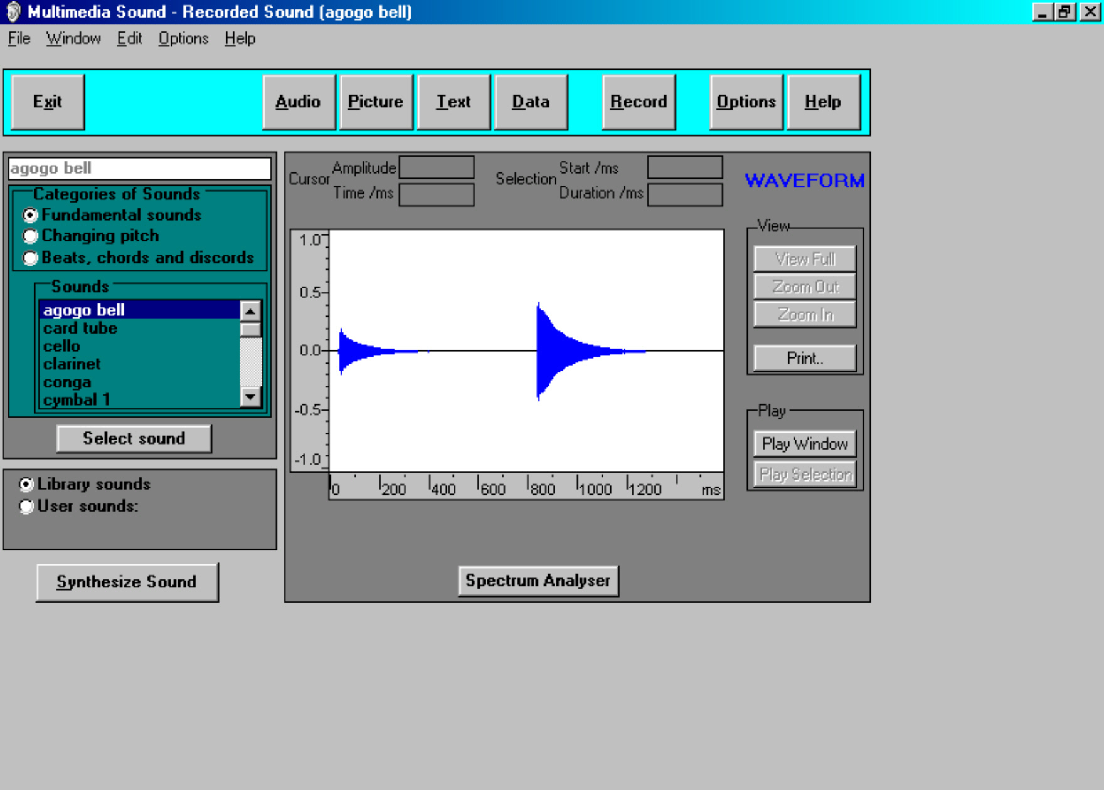  Multimedia Sound’s main screen | Note: If you are connected via a network you may need to obtain additional instructions.  - Plug in and, where necessary, switch on the microphone. Ensure that this microphone is kept away from the loudspeakers in order to avoid the loud whine of feedback.  - Load Multimedia Sound and then click on the opening screen to obtain the display shown.
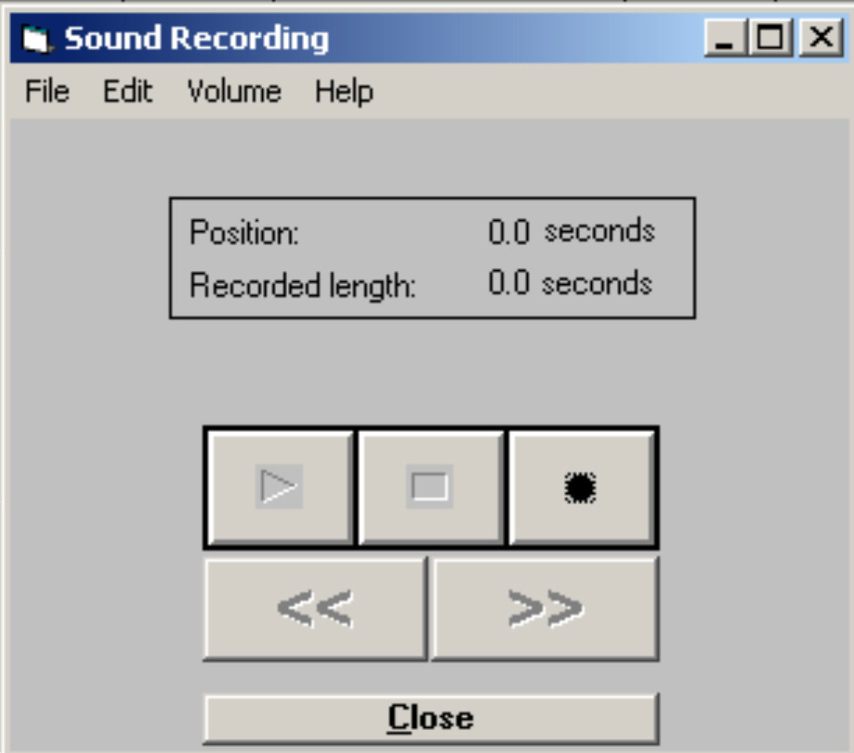‘  Sound Recording’ box | - Click the Record button in the Toolbar to display the Sound Recording box. Note what the buttons in this box are for.  Select a cracker/wafer, noting down what variety it is. Click the Start recording button in the ‘Sound Recording’ box and snap the cracker/wafer next to the microphone. Then click the Stop recording button.  Now click on File in the Menu bar of the ‘Sound Recording’ box and then on Save as in the drop-down menu that appears. The ‘Save as’ box will then be displayed.
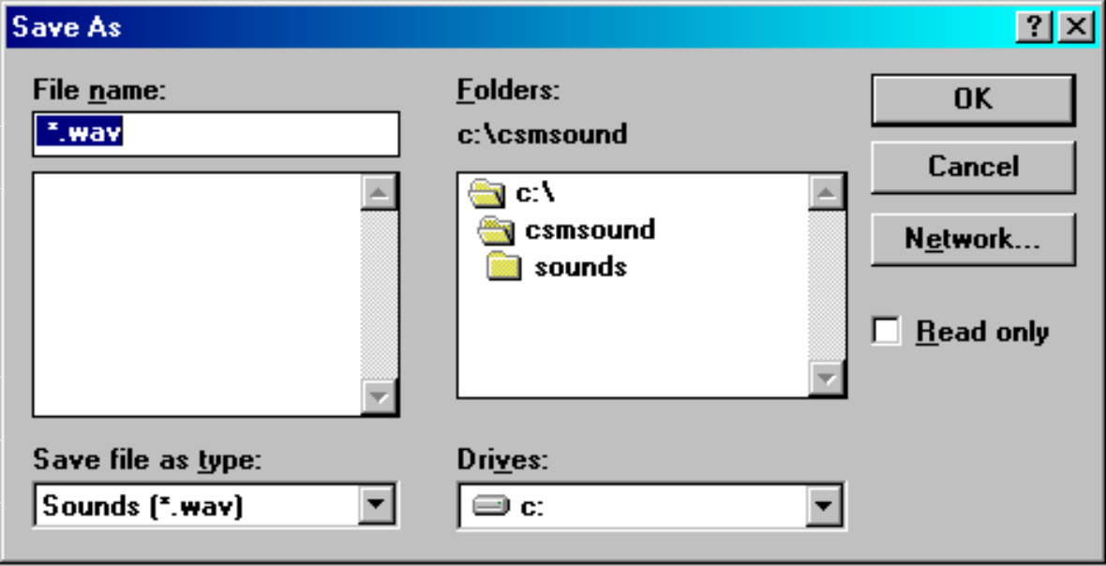  ‘Save as’ box | - Press the Backspace key to delete the highlighted filename and then type ‘s1’ for ‘cracker/wafer sample 1’ into this box. Double-click the ‘sounds’ folder and then click the OK button. This will have saved the sound file for this sample.  - Now click on File and New in the Sound recording box to reset the Sound Recorder.  - Obtain and save files for the other cracker/wafer samples giving them the filenames s2, s3, s4 etc. Note the type of cracker used each time.  - Keeping it out of view, snap one of the criackers again and save it as smystery’.  - If you have been given a non-fresh cracker or wafer, obtain and save a file for it wityh a name such as ‘s2old’ if it was the same type as that given a filename ’s2’.

Activity (i): Using a microphone to investigate crispness with Multimedia Sound
S2.1C
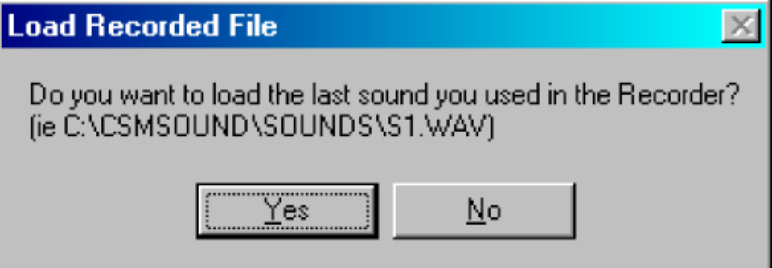  ‘Load Recorded File’ box | - Now click the Close button. You will now see a Load Recorded File box displayed .  - Click the No button.
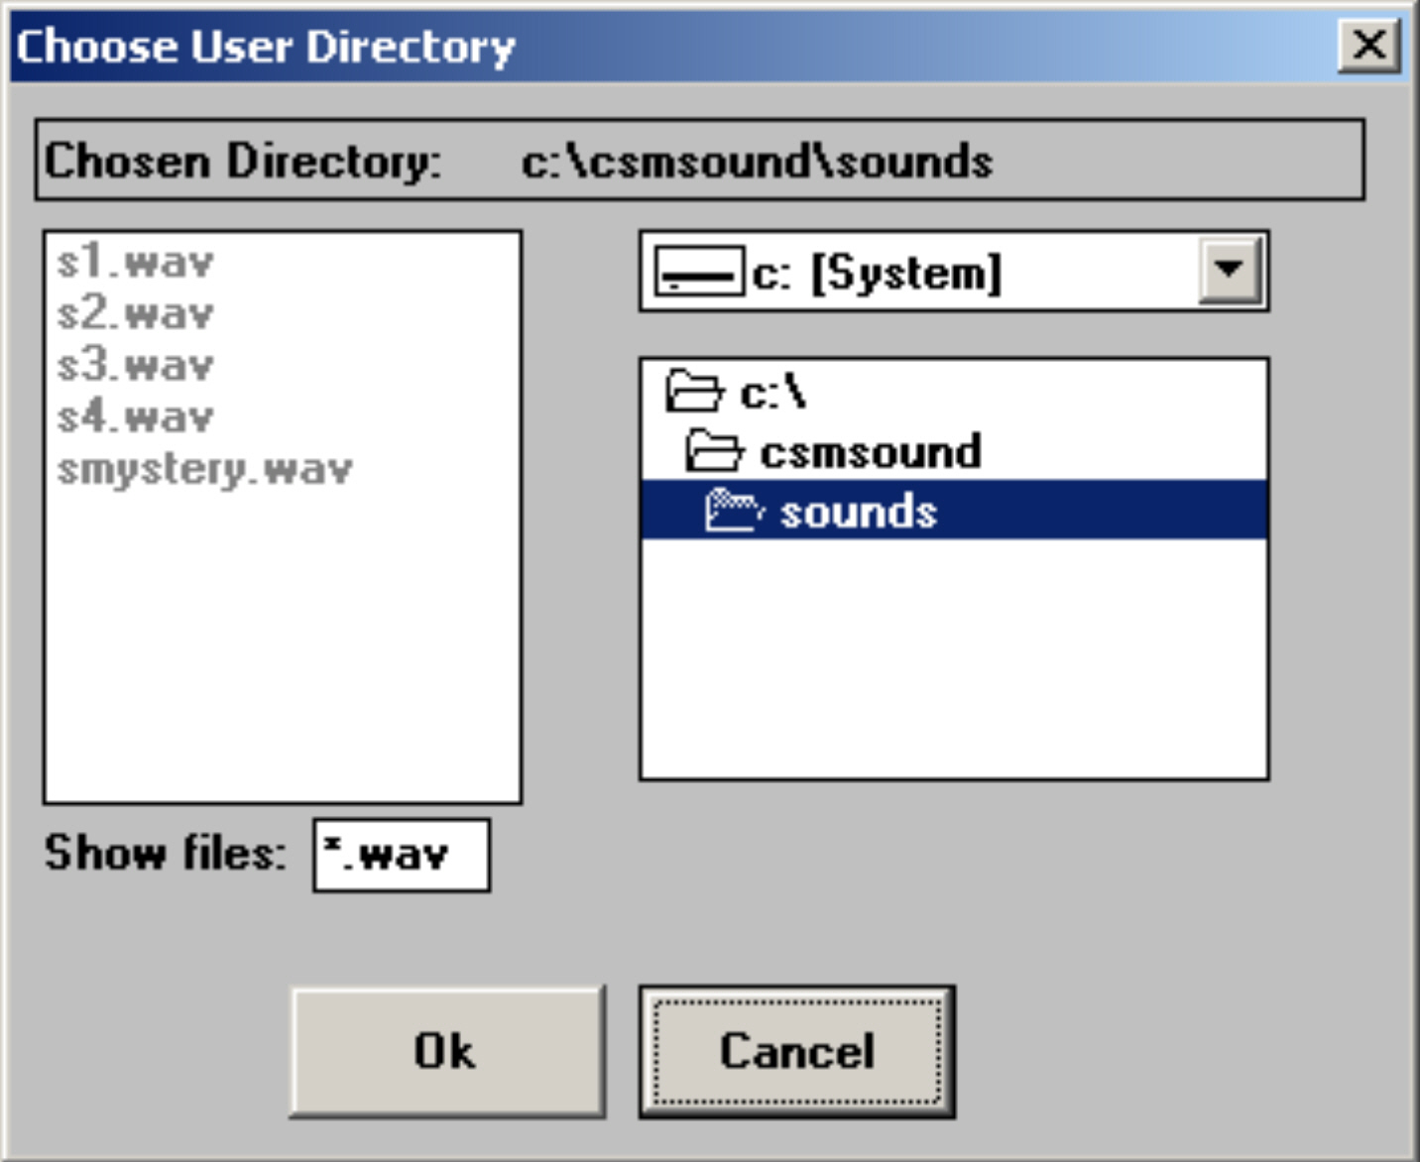  ‘Choose User Directory’ box | - Now click the cursor in the white circle at the bottom of the left-hand column alongside ‘User sounds’ and then on the Set directory button to display the Choose User Directory box.
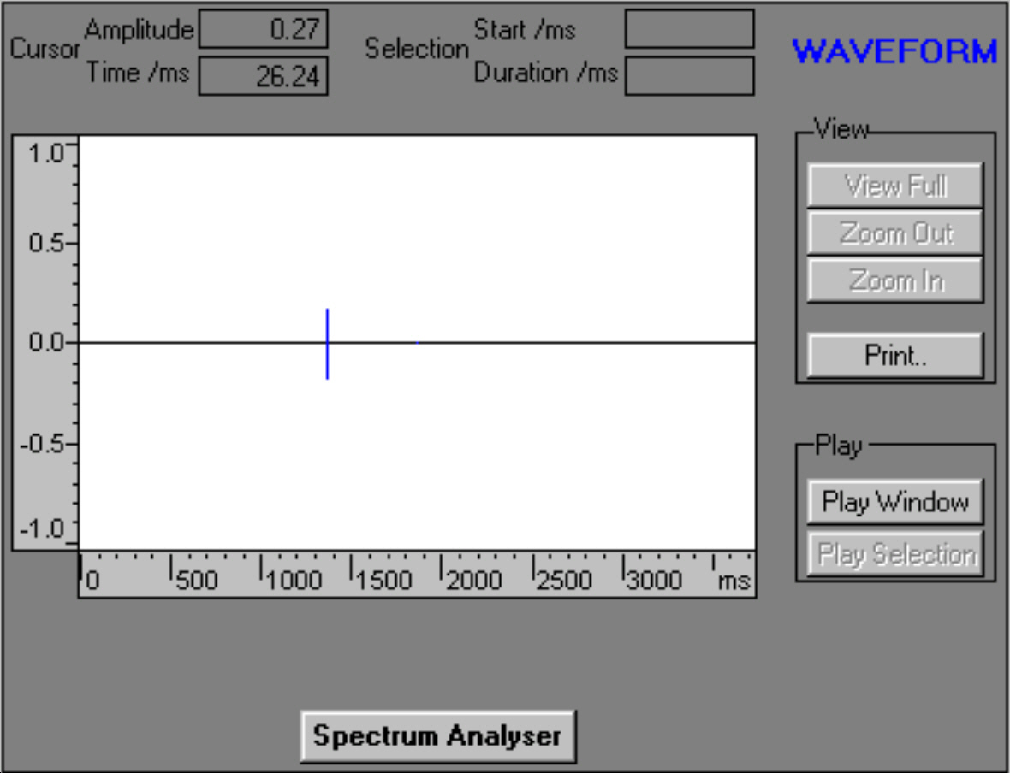  ‘‘Waveform’ window with unexpanded sound trace | - Now click the OK button. Your sample files should now be listed at the top of the left-hand column. Click on the first one to highlight it and then click the Select sound button. You should now see the Waveform window as with an unexpanded sound trace displayed.  - If you have loudspeakers or headphones available and you now click the Play Window button you will hear the snap of your sample again. Repeat with the other samples. You will probably agree that it is difficult to tell the samples apart from the sounds of their snapping alone. However, this program allows you to look in detail at the waveforms produced by each sample.

Activity (i): Using a microphone to investigate crispness with Multimedia Sound
S2.1D
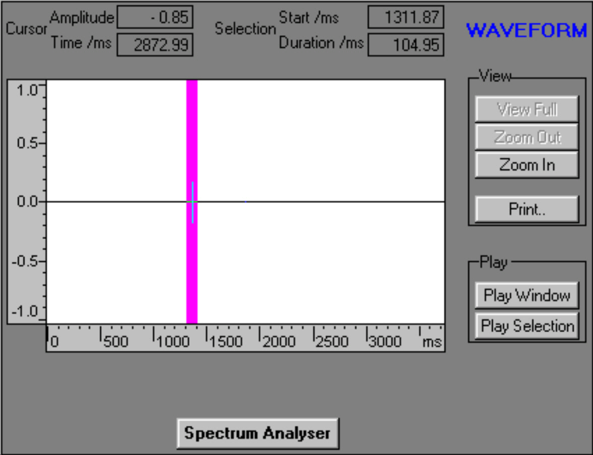  Dragged cursor highlighting unexpanded sound trace | - Select and display the sound file of your first sample again. Now move the cursor to just to the left of the unexpanded sound trace, hold down the left mouse button and drag the cursor to just a little to the right of the trace and release. A section of the trace will be highlighted as shown:
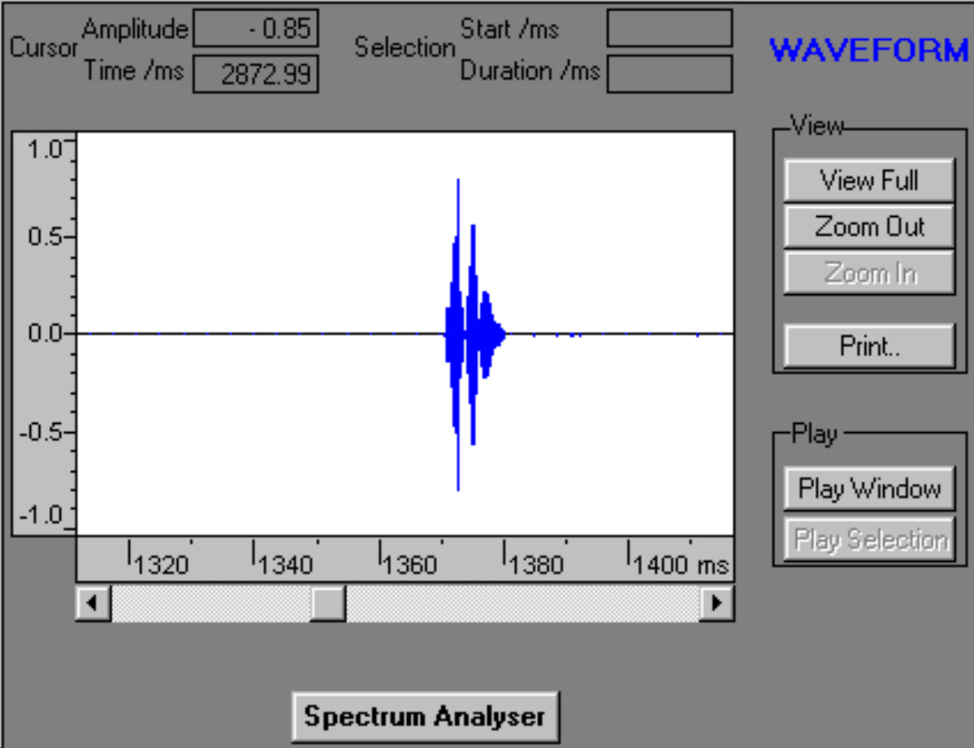  Expanded sound trace | - Click on the Zoom In button to obtain the expanded sound trace.

Activity (i): Using a microphone to investigate crispness with Multimedia Sound
S2.1E
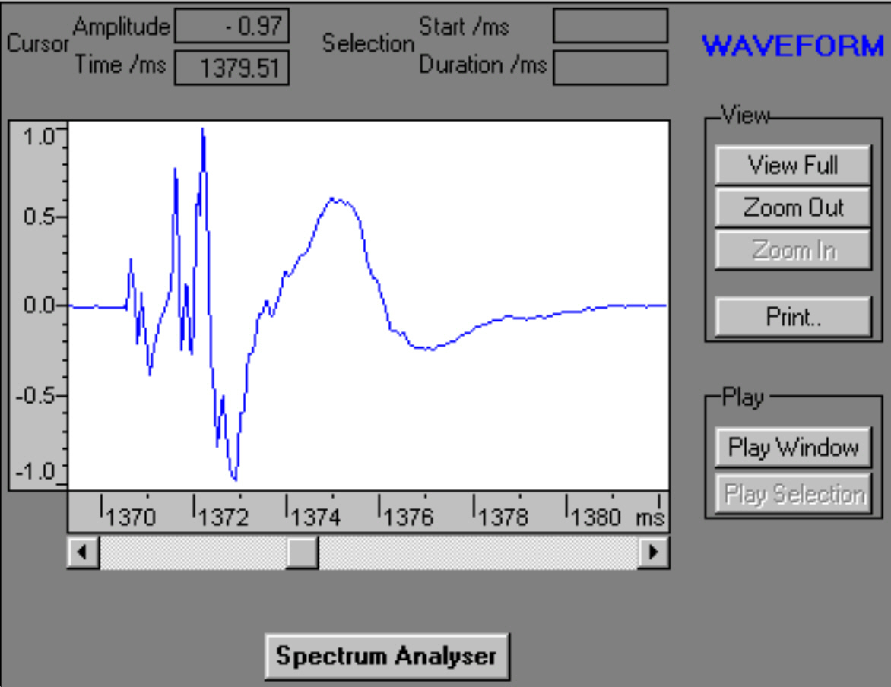  Further expanded sound trace | - This waveform trace can be expanded still further, as shown, by holding down the left mouse button whilst dragging the cursor from just to the left of the trace to just to the right of it, releasing the left mouse button and then clicking the Zoom In button.
 | Whilst you might be able to see that this waveform trace is unique to one type of cracker/wafer, this program has an additional feature that can confirm this: it is a Spectrum Analyser. This feature displays the intensities of the various frequency components that make up the trace.
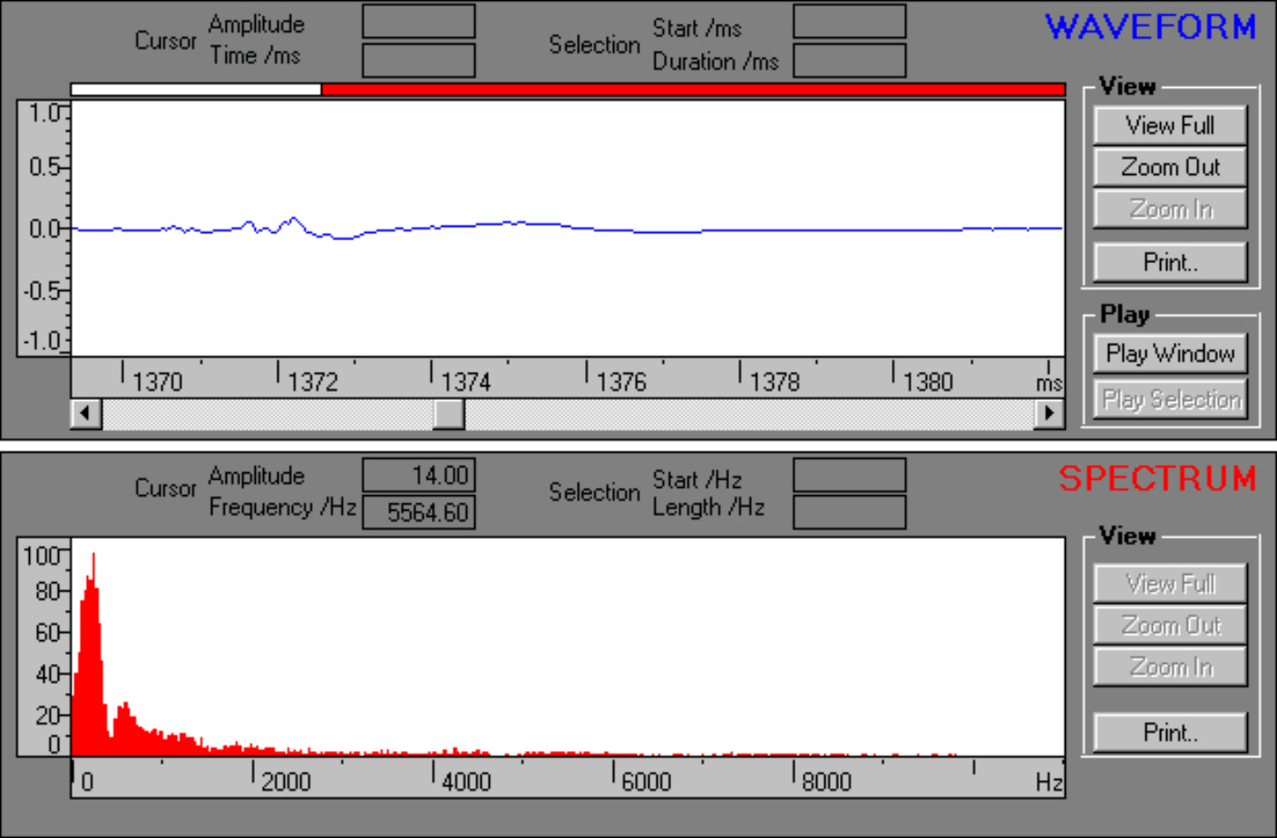  Waveform and Frequency Spectrum | - Click the Spectrum Analyser button to display the additional frequency spectrum of the trace.  - Click the Close button to return to the previous screen and repeat the spectrum analysis with the other samples’ traces.  - Compare the traces of these different samples, using the Waveform trace and then the Frequency Spectrum trace. See if your colleagues can identify the Mystery cracker/wafer, and ,if successful, whether the Waveform of the Frequency Spectrum trace was better for identifying it.  - You could also compare the trace of a fresh cracker with that of a non-fresh cracker of the same type.

- To finish with the program click the Exit button and respond ‘Yes’ to the question ‘Do you really want to exit this application?’.

- To set the computer up for the next user, use Windows Explorer to locate the ‘csmsound’ folder and its ‘sounds’ sub-folder. Open the ‘sounds’ sub-folder and delete the files that you had saved.

This type of technique can be used in quality control. Traces from perfect specimens could be compared to traces from samples obtained during production: any major mismatch would identify a problem.

Activity (i): Using a microphone to investigate crispness with Multimedia Sound
S2.1F

Questions
How unique were the samples’ traces?

Was the waveform or the frequency spectrum more useful in telling the samples apart or identifying a sample?

What difference does lack of freshness make to the traces?

