Activity (i): Using a microphone to investigate crispness with DrDAQ
S1.1A

Procedure

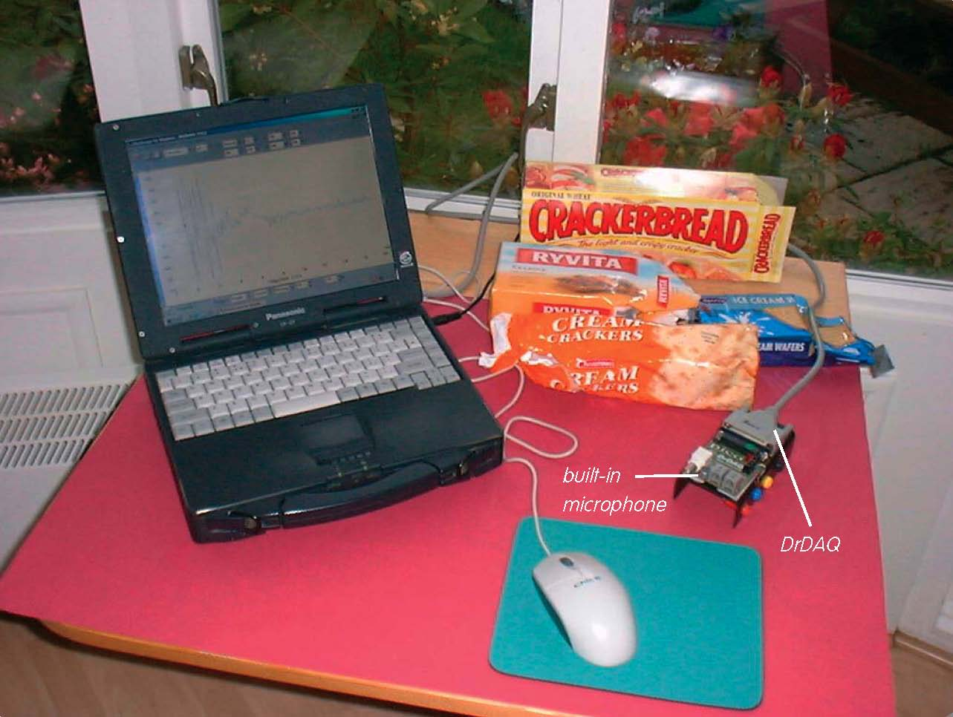

Computer and DrDAQ set up to examine crispness

Note: If you are connected via a network you may need to obtain additional instructions.

- Before the computer is switched on, check that DrDAQ has been plugged into the computer.

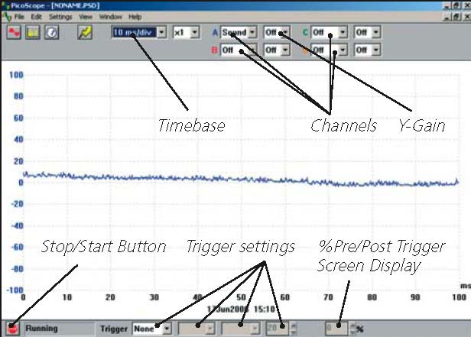  Activity (i): Using a microphone to investigate crispness with DrDAQ  S1.1B  DrDAQ opening screen | - Switch on and load the PicoScope software. If necessary enlarge by clicking the in the top right-hand corner of the screen to provide a full screen display as shown below with the program already running.  - Click the STOP button in the bottom left-hand corner of the screen.  - Adjust the Timebase setting to 2 ms/div with an X-gain of x1. Set Channel A to Sound and its Y-gain to x1. Leave Channels B, C and D off.
 | Note: If the program appears to have frozen at any time then it can usually be unfrozen by pressing the F10 function key. If this does not succeed then close down the program by pressing the Ctrl, Alt and Delete keys simultaneously, and then restart the program.
- Now set the Trigger to Single (Click the OK button in response to the warning message that appears), Sound, Rising, 10 and the Screen Display to -10%. The last of these lets you set when the trace is started from, and in this case the first 10% of the display is prior to the sound being produced. It ensures that all the trace is captured if required.
Note: If there is a lot of noise – electrical or sound – you may have to raise the trigger level to 20 or more to prevent triggering before you have snapped the cracker/wafer.
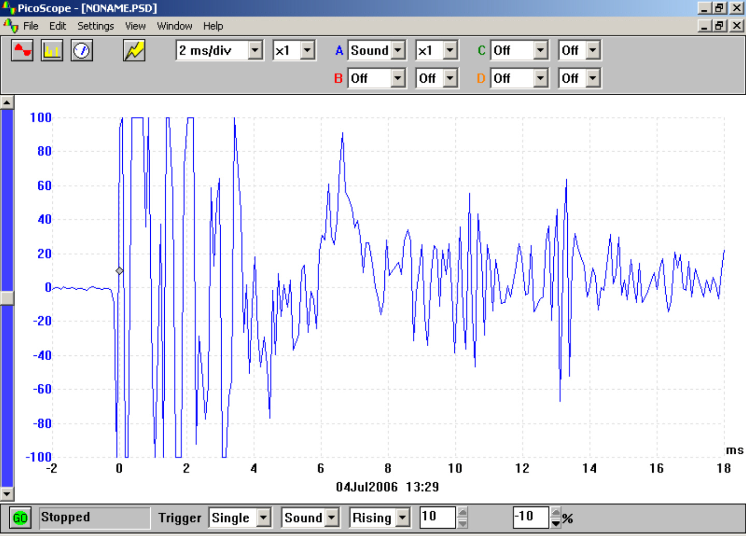  Waveform of a snapped cracker | - Select a cracker/wafer, noting down what variety it is. Now click the GO button and snap the cracker/wafer next to the on-board microphone. You should obtain a display something like the one shown.

Activity (i): Using a microphone to investigate crispness with DrDAQ
S1.1C
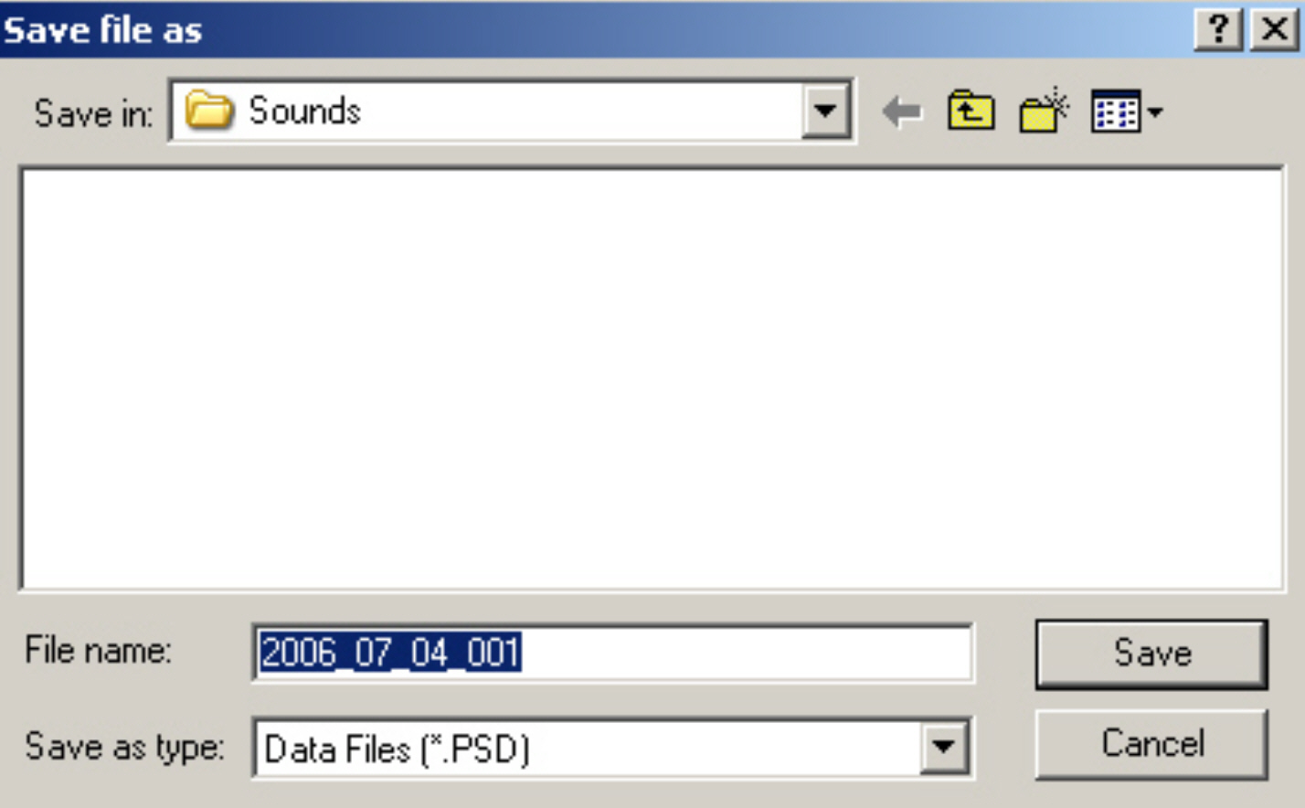  ‘Save file as’ box | - If the trace amplitude exceeds the size of the Y-axis on the screen then click the GO button again and repeat the snapping slightly further away from the microphone.  - Click on File in the Menu bar and then on Save as in the drop-down menu that appears. Locate the ‘Pico’ folder and then the ‘Sounds’ sub-folder. The ‘Save file as’ box will then be displayed.
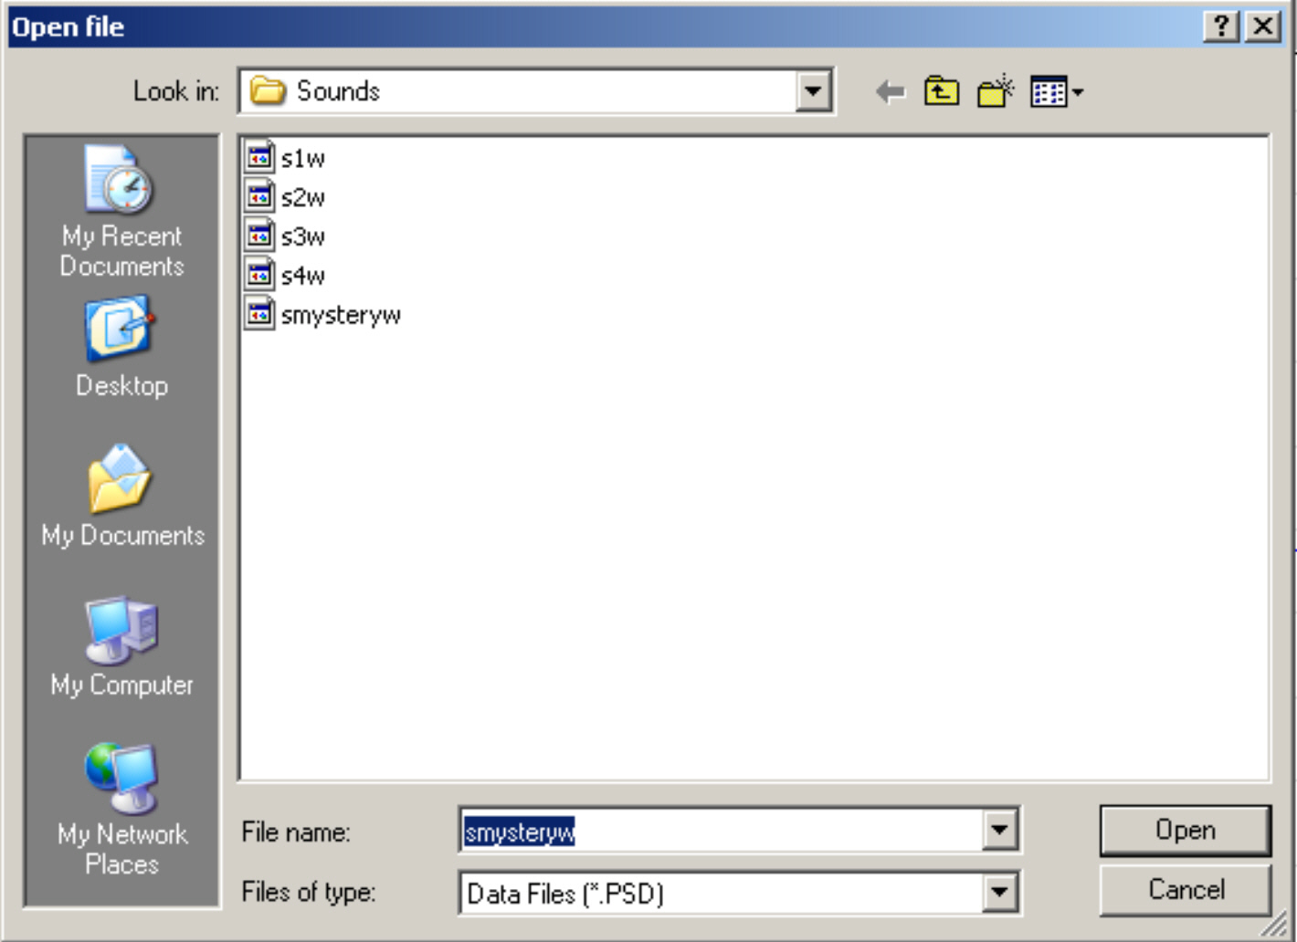  ‘Open file’ box with five files listed | - Click in the box alongside ‘File name’ and press the Backspace key to delete whatever filename appears and type ‘s1w’ for cracker/wafer ‘sample 1 waveform’ in its place. Now click the Save button to save the sound file for this sample.  - Repeat the operation by clicking the GO button again and snapping the other cracker/wafer samples available. Give these filenames s2w, s3w, s4w etc. Snap one of the samples again, hiding it from your colleagues, and save this as ‘smysteryw’. (Make a note of which sample matches with this file).  - If you have a non-fresh sample snap it and obtain a trace. Save the file with a name such as ‘s2wold’ if it was the same type as one given a filename ‘s2w’ previously.  - To look at and compare these files click File in the Menu bar and then Open in its drop-down menu to display the ‘Open file’ box. Click on the file that you wish to open and then click the Open button.

Whilst you might be able to see that each waveform trace is unique to one type of cracker/wafer, this program has an additional feature that can confirm this, it is the Spectrum Analyser. This feature displays the intensities of the various frequency components that make up the trace.

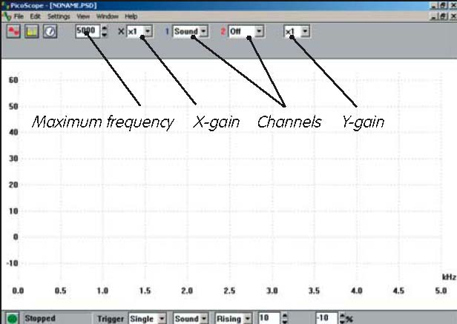  Activity (i): Using a microphone to investigate crispness with DrDAQ  S1.1D  ‘  Spectrum Analyser screen | - To use the Spectrum Analyser you must first close down the Oscilloscope mode by clicking on the lower of the two Xs in the top right-hand corner of the screen.  - Click on the Spectrum Analyser icon to bring up a screen display like the one shown.
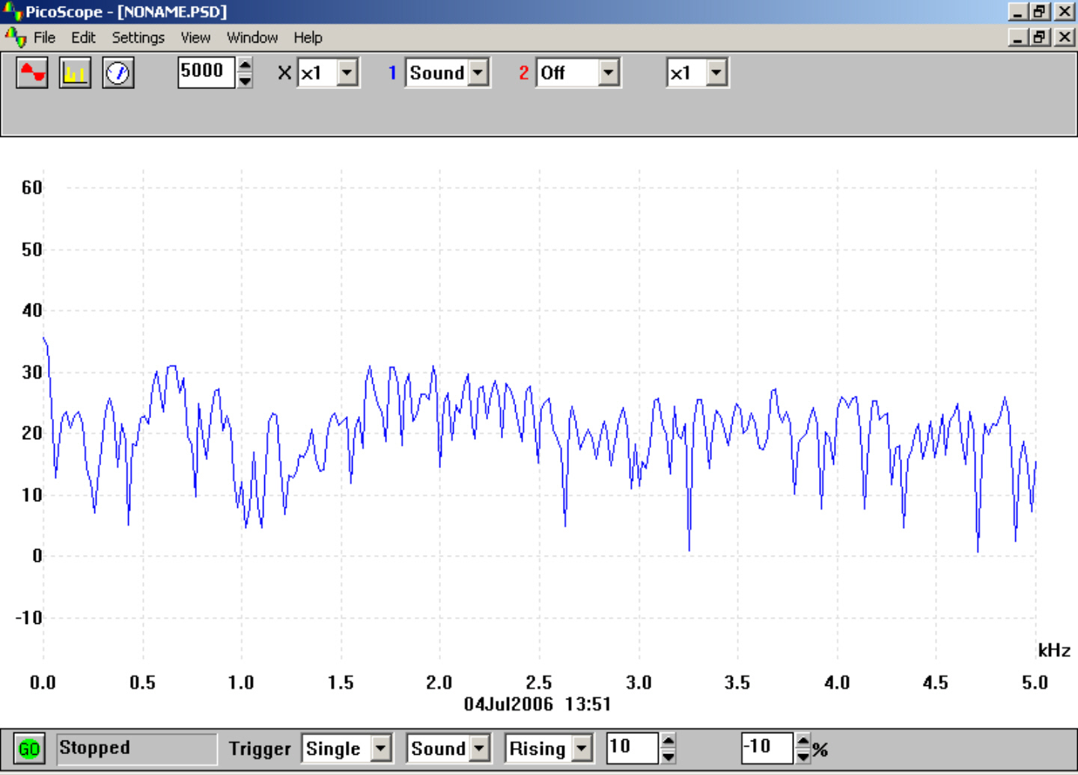  Frequency spectrum of cracker | - Leave the maximum frequency at 5000 Hz (other Pico dataloggers and virtual instruments can deal with frequencies way beyond 5000 Hz) and the X-gain at x1. Channel 1 should be set to Sound, B to Off and the Y-gain to x1. The Trigger settings you used before should have been retained.  - Click the GO button. Snap the first type of cracker/wafer sample again next to the microphone to reveal the intensities of the range of frequencies (within 0-5000 Hz on this device) that are produced. A typical frequency spectrum is shown.

Activity (i): Using a microphone to investigate crispness with DrDAQ
S1.1E
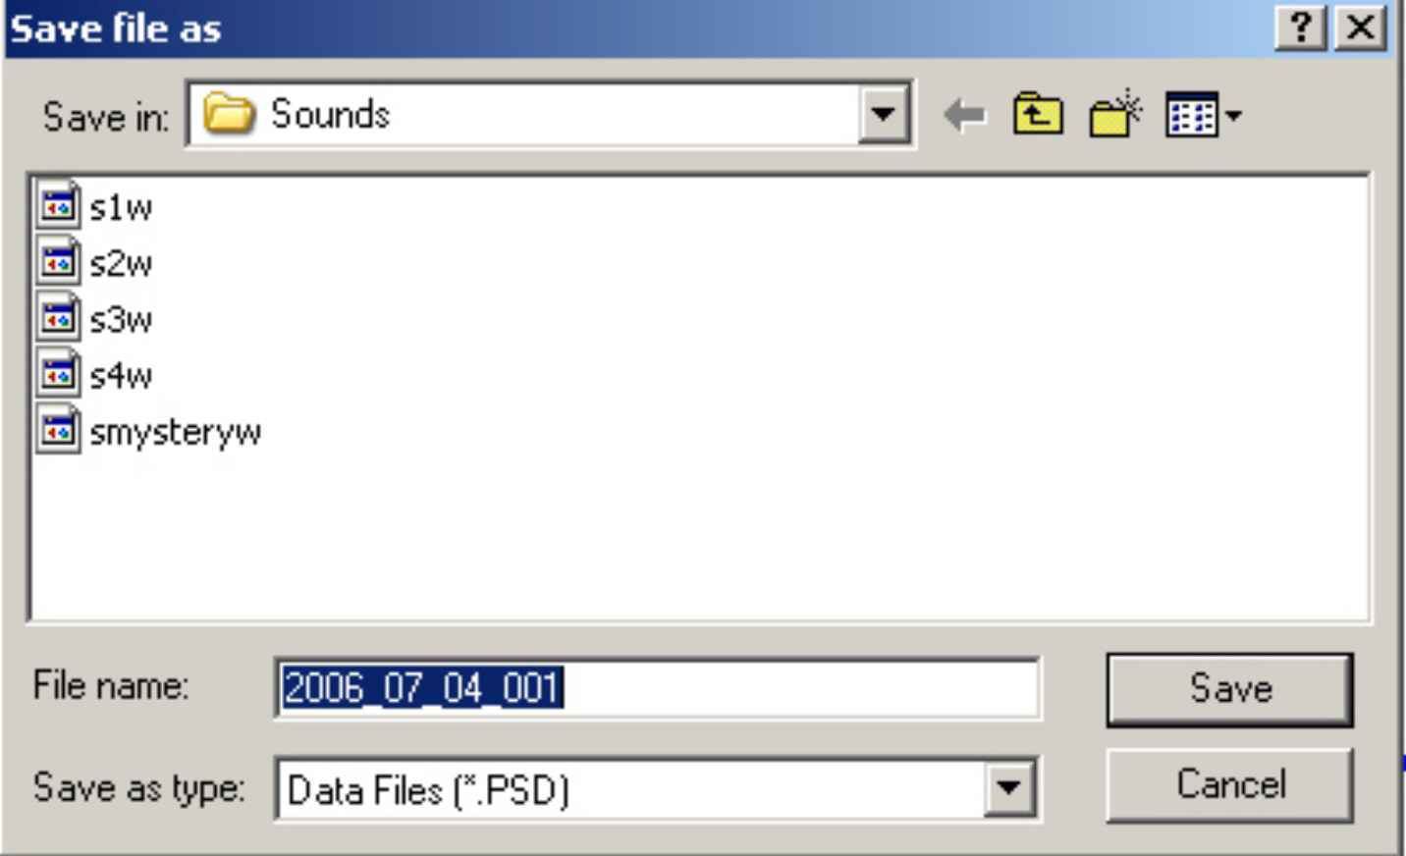  ‘Save file as’ box with five files listed | - Click on File in the Menu bar and then on Save as in the drop-down menu that appears. The ‘Save file as’ box will then be displayed, with the files that you saved earlier.  - Click on the box alongside ’File name’ and press the Backspace key to delete whatever filename is present and type ‘s1s’ ( for sample1spectrum ) in its place. Arrange it so that the file is again saved in the ‘Sounds’ sub-folder of the Pico folder – this should be automatic – and then click the OK button. This will save the frequency spectrum sound file for this sample.
- Repeat the operation by clicking the GO button again and snapping the other cracker/wafer samples available. Give these the filenames s2s, s3s, s4s etc. As before, repeat snapping one of the samples ( the same type as before) and save the file as ‘smysterys’.

- If you have a non-fresh sample snap it and obtain a trace. Save the file with a name such as ‘s2sold’ if it was the same type as one given a filename ‘s2s’ previously.

- To look at and compare these files click File in the Menu bar and then Open in its drop-down menu to display the ‘Open file’ box as shown. Click on the file that you wish to open and then click the Open button.
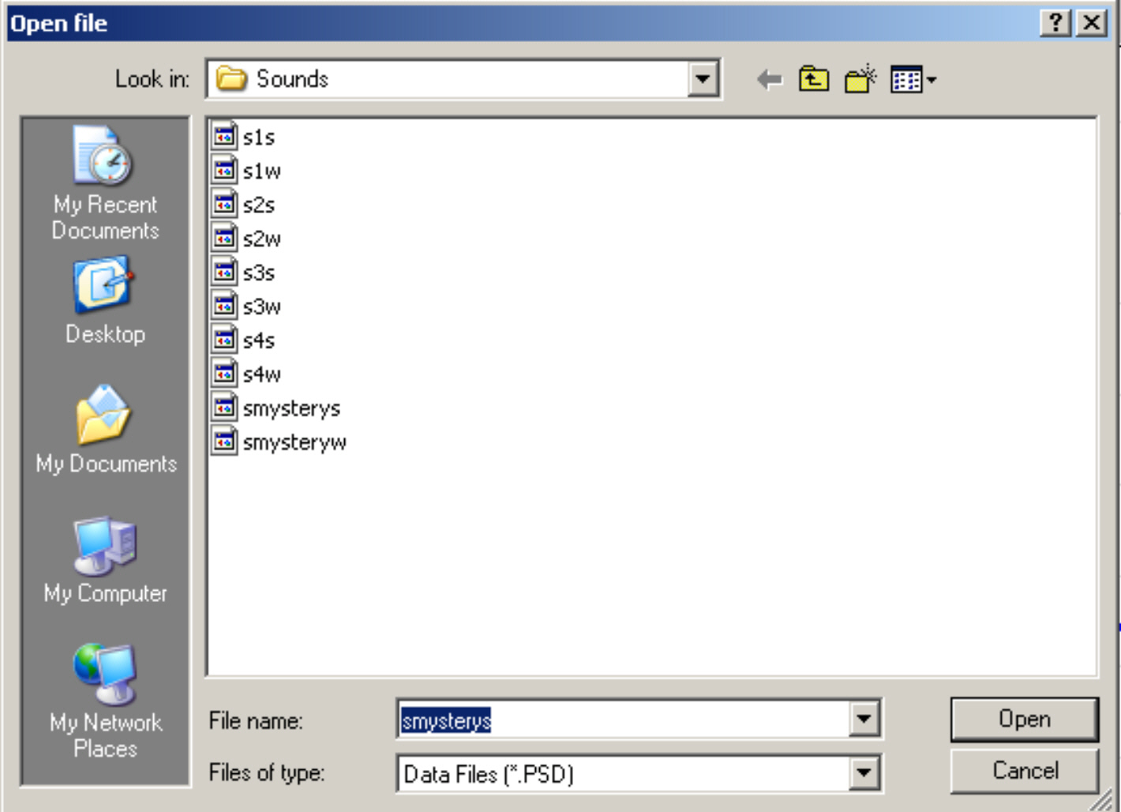  ‘Open file’ box with all files listed | - Compare the traces of these different samples. See if colleagues can identify which sample had been the ‘mystery’ sample, and compare the trace of a fresh cracker with that of a non-fresh cracker of the same type.  - To set the computer up for the next user, click File in the Menu bar and then Open in its drop-down menu. Now delete each of the saved files by highlighting each og them in turn and pressing the Del(ete) key on the computer keyboard. Click the Yes button in response to the question ‘Are you sure you want to send( ‘s1w’ etc) to the Recycle Bin?’  - When all the saved files have been deleted, close the ‘Open file’ box by clicking on the X in its top right hand corner.

- To finish with the program click on File in the Menu bar and then on Exit in its drop-down menu.

This type of technique can be used in quality control. Traces from perfect specimens could be compared to traces from samples obtained during production: any major mismatch would identify a problem.

Activity (i): Using a microphone to investigate crispness with DrDAQ
S1.1F

Questions

How unique were the samples’ traces?

Was the waveform or the frequency spectrum more useful in telling the samples apart?

What difference does lack of freshness make to the traces?

