Using a Potential Divider with a Sensor
PD1.0

Many sensors change in resistance with whatever they are sensing: although we could measure the change in resistance, we usually use these with what is called a potential divider set up: this involves placing a resistor in series with the sensor, as shown:

A sensor and resistor set up in a potential divider circuit

Key ideas

- As the sensor’s resistance changes, the voltage across it changes, and the voltage across the resistor changes, too. If the sensor’s resistance increases, the voltage across it will increase while the voltage across the resistor will go down by the same amount.

- We could take the voltage change across either the sensor or the resistor: it is usually more helpful to use the arrangement which gives an increasing voltage as the quantity being sensed (light level, load, temperature) increases.

- The best choice of resistor to put in series with a sensor is one which gives the largest change in output voltage across the sensor or the resistor.

In reality the choice is often more complex, as many sensors do not change their resistance in a linear way. The choice of the series resistor is then a compromise to give the best resolution within a chosen section of the sensor’s range. (The bigger the change in voltage output for a given change in whatever quantity is being sensed, the better the resolution).

PD1.1A

Using a Potential Divider with a Sensor

Example A:
What happens to the voltage across the sensor and the resistor as the sensor’s resistance changes?

If both the sensor and the resistor had resistances of 1 000 000Ω (1MΩ, a megohm) initially, then both the voltmeters would each read 3V with a 6V battery connected across them both. (We are assuming that the battery has an e.m.f. of exactly 6V and that it has no internal resistance. We are also assuming that the voltmeters have infinite resistance and so do not affect the current flow in the circuit) .

However, if the sensor’s resistance now falls to 0.5MΩ, then the voltmeter across it will read approximately 2V and that across the resistor approximately 4V:

Total voltage across sensor and resistor /V | Resistance of sensor/ MΩ | Resistance of resistor/ MΩ | Voltage across sensor /V | Voltage across resistor /V
6 | 1 | 1 | 3 | 3
6 | 0.5 | 1 | 2 | 4

We can look at this in terms of the resistance formula R=V/I and its rearranged versions I=V/R and V=IR:

- The current I flowing in the circuit will be given by the expression:
I = V_{B}/R_{Total}

Where V_{B} is the battery voltage and R_{Total} the resistance of the resistor and sensor added together.
If the resistor and sensor are each of resistance 1MΩ then, with a 6V battery across them both, then:
I = 6V/2MΩ = 6/(2 × 10⁶) = 3 x 10⁻⁶A or 3μA

To calculate the voltage V_{S} across the sensor we must rearrange the expression
I = V/R

to get V_{S} = IR_{S}, where R_{S} is the resistance of the sensor.
Substituting values for I and R_{S} gives

V_{S} = (3 x 10⁻⁶A) × (1 × 10⁶) = 3V

The voltage across the resistor, V_{R,} is the same because it has the same resistance as the sensor.

Using a Potential Divider with a Sensor
PD1.1B

- If the sensor’s resistance now falls to 0.5MΩ , while the resistance of the resistor is still 1MΩ, then the current flowing through the sensor and the resistor will be given by the expression:

I = V_{B}/R_{Total} = 6V/1.5MΩ = 6/(1.5 × 10⁶) = 4 × 10⁻⁶ A or 4μA.

Therefore the voltage across the sensor is:

V_{S} = IR_{S} = (4 × 10⁻⁶) × (0.5 × 10⁶) = 2V

and the voltage across the resistor is:

V_{R} = IR_{R} = (4 × 10⁻⁶) × (1.0 × 10⁶) = 4V

Example B: How do we choose the best resistor to use with a sensor?

Suppose we need a temperature sensor to be used over the range 0°C to 100°C:
- If it is placed in series with a 47kΩ resistor, the voltage across this resistor changes from 1.0V to 2.0V.
- However, when placed in series with a 180kΩ resistor, the voltage change is from 1.5V to 3.0V.

The 180kΩ resistor would be a better choice as the change of voltage with it is 1.5V instead of just 1.0V.

Examples
PD1.1C

Example C: How do we work out the change in voltage output if we know two values for the resistance of a sensor?

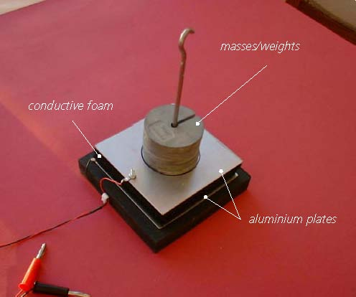
A conductive foam sensor

A conductive foam force sensor has a resistance of around 0.18MΩ when no load has been placed on it, and about 0.07MΩ with a load of 4.90N (mass of 500g) on it.

With a 1MΩ resistor:
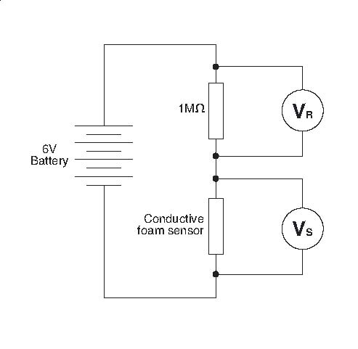

Potential divider set up with sensor and 1MΩ resistor

Using a Potential Divider with a Sensor
PD1.1D

The current I flowing through the sensor and resistor will be given by the expression:

I = V_{B}/R_{Total}

Where V_{B} is the battery voltage and R_{Total} is the resistance of the sensor and the resistor added together.
When there is no load on the sensor this means:

I = 6V/(1MΩ + 0.18MΩ) = 6/(1.18 x 10⁶) = 5.08 ×10⁻⁶A or 5.08μA

The voltage V_{S} across the sensor when there is no load will be given by the expression:

V_{S} = I × R_{SE}

where R_{SE} is the resistance of the sensor when it has no load on it. Substituting values for I and R_{SE} gives:

V_{S} = (5.08 ×10⁻⁶) × (0.18 x 10⁶) = 0.91V

The voltage V_{R} across the resistor is given by the expression:

V_{R} = I × R_{R}

where R_{R} is the resistance of the resistor in the potential divider circuit.
Substituting values for I and R_{R} gives

V_{R} = (5.08 ×10⁻⁶) × (1.0 x 10⁶) = 5.08V

Now let’s look at how things change when there is a load on the sensor.

The current I flowing through the sensor and resistor is given by the expression:

I = V_{B}/R_{Total}

Where V_{B} is the battery voltage and R_{Total} is the resistance of the sensor and the resistor added together.
Substituting values for V_{B} and R_{Total} gives :

I = 6V/(1MΩ + 0.07MΩ) = 6/(1.07 x 10⁶) = 5.60 ×10⁻⁶A or 5.60μA

Using a Potential Divider with a Sensor
PD1.1E

The voltage V_{S} across the sensor is given by the expression:

V_{SL} = I × R_{SL}
where R_{SL} is the resistance of the sensor when it has a load on it.
Substituting values for I and R_{SL} gives:

V_{S} = (5.60 ×10⁻⁶) × (0.07 x 10⁶) = 0.39V

The voltage V_{R} across the resistor is given by the expression:

V_{R} = I × R_{R}

Where R_{R} is the resistance of the resistor in the potential divider circuit. So we have:

V_{R} = (5.60 ×10⁻⁶) × (1.0 x 10⁶) = 5.60V

The change in voltage across the sensor as the load is added is (0.39V – 0.91V) or –0.52V.
The change in voltage across the resistor as the load is added is (5.60V – 5.08V) = +0.52V.
Note that the voltage across the sensor has decreased whilst the voltage across the resistor has increased by the same amount.

Using a Potential Divider with a Sensor
PD1.2A

Questions

Q1. In Example A, why would it be of no use just to have the sensor connected across the battery and measure the voltage across it as its resistance changes? What would you expect to see happening, if anything? Explain.

The rest of the questions are all about the circuit used in Example C, and consider the effect of changing the resistance of the fixed resistor.
The conductive foam force sensor has a resistance of around 0.18MΩ when no load has been placed on it, and about 0.07MΩ with a load of 4.90N (mass 500g)on it.

Here is the original circuit with the 1MΩ resistor:
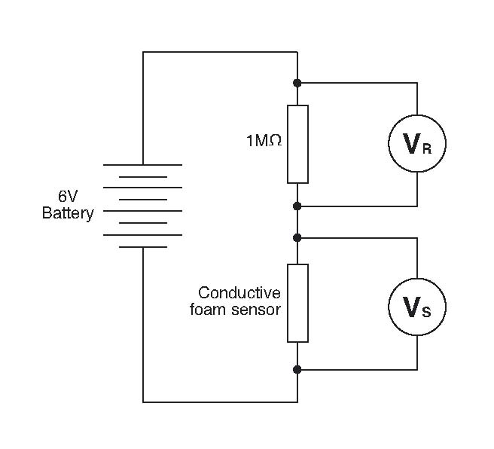

Potential divider set up with sensor and 1MΩ resistor

In the circuit with a 0.47MΩ (470kΩ) resistor:

Q2. Calculate the current I, when there is no load on the sensor.

Q3. Calculate the voltage V_{S} across the sensor

Q4. Calculate the voltage V_{R} across the resistor

Using a Potential Divider with a Sensor
PD1.2B

Q5. Calculate the current I flowing through the sensor and resistor when there is a load on the sensor

Q6. Calculate the voltage V_{S} across the sensor

Q7. Calculate the voltage V_{R} across the resistor

Q8. Calculate the change in voltage across the sensor as the load is added.

Q9. Calculate the change in voltage across the resistor as the load is added.

In the circuit with a 0.1 M Ω resistor:

Q10. Calculate the current I, when there is no load on the sensor.

Q11. Calculate the voltage V_{S} across the sensor

Q12. Calculate the voltage V_{R} across the resistor

Q13. Calculate the current I flowing through the sensor and resistor when there is a load on the sensor

Q14. Calculate the voltage V_{S} across the sensor

Q15. Calculate the voltage V_{R} across the resistor

Q16. Calculate the change in voltage across the sensor as the load is added.

Q17. Calculate the change in voltage across the resistor as the load is added.

Using a Potential Divider with a Sensor
PD1.2C

In the circuit with a 0.047 M Ω resistor:

Q18. Calculate the current I, when there is no load on the sensor.

Q19. Calculate the voltage V_{S} across the sensor

Q20. Calculate the voltage V_{R} across the resistor

Q21. Calculate the current I flowing through the sensor and resistor when there is a load on the sensor

Q22. Calculate the voltage V_{S} across the sensor

Q23. Calculate the voltage V_{R} across the resistor

Q24. Calculate the change in voltage across the sensor as the load is added.

Q25. Calculate the change in voltage across the resistor as the load is added.

In the circuit with a 0.02 M Ω resistor:

Q26. Calculate the current I, when there is no load on the sensor.

Q27. Calculate the voltage V_{S} across the sensor

Q28. Calculate the voltage V_{R} across the resistor

Q29. Calculate the current I flowing through the sensor and resistor when there is a load on the sensor

Q30. Calculate the voltage V_{S} across the sensor

Using a Potential Divider with a Sensor
PD1.2D

Q31. Calculate the voltage V_{R} across the resistor

Q32. Calculate the change in voltage across the sensor as the load is added.

Q33. Calculate the change in voltage across the resistor as the load is added.

Q34. Use the values you have calculated in questions 2-33 to complete the table.

Resistor value |  | 1.0MΩ | 0.47MΩ | 0.1MΩ | 0.047MΩ | 0.02MΩ
Unloaded sensor | Current I /A | 5.08 ×10⁻⁶
Unloaded sensor | Voltage V_{s} /V | 0.91
Unloaded sensor | Voltage V_{R} / V | 5.08
Loaded sensor | Current I /A | 5.60 ×10⁻⁶
Loaded sensor | Voltage V_{s} /V | 0.39
Loaded sensor | Voltage V_{R} /V | 5.60
Change in voltage across sensor as it is loaded /V |  | -0.52
Change in voltage across resistor as sensor is loaded /V |  | +0.52

Using a Potential Divider with a Sensor
PD1.2E

Answers

Q1. No change of voltage would be seen as the connection of the voltmeter is directly across the battery and so it would be the battery voltage (or e.m.f.) that would be noted, and that would not change. In reality there would be a small change due to the battery’s internal resistance. As the sensor’s resistance falls the current in the circuit would rise. A larger current flowing through this internal resistance would produce a voltage drop across it and so a smaller voltage would be noted across the battery.

Answers to calculations questions 2-34

In the circuit with a 0.47M Ω resistor:
Q2: I = 6V/(0.47MΩ + 0.18MΩ) = 6/(0.65 x 10⁶) = 9.23 ×10⁻⁶A or 9.23μA
Q3. V_{S} = (9.23 ×10⁻⁶) × (0.18 x 10⁶) = 1.66V
Q4. V_{R} = (9.23 ×10⁻⁶) × (0.47 x 10⁶) = 4.34V
Q5. I = 6V/(0.47MΩ + 0.07MΩ) = 6/(0.54 x 10⁶) = 11.1 ×10⁻⁶A or 11.1μA
Q6. V_{S} = (11.1 ×10⁻⁶) × (0.07 x 10⁶) = 0.78V
Q7. V_{R} = (11.1 ×10⁻⁶) × (0.47 x 10⁶) = 5.22V
Q8. The change in voltage across the sensor as the load is added is
(0.78V – 1.66V) or –0.88V.
Q9. The change in voltage across the resistor as the load is added is
(5.22V – 4.34V) = +0.88V.

In the circuit with a 0.1M Ω resistor:
I = 6V/(0.1MΩ + 0.18MΩ) = 6/(0.28 x 10⁶) = 21.43 ×10⁻⁶A or 21.43μA
V_{S} = (21.43 ×10⁻⁶) × (0.18 x 10⁶) = 3.86V
V_{R} = (21.43 ×10⁻⁶) × (0.1 x 10⁶) = 2.14V
I = 6V/(0.1MΩ + 0.07MΩ) = 6/(0.17 x 10⁶) = 35.29 ×10⁻⁶A or 35.29μA
V_{S} = (35.29 ×10⁻⁶) × (0.07 x 10⁶) = 2.47V
V_{R} = (35.29 ×10⁻⁶) × (0.1 x 10⁶) = 3.53V
The change in voltage across the sensor as the load is added is
(2.47V – 3.86V) or –1.39V.
The change in voltage across the resistor as the load is added is
(3.53V – 2.14V) = +1.39V.

With a 0.047MΩ (47kΩ) resistor:
I = 6V/(0.047MΩ + 0.18MΩ) = 6/(0.227 x 10⁶) = 26.43 ×10⁻⁶A or 26.43μA
V_{S} = (26.43 ×10⁻⁶) × (0.18 x 10⁶) = 4.76V
V_{R} = (26.43 ×10⁻⁶) × (0.047 x 10⁶) = 1.24V
I = 6V/(0.047MΩ + 0.07MΩ) = 6/(0.117 x 10⁶) = 51.28 ×10⁻⁶A or 51.28μA
V_{S} = (51.28 ×10⁻⁶) × (0.07 x 10⁶) = 3.59V
V_{R} = (51.28 ×10⁻⁶) × (0.047 x 10⁶) = 2.41V
The change in voltage across the sensor as the load is added is
(3.59V – 4.76V) or –1.17V.
The change in voltage across the resistor as the load is added is
(2.41V – 1.24V) = +1.17V.

Using a Potential Divider with a Sensor
PD1.2F

With a 0.02MΩ (20kΩ) resistor:
I = 6V/(0.02MΩ + 0.18MΩ) = 6/(0.20 x 10⁶) = 30.0 ×10⁻⁶A or 30.0μA
V_{S} = (30.0 ×10⁻⁶) × (0.18 x 10⁶) = 5.4V
V_{R} = (30.0 ×10⁻⁶) × (0.02 x 10⁶) = 0.6V
I = 6V/(0.02MΩ + 0.07MΩ) = 6/(0.09 x 10⁶) = 66.67 ×10⁻⁶A or 66.67μA
V_{S} = (66.67 ×10⁻⁶) × (0.07 x 10⁶) = 4.67V
V_{R} = (66.67 ×10⁻⁶) × (0.02 x 10⁶) = 1.33V
The change in voltage across the sensor as the load is added is
(4.67V – 5.4V) or –0.73 V.
The change in voltage across the resistor as the load is added is
(1.33V – 0.6V) = +0.73V.

Q34.

Resistor value |  | 1.0MΩ | 0.47MΩ | 0.1MΩ | 0.047MΩ | 0.02MΩ
Unloaded sensor | Current I /A | 5.08 ×10⁻⁶ | 9.23 ×10⁻⁶ | 21.43 ×10⁻⁶ | 26.43 ×10⁻⁶ | 30.0 ×10⁻⁶
Unloaded sensor | Voltage V_{s} /V | 0.91 | 1.66 | 3.66 | 4.76 | 5.4
Unloaded sensor | Voltage V_{R} / V | 5.08 | 4.34 | 2.14 | 1.24 | 0.6
Loaded sensor | Current I /A | 5.60 ×10⁻⁶ | 11.1 ×10⁻⁶ | 35.29 ×10⁻⁶ | 51.28 ×10⁻⁶ | 66.67 ×10⁻⁶
Loaded sensor | Voltage V_{s} /V | 0.39 | 0.78 | 2.47 | 3.59 | 4.67
Loaded sensor | Voltage V_{R} /V | 5.60 | 5.22 | 3.53 | 2.41 | 1.33
Change in voltage across sensor as it is loaded /V |  | -0.52 | -0.88 | -1.39 | -1.17 | -0.73
Change in voltage across resistor as sensor is loaded /V |  | +0.52 | +0.88 | +1.39 | +1.17 | +0.73

The 0.1MΩ resistor is the one to use here, because it gives the largest difference in voltage.

