Activity: Selecting the best value resistor
PD2.1A

Introduction

Many sensors that change in resistance with whatever they are sensing are often set up in a potential divider circuit. This places the sensor in series with a resistor and a battery. As the sensor’s resistance changes, the voltage across it (and across a resistor in series with it) also changes.

- The problem is how to select the best value resistor to put in series with the sensor.
- The key to the solution is to select a resistor which gives the largest change in voltage across the range over which the sensor is used.

For example, suppose we need a temperature sensor to be used over the range 0°C to 100°C:
- If it is placed in series with a 47kΩ resistor, the voltage across this resistor changes from 1.0V to 2.0V.
- However, when placed in series with a 180kΩ resistor, the voltage change is from 1.5V to 3.0V.

The 180kΩ resistor would be a better choice as the change of voltage with it is 1.5V instead of just 1.0V.

In reality the choice is often more complex, as many sensors do not change their resistance in a linear way. The choice of the series resistor is then a compromise to give the best resolution within a chosen section of the sensor’s range. (The bigger the change in voltage output for a given change in whatever quantity is being sensed, the better the resolution).

Activty: Selecting the best value resistor
PD2.1B

Procedure

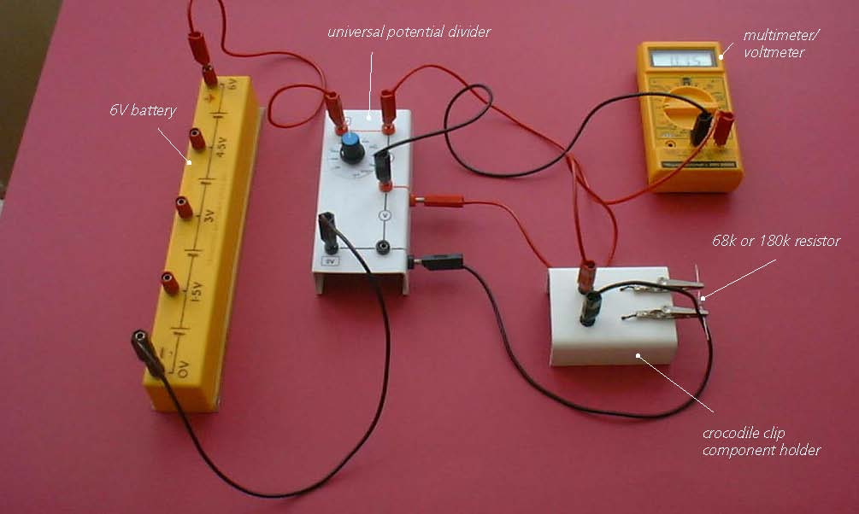

Potential divider circuit: test circuit

- Set the universal potential divider unit’s resistor to 4.7kΩ.
- Connect the 6V battery so that its +6V socket is connected to the red +6V socket of the potential divider unit and its 0V socket to the black 0V socket of the potential divider unit.
- Connect a crocodile clip component holder so that its sockets are connected to the black and red Sensor sockets on the side of the potential divider unit.
- Clip a 68kΩ resistor (to represent a sensor’s minimum resistance) into the crocodile clip component holder.
- Finally, connect a voltmeter (or a multimeter on its voltage range) to the upper pair of red output voltage sockets on the potential divider unit.

- Record the voltmeter reading for each potential divider resistor value from 4.7kΩ to 1MΩ in the second column of your results table.

- Replace the 68kΩ resistor in the crocodile clip component holder by a 180kΩ resistor (to represent the sensor’s maximum resistance).
- Record the voltmeter reading for each potential divider resistor value from 4.7kΩ to 1MΩ in the third column of your results table.
- Fill in the values for the change in voltage output in the fourth column of the table. (Column 4 value = column 2 value – column 3 value).

Activity: Selecting the best value resistor
PD2.1C

Results

Potential divider resistor value | Voltage output from potential divider with 68kΩ resistor in place of sensor /V | Voltage output from potential divider with 180kΩ resistor in place of sensor /V | Change of Voltage output from potential divider /V
4.7kΩ
10kΩ
20kΩ
47kΩ
100kΩ
470kΩ
1MΩ

Questions

Which potential divider resistor value produced the largest change in output voltage?

Which potential divider resistor is likely to be the most suitable to use if the sensor’s minimum resistance over the range in use is 68kΩ and its maximum resistance over this same range is 180kΩ?

