Activity (i): Using a multimeter on a resistance range
P1.1A

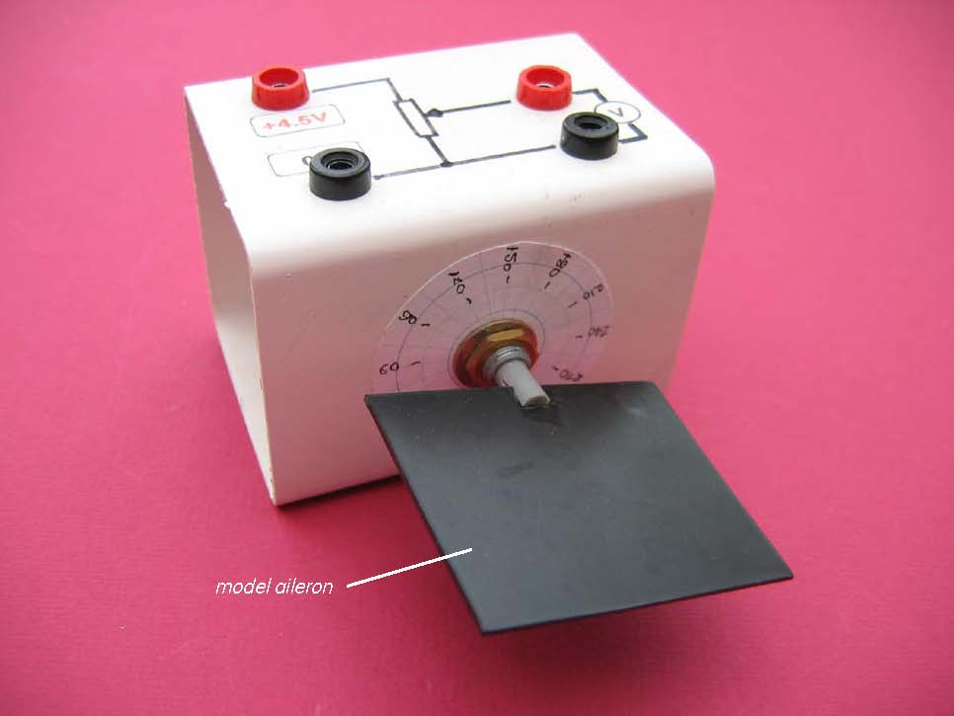

Model aileron attached to a rotary potentiometer

You might have thought that the simplest way to sense a model aileron’s position when it is connected to a rotary potentiometer is to measure the change of resistance with angle of turn. Whilst this is a simple approach which would work, it is not the one used commercially: this relies on the measurement of a voltage output from a potential divider set up.

Activity (i): Using a multimeter (or voltmeter)
P1.1B

Procedure
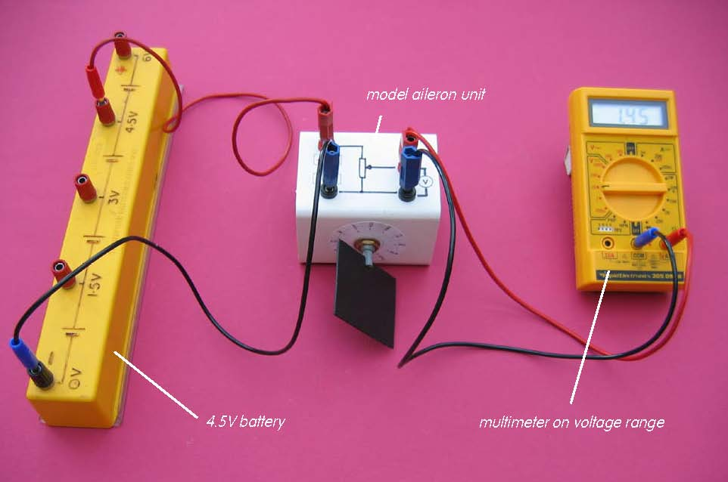

Set up of model aileron with battery and multimeter

Calibration:

- Connect the red +4.5V socket on the model aileron unit to the +4.5V socket on the battery and the black 0V socket to the 0V socket of the battery.
- Connect the output voltage sockets to a multimeter set on its 20V range or to a 5V or 10V voltmeter.
- Check that rotation of the model aileron does change the voltage output.
- Record the voltage output from the sensor for each of the angles of rotation listed from 0° to around 300°. In reality an aileron would never rotate through such a large range.
- Now plot a graph of voltage output (Y-axis) against the angle of rotation (X-axis) and incorporate a best-fit line. You could do this manually or by entering your results into a graphing package or spreadsheet.

Using the calibrated rotation sensor:

You will now have calibrated the rotation sensor, producing a graph or calibration ‘curve’ which you will be able to use to help you find the value of an unknown position or angle.

- Rotate the model aileron but do not note its position at this stage. Record the voltage output.
- Using your calibration ‘curve’ note down what you think the model aileron’s position must be.
- Now check what its position is.

Activity (i): Using a multimeter (or voltmeter)
P1.1C

Results

Angle of rotation /° | Voltage output /V
0
30
60
90
120
150
180
210
240
270
300

Questions

Does your graph show the voltage output to be
- linearly related to the angle of rotation of the model aileron
and
(b) directly proportional to the angle of rotation? Explain.

How close was your estimated position to its actual position?

