Activity (ii): Using PicoScope on DrDAQ
P1.2A

Procedure
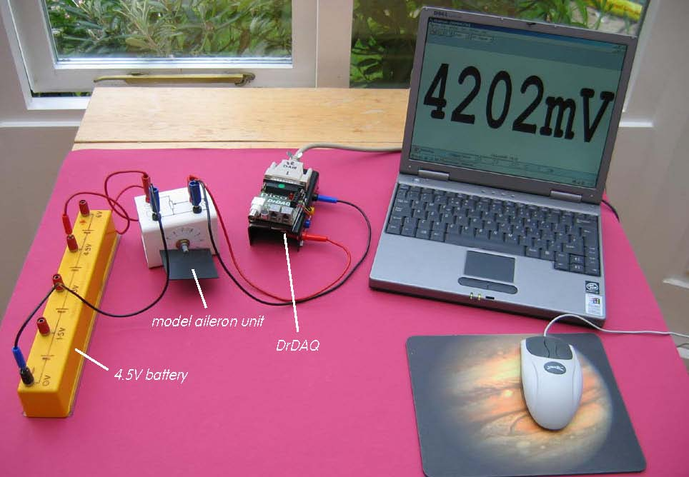

Model aileron with rotary potentiometer sensor set up to use with Picoscope on DrDAQ

Calibration:

Note: If you are connected via a network you may need to obtain additional instructions.

Before the computer is switched on check that DrDAQ has been plugged into the computer.

- Connect the red +4.5V socket on the model aileron unit to the +4.5V socket on the battery and the black 0V socket to the 0V socket of the battery.
- Now connect the red output voltage socket of the model aileron unit to the V socket on DrDAQ and the black output voltage socket to the GND socket on DrDAQ.

Activity (ii): Using PicoScope on DrDAQ
P1.2B

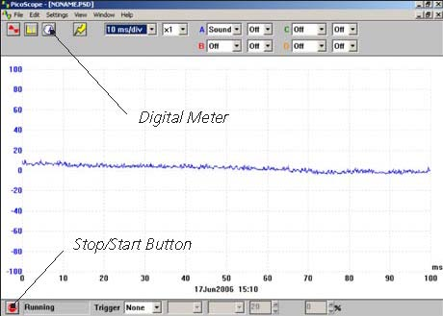  DrDAQ opening screen | - Switch on and load the PicoScope software. If necessary, enlarge by clicking the in the top right-hand corner of the screen to provide a full screen display as shown with the program already running.  Note: If the program appears to have frozen at any time then it can usually be unfrozen by pressing the F10 function key. If this does not succeed then close down the program by pressing the Ctrl, Alt and Delete keys simultaneously, and then restart the program.
- Click the STOP button in the bottom left-hand corner of the screen.
- Close down the Oscilloscope mode by clicking the lower of the two Xs in the top right-hand corner of the screen.

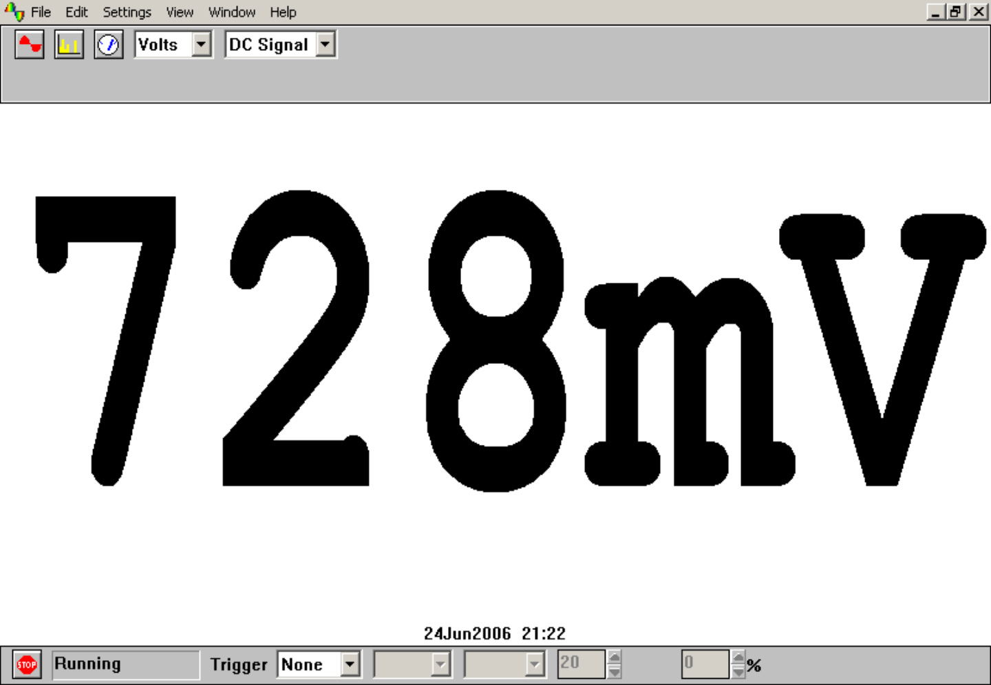Digital Voltmeter display | - Now click on the Digital Meter icon in the Toolbar, select Volts and DC Signal and then click the GO button to put PicoScope into Display Voltmeter mode. Rotate the model aileron to check that the potentiometer sensor is functioning and you should get a display like that shown, though not necessarily of that value.  - Record the voltage output from the sensor for each of the angles of rotation listed from 0° to around 300°. In reality an aileron would never rotate through such a large range.  - Now plot a graph of voltage output (Y-axis) against the angle of rotation (X-axis) and incorporate a best-fit line. You could do this manually or by entering your results into a graphing package or spreadsheet.

Activity (ii): Using PicoScope on DrDAQ
P1.2C

Using the calibrated angle of rotation sensor:

You will now have calibrated the sensor, producing a graph or calibration ‘curve’ which you will be able to use to help you find the value of an unknown position or angle.

- Rotate the model aileron but do not, at this stage, note its position. Record the voltage output.
- Using your calibration ‘curve’ note down what you think the model aileron’s position must be.
- Now look at what its position is.

It would be unusual to find an instrument which had not been calibrated for direct use. With a computer-based device it is often possible to calibrate it so that it automatically displays the quantity you wish to measure directly on the screen. In this case you would want to get the computer to ‘convert’ the voltage output from the sensor to give an angle display on the screen. With PicoScope this is easily done by setting up a Custom Range.

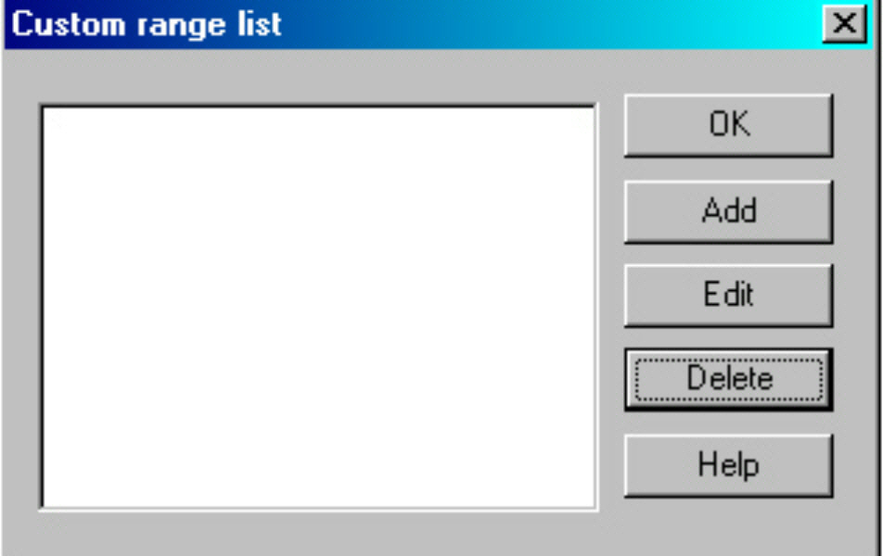  Custom range list | - Click the STOP button. Now click on Settings in the Menu bar and then on Custom ranges in the drop-down menu to display the Custom range list as shown.
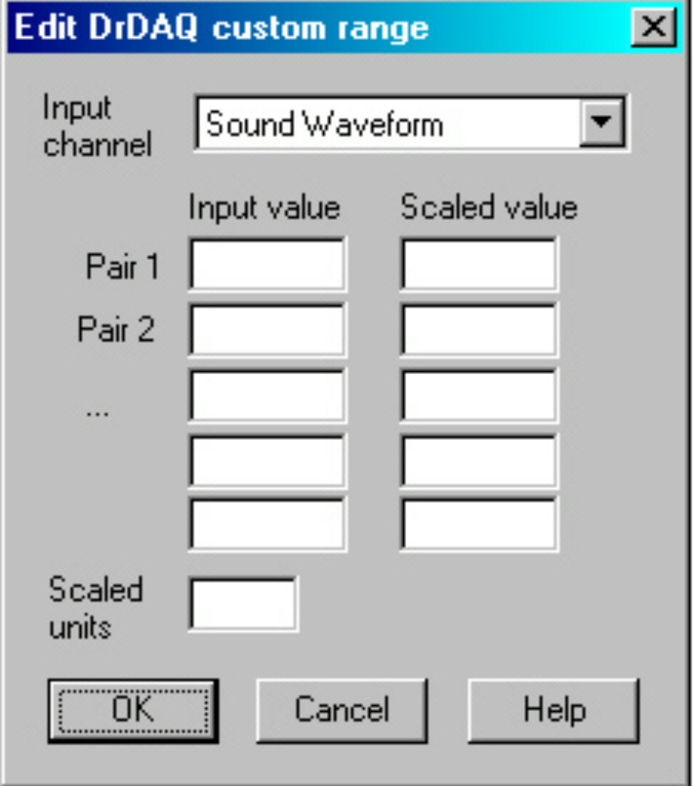  Edit DrDAQ Custom range box | - Click on Add to display the Edit DrDAQ custom range box:

Activity (ii): Using PicoScope on DrDAQ
P1.2D

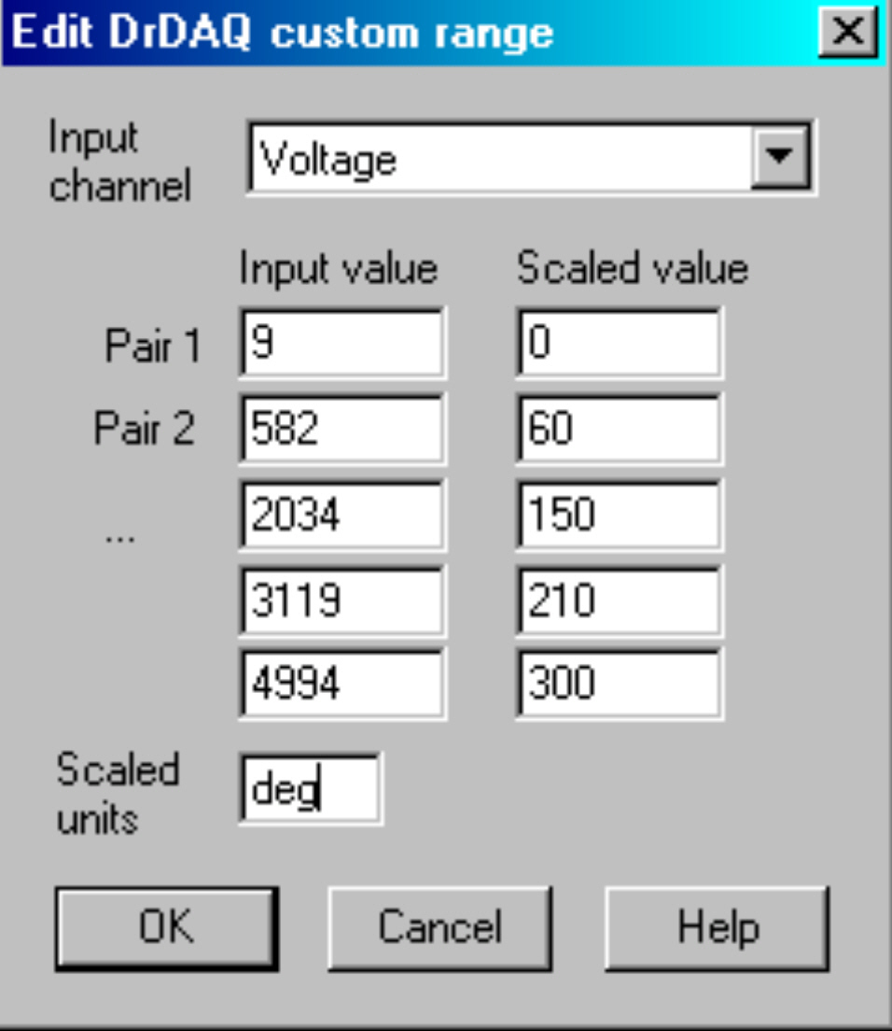  Adding values and scaled units | - Select the Input channel ‘Voltage’ by clicking on the down arrow alongside. Now type in your pairs of data into the two columns – output voltages into the Input value column and the angles into the Scaled value column. Ensure that you input the smallest angle (0°) and the output voltage that this produced as Pair 1. Make the last pair the largest angle (around 300°) and its corresponding output voltage.  - Type ‘deg’ (for degrees) into the Scaled units box.
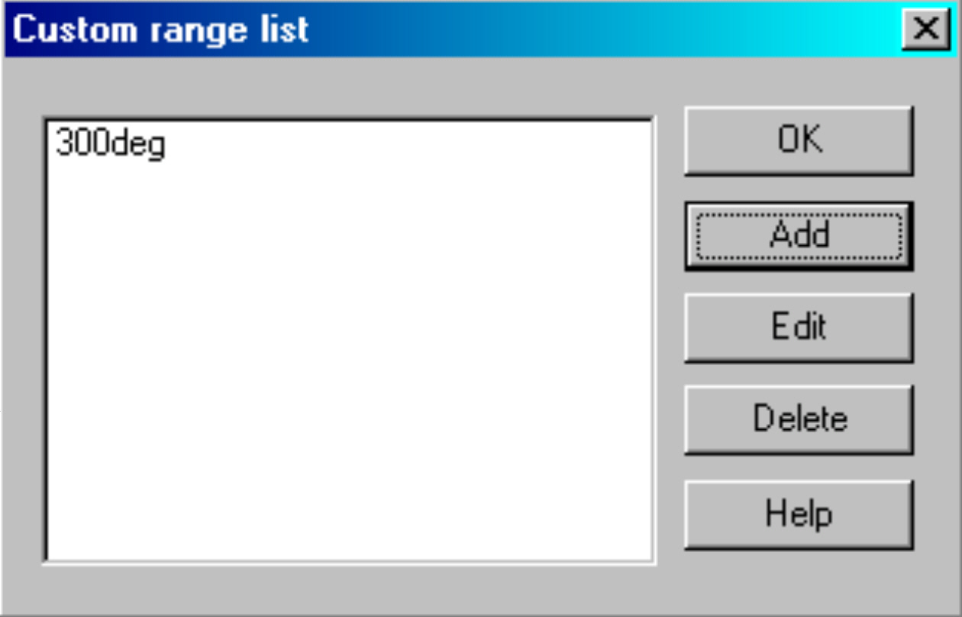  Custom range list with new range added | - Click the OK button. You should now see a ‘300deg’ range appear in the Custom range list :  - Highlight this new range and click the OK button.
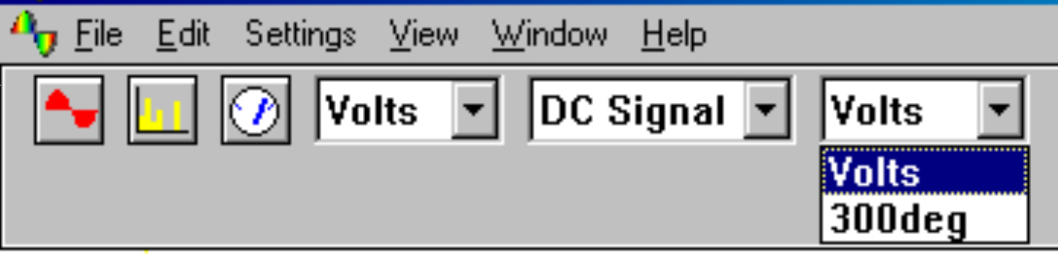  New range to select | - Click on the down-arrow next to the right-hand ‘volts’: you should see an extra box for this new range, as shown:

Activity (ii): Using PicoScope on DrDAQ
P1.2E

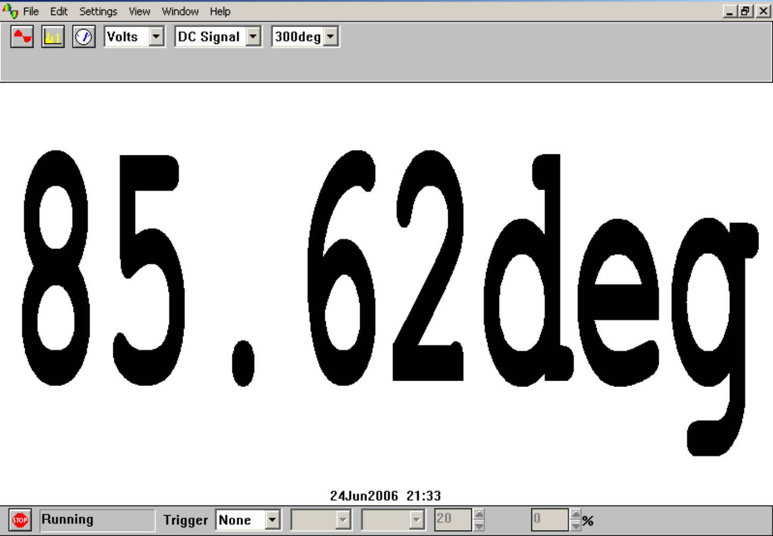  Unknown angle displayed in degrees | - Select this new range, rotate the model aileron to a new angle and then click the GO button. You should now see a digital meter reading displayed directly as a angle (although not necessarily the value shown)

- Click the STOP button.

- To return the program to its original state, first click on the down arrow alongside ‘330deg’ and reset to ‘Volts’. Now click on Settings in the Menu bar and then on Custom ranges in the drop-down menu to display the Custom range list. Highlight the newly added range and click the Delete button to remove it, then click the OK button.

- To finish with the program click File on the Menu bar and Exit in its drop-down menu to leave the program.

Note: When you keyed your data into the ‘Input value’ and ‘Scaled value’ columns you were giving the computer information from which it could estimate other values that occur in between – it interpolates. It is doing the same job that you do with a graph and best-fit line. If the relationship between the data is a linear one then only two pairs of data items are needed, but otherwise a spread of data pairs across the range is needed.

Activity (ii): Using PicoScope on DrDAQ
P1.2F

Results

Angle of rotation /° | Voltage output /mV
0
30
60
90
120
150
180
210
240
270
300

Questions

Does your graph show the voltage output to be
(a) linearly related to the angle of rotation of the model aileron
and
- directly proportional to the angle of rotation? Explain.

How close was your estimated position to its actual position?

How well does the displayed value for the ‘unknown angle’ value match with the actual value?

