Using a photodiode to measure Percentage Reflectance
L1.1A

Procedure

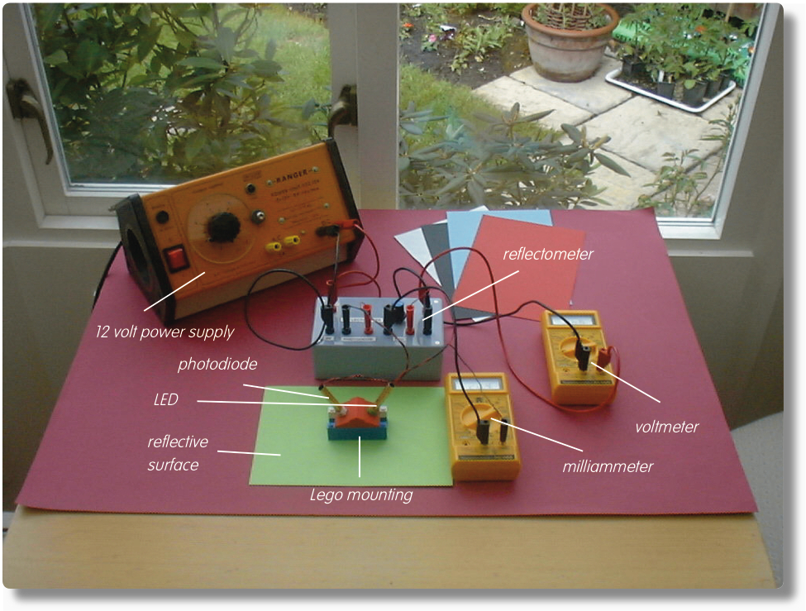

Reflectometer set up to measure Percentage Reflectance

Your first task is to measure the Reflected Illuminance as sensed by a photodiode following reflection of light from light emitting diodes (LEDs) off various surfaces.

- Insert the photodiode into the hole in one side of the ‘roof’ of the Lego® mounting and the green LED into the hole on the other side. Connect the photodiode, green light LED, milliammeter (200mA range), voltmeter (20V range initially, but move to 2V or 200mV range as required) and 12V supply to the Reflectometer as shown above.

- Adjust the control knob on the Reflectometer until the current through the LED, as measured by the milliammeter, is as near to 20mA as possible.

- Place the Lego® mounting onto a range of surfaces such as different coloured papers and record the voltmeter readings for each in your table of reflectance data.

Using a photodiode to measure Percentage Reflectance
L1.1B

- Now remove the LED with its section of ‘roof’ and transfer it to the other Lego® mounting. Replace the missing section of ‘roof’ with a complete ‘roof’ section. Position the two mountings so the LED shines directly towards the photodiode as shown:

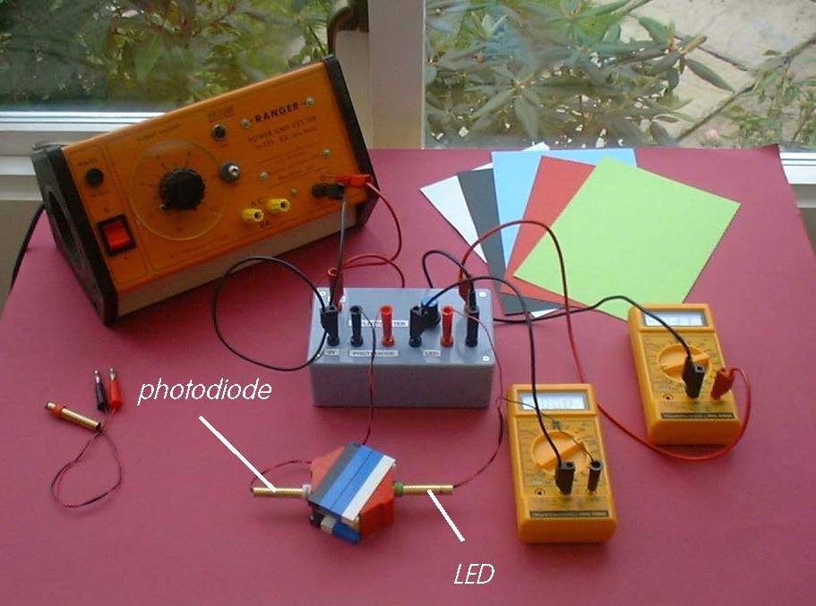
Reflectometer set up with LED shining directly towards the photodiode

The distance the light travels between the LED and the photodiode in this situation will be identical to that taken by the light when it reflects off of a surface and up to the photodiode as shown:

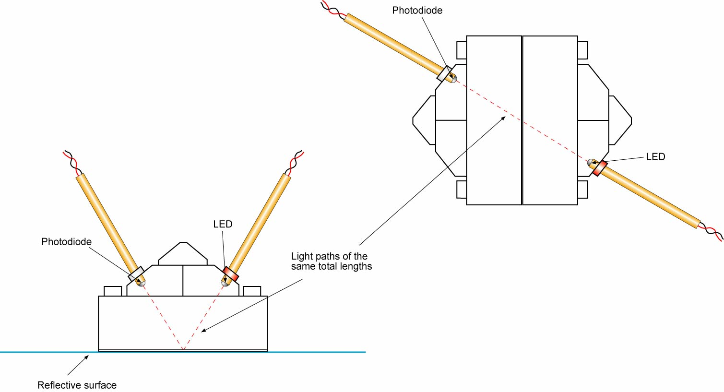

Light paths for reflecting and direct beams from LED to photodiode

Using a photodiode to measure Percentage Reflectance
L1.1C

- To take account of any slight misalignment of the LED and photodiode, slide the mountings a little until the voltmeter reading is the highest possible. Record this value in the Reflecting surface column of your table as ‘Direct’.

- Repeat the process with the other LED and then switch off the power supply and the meters. Your readings are likely to be very different as you will be using an entirely different wavelength of light.

To calculate the Percentage Reflectance for each surface we need an amended form of the following expression:

% Reflectance = (Reflected illuminance/Incident illuminance) x 100

The Reflected illuminances are directly proportional to the voltages obtained when the LEDs’ light was being reflected from different surfaces. The Incident illuminances are directly proportional to the voltages obtained when the LEDs’ light was beamed directly onto the photodiode. The Percentage Reflectance can therefore be calculated from the expression:

% Reflectance = (Voltage when beam reflected/Voltage when beam direct) x 100

e.g. If with the green LED the voltage when its light was reflected off red paper was 0.046V, and when the light beam was direct to the photodiode the voltmeter read 4.43V, then the % Reflectance would be given by:

% Reflectance = (0.046V/4.43V) x 100 = 1.04

- Calculate the % Reflectance for each surface with each LED and enter the values in your results table.

Using a photodiode to measure Percentage Reflectance
L1.1D

Results

Colour of LED’s light:
Type of reflecting surface | Voltmeter reading /V | % Reflectance

Colour of LED’s light:
Type of reflecting surface | Voltmeter reading /V | % Reflectance

Reflectance data for two LEDs and different reflecting surfaces

Questions

Why was it necessary to have the ‘direct’ light paths and the ‘reflected’ light paths of the same total length?

