Activity (ii): Using a potential divider network and a voltmeter

L2.2A
Procedure
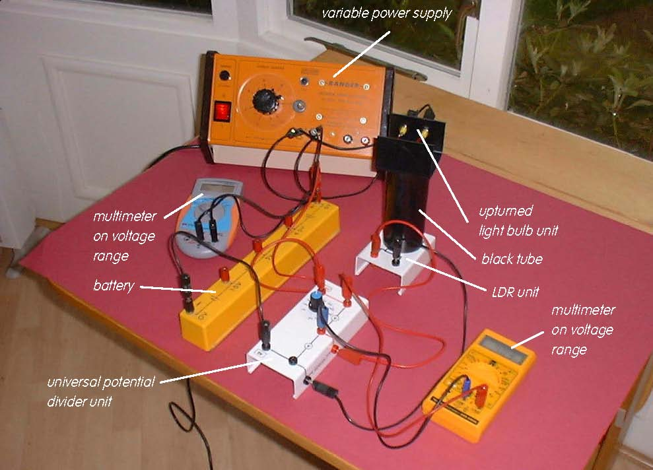

LDR set up in a potential divider network

Calibration:

With an LDR arranged in a potential divider network, a change in its resistance produces a change in the output voltage either across it, or across the other resistance section of the potential divider. It is the most common arrangement used with sensors.

- Set the universal potential divider unit to 1kΩ. Connect the 6V battery so that its +6V socket is connected to the red +6V socket of the potential divider unit and its 0V socket to the black 0V socket of the potential divider unit. Connect the LDR unit so that the black and red sockets are connected to the black and red Sensor sockets on the side of the potential divider unit. Finally, connect a multimeter on its voltage range (or a voltmeter) to the upper pair of red output voltage sockets on the potential divider unit.

- Now connect the light bulb to the a.c. or d.c. supply sockets of a variable power supply. Also connect a voltmeter or a multimeter on a voltage range (a.c. if you are using an a.c. supply, d.c. if you are using a d.c. supply), one lead into one of the sockets on the bulb holder and another lead into its other socket. Place the black tube over the LDR and upturn the bulb into this tube.

Activity (ii): Using a potential divider network and a voltmeter
L2.2B

- Use the supply voltage data from Table 1 in activity (i) to adjust the illuminances on the LDR to each of the values shown in Table 3, ie 0-1000 lux in 100 lux steps. For each illuminance, note down in your table the voltage output from the potential divider unit shown on the multimeter or voltmeter. When you have completed recording your set of data, switch off the power supply and meters.

- Now plot a graph of voltage output from the potential divider unit (Y-axis) against illuminance (X-axis) and incorporate a best-fit line.

Using the LDR with a potential divider to provide a measure of illuminance:

- You will now have calibrated the LDR, producing a graph or calibration ‘curve’ which you will be able to use to obtain values of the illuminance just from the voltage output measurements.

- Remove the tube and bulb from the LDR so that the LDR is just illuminated by the laboratory lighting. Using your calibration ‘curve’ note down what you think the illuminance on the LDR must be. Check this with the Luxmeter.

Activity (ii): Using a potential divider network and a voltmeter
L2.2C

Results

Illuminance /lux | Voltage output from potential divider /V
0
100
200
300
400
500
600
700
800
900
1000

Table 3

Questions

Does your graph show the voltage output from the potential divider unit to be (a) linearly related to the illuminance and
(b) directly proportional to the illuminance? Explain.

How close were the prediction for the illuminance and the actual illuminance (luxmeter reading)?

Why wouldn’t a prediction for illuminance be likely to be reliable if the voltage output measured was way beyond those used to produce the calibration ‘curve’?

