Activity (iii): Using a potential divider network and Dr DAQ
L2.3A

Procedure

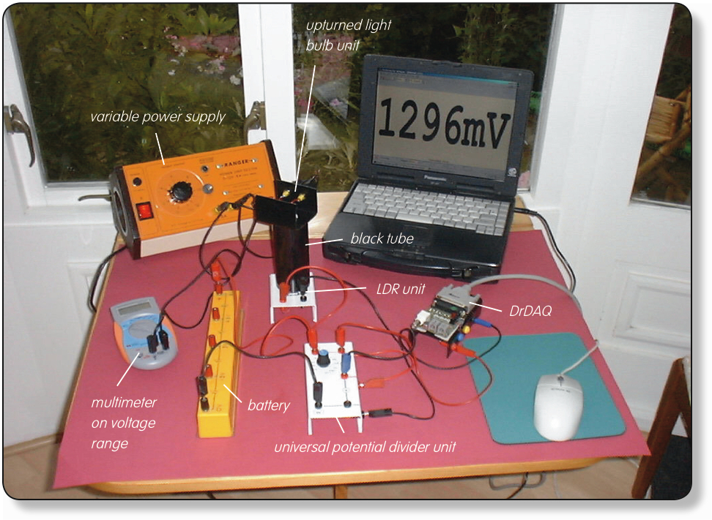
Set up of apparatus to measure illuminance with a potential divider network, an LDR and DrDAQ

Calibration:

NOTE: If you are connected via a network you may need to obtain additional instructions.

- Before the computer is switched on, check that DrDAQ has been plugged into the computer.

- Set the universal potential divider unit to 1kΩ. Connect the 6V battery so that its +6V socket is connected to the red +6V socket of the potential divider unit and its 0V socket to the black 0V socket of the potential divider unit. Connect the LDR unit so that the black and red sockets are connected to the black and red Sensor sockets on the side of the potential divider unit. Connect the upper red Voltage output socket of the potential divider unit to the V socket on DrDAQ and the lower red Voltage output socket to the GND socket on DrDAQ.

- Now connect the light bulb to the a.c. or d.c. supply sockets of a variable power supply. Also connect a voltmeter or a multimeter on a voltage range (a.c. if you are using an a.c. supply, d.c. if you are using a d.c. supply), one lead into one of the sockets on the bulb holder and another lead into its other socket. Place the black tube over the LDR and upturn the bulb into this tube.

Activity (iii): Using a potential divider network and Dr DAQ
L2.3B

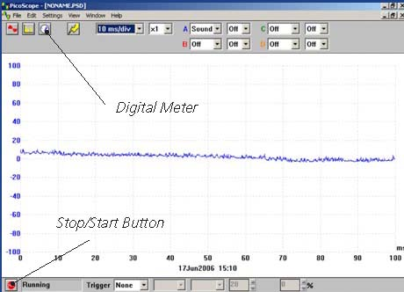  DrDAQ opening screen | - Switch on and load the PicoScope software. If necessary, enlarge by clicking the in the top right-hand corner of the screen to provide a full screen display as shown with the program already running.  NOTE: If the program appears to have frozen at any time then it can usually be unfrozen by pressing the F10 function key. If this does not succeed then close down the program by pressing the Ctrl, Alt and Delete keys simultaneously, and then restart the program.
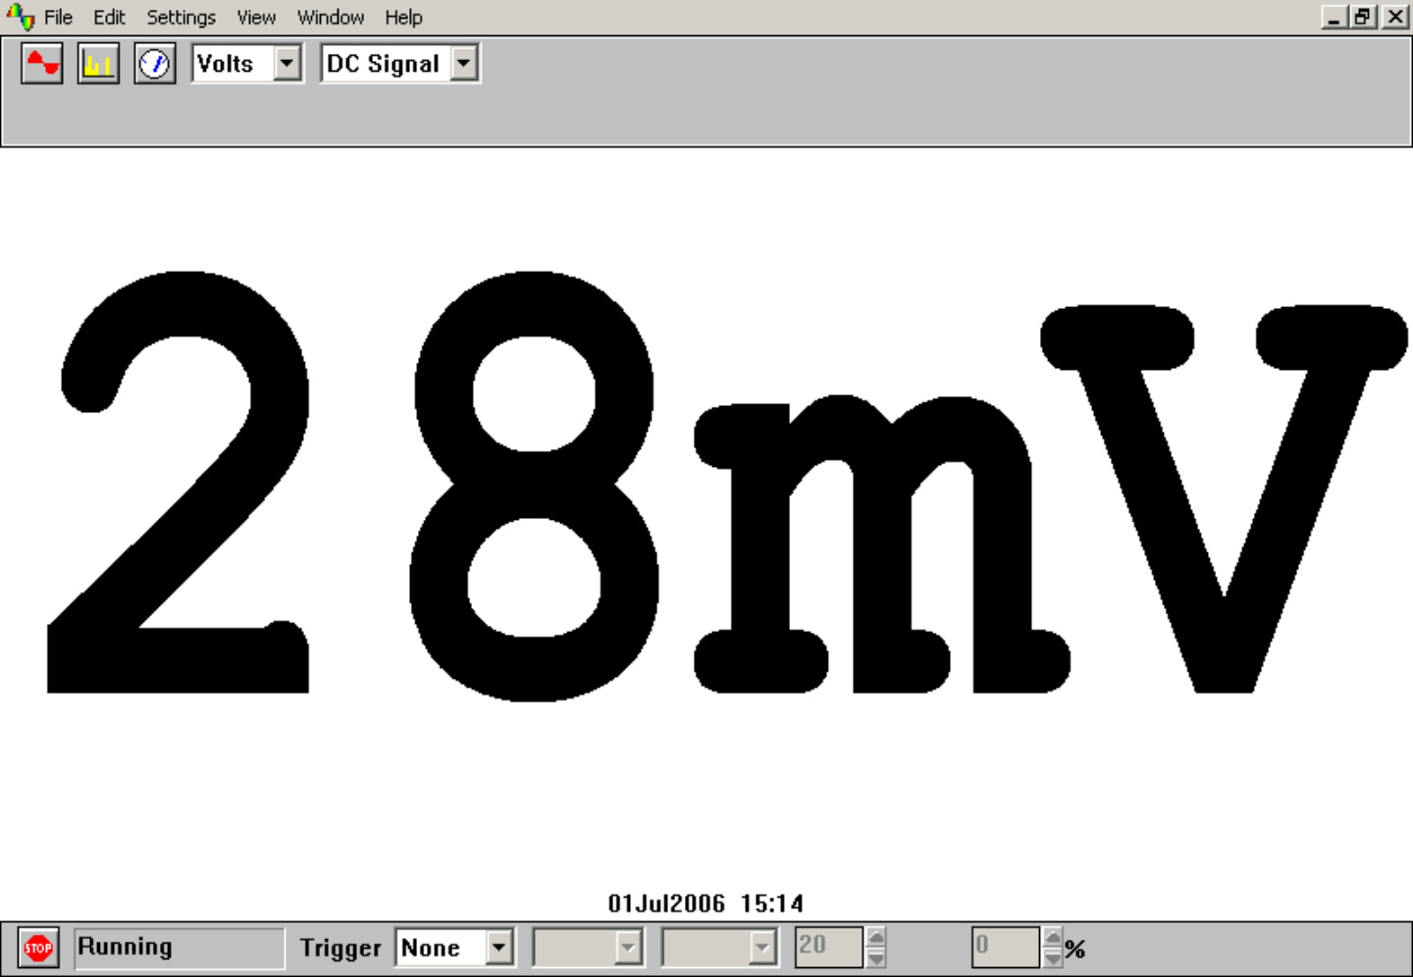  Digital Voltmeter display | - Click the STOP button in the bottom left-hand corner of the screen. Close down the Oscilloscope mode by clicking the lower of the two Xs in the top right-hand corner of the screen. Now click on the Digital Meter icon in the Toolbar, select Volts and DC Signal and then click the GO button to put PicoScope into Display Voltmeter mode. You should now see a small voltage reading on the screen similar to that shown.
- Use the supply voltage data from Table 1 in activity (i) to adjust the illuminances on the LDR to each of the values shown in Table 4, ie 0-1000 lux in 100 lux steps. For each illuminance note down in your table the voltage output from the potential divider unit shown on DrDAQ. If the readings are not stable, record ‘average’ or ‘most often displayed’ values. When you have completed recording your set of data, switch off the power supply and meter.

- Now plot a graph of voltage output from the potential divider unit (Y-axis) against the illuminance (X-axis) and incorporate a best-fit line.

Activity (iii): Using a potential divider network and Dr DAQ
L2.3C

Using the LDR with a potential divider with DrDAQ to provide a measure of illuminance:

You will now have calibrated the LDR, producing a graph or calibration ‘curve’ which you will be able to use to obtain values of the illuminance just from the voltage output measurements obtained.

- Remove the tube and bulb from the LDR so that the LDR is just illuminated by the laboratory lighting. Using your calibration ‘curve’, note down what you think the illuminance on the LDR must be. Check this with the Luxmeter.

In the last part of this activity you can use PicoScope on DrDAQ to obtain a display reading directly in lux.

It would be unusual to find an instrument which had not been calibrated for direct use. With a computer-based device it is often possible to calibrate it so that it automatically displays the quantity you wish to measure directly on the screen. In this case you would want to get the computer to ‘convert’ the voltage output from the potential divider to give an illuminance display in lux on the screen. With PicoScope this is easily done by setting up a Custom Range.

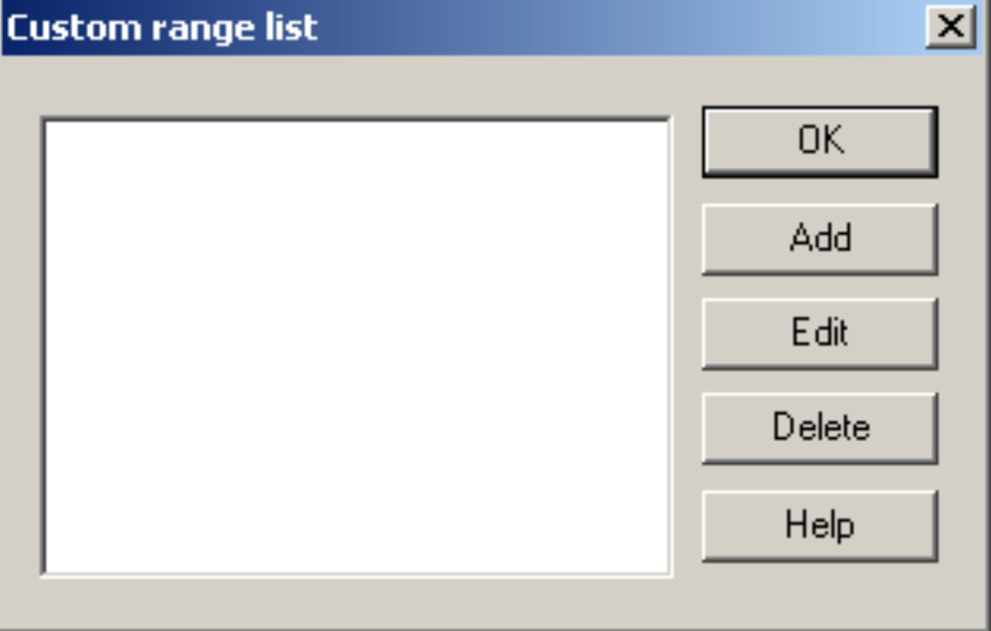  Custom range list | - Click the STOP button. Now click on Settings in the Menu bar and then on Custom ranges in the drop-down menu to display the Custom range list as shown.

Activity (iii): Using a potential divider network and Dr DAQ
L2.3D

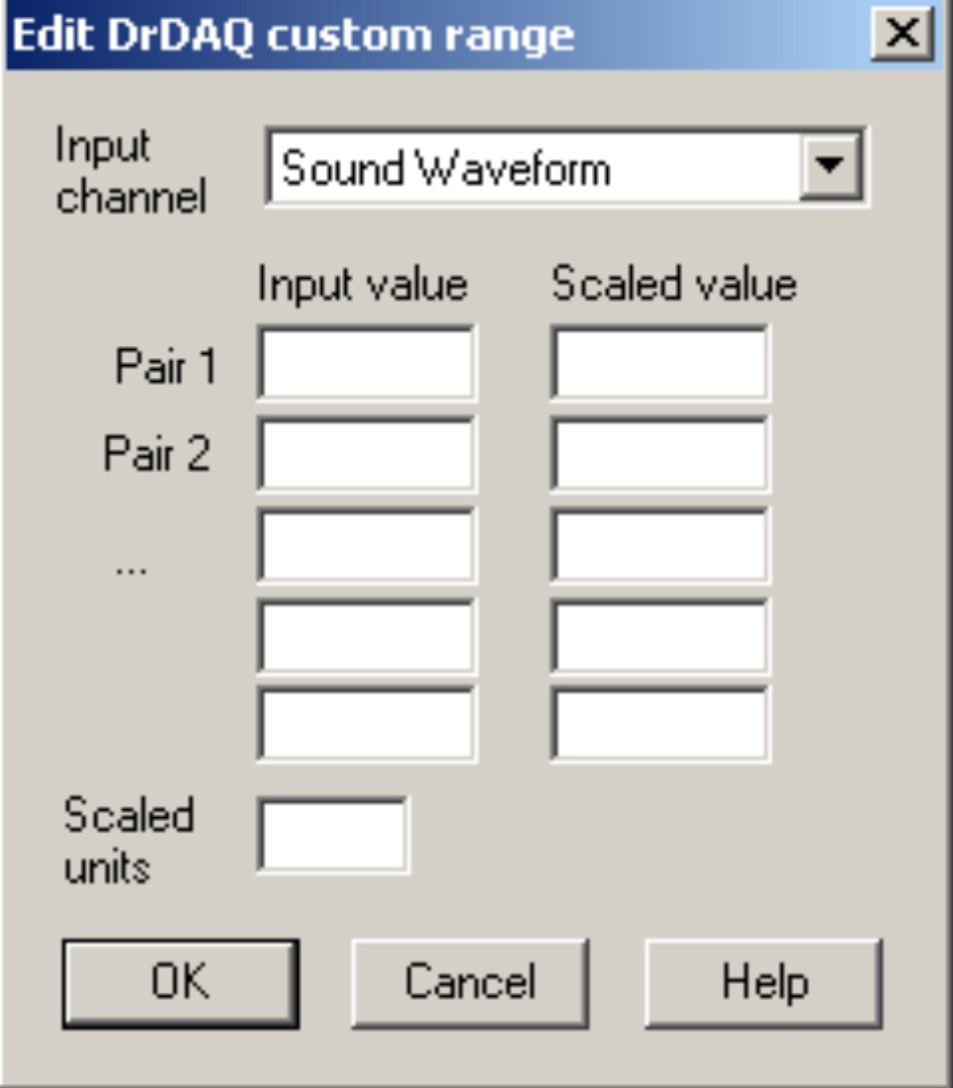  Edit DrDAQ Custom range box | - Click on Add to display the Edit DrDAQ custom range box as shown.
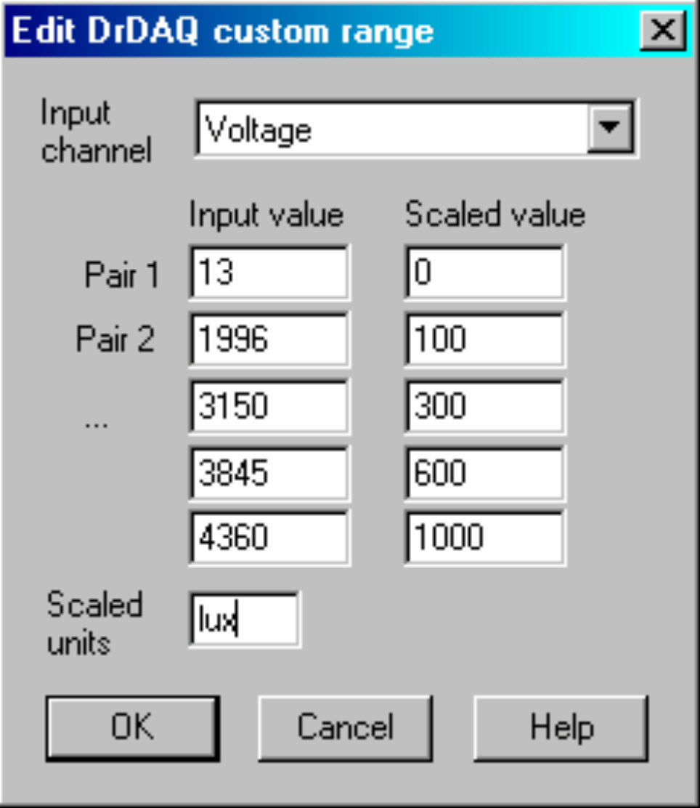  Add values and scaled units | - Select the Input channel ‘voltage’ by clicking on the down arrow alongside. Now type in your pairs of data into the two columns – voltage outputs into the Input value column and the illuminance into the Scaled value column. Ensure that you input the lowest voltage output and its matching illuminance as Pair 1. Make the last pair the highest voltage output obtained and its corresponding illuminance. Type ‘lux’ into the Scaled units box. It should look like the ‘Add values and scaled units’ image.

Activity (iii): Using a potential divider network and Dr DAQ
L2.3E

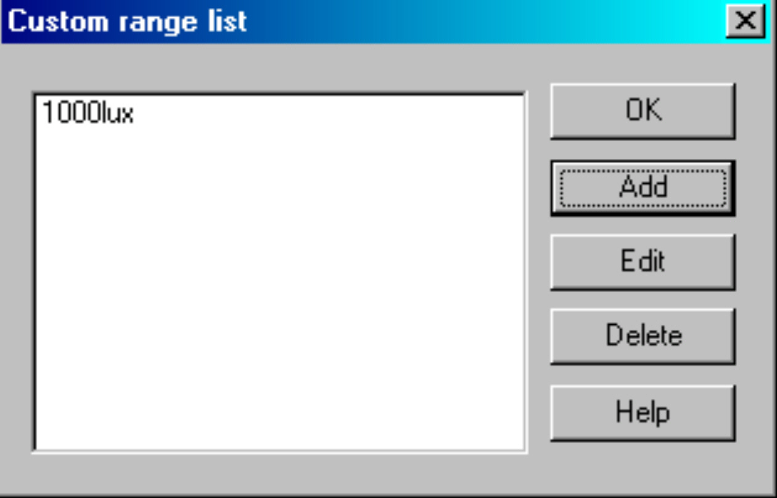  Custom range list with new range added | - Click the OK button. You should now see a ‘1000lux’ range appear in the Custom range list.
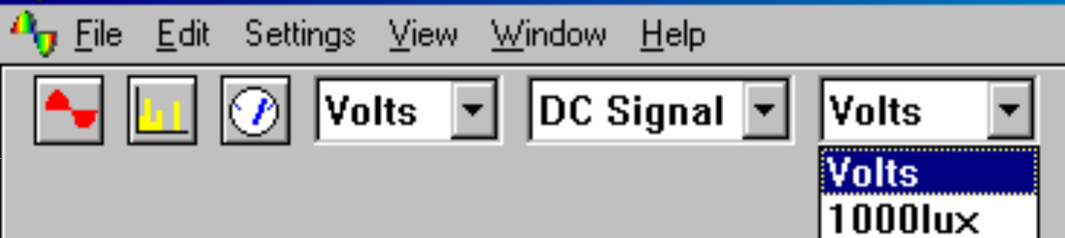  New range to select | - Highlight this new range and click OK button. You should now see that, when the down-arrow next to the right-hand volts is clicked on, an extra box for this new range appears.
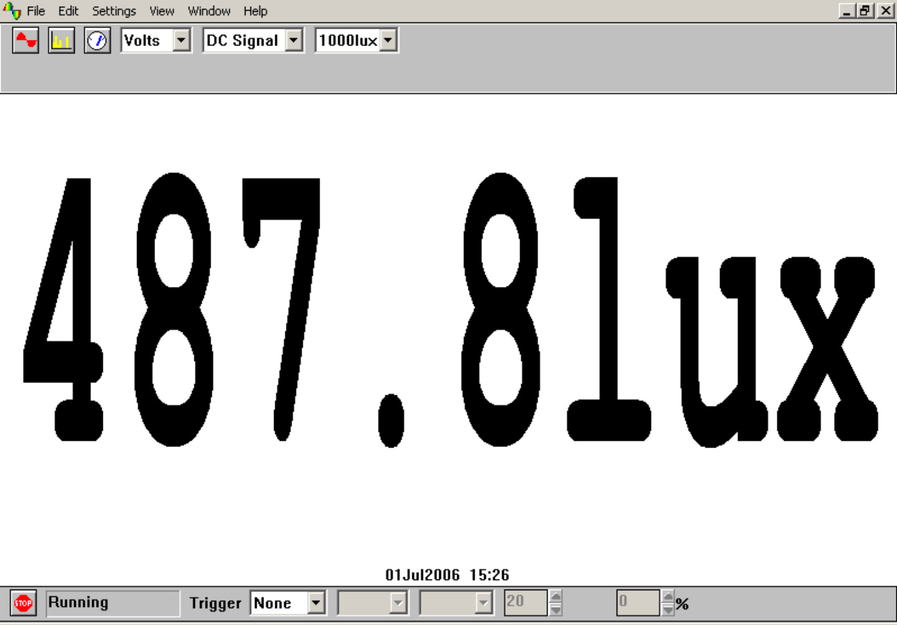  Unknown illuminance displayed in lux | - Select this new range. Remove the tube and bulb from the LDR so that the LDR is just illuminated by the laboratory lighting and then click the GO button. You should now see a digital meter reading displayed directly as an illuminance (not necessarily the value shown).  - Compare the displayed Illuminance value with the value on the Luxmeter.  - Click the STOP button.

- To return the program to its original state, click on the down arrow alongside ‘1000lux’ and select ‘Volts’. Now click onSettings in the Menu bar and then on Custom ranges in the drop-down menu to display the Custom range list. Highlight the newly added range and click the Delete button to remove it, then click the OK button.

- To finish with the program click File on the Menu bar and Exit in its drop-down menu to leave the program.

Note: When you keyed your data into the ‘Input value’ and ‘Scaled value’ columns you were giving the computer information from which it could estimate other values that occur in between – it interpolates. It is doing the same job that you do with a graph and best-fit line. If the relationship between the data is a linear one then only two pairs of data items are needed, but otherwise a spread of data pairs across the range is needed.

Activity (iii): Using a potential divider network and Dr DAQ
L2.3F

Results

Illuminance /lux | Voltage output from potential divider into DrDAQ /mV
0
100
200
300
400
500
600
700
800
900
1000

Table 4
Questions

Does your graph show the voltage output from the potential divider unit into DrDAQ to be
(a) linearly related to the illuminance and
(b) directly proportional to the illuminance? Explain.

How close were the prediction for the illuminance and the actual illuminance (luxmeter reading)?

Why wouldn’t a prediction for illuminance be likely to be reliable if the voltage output measured was way beyond those used to produce the calibration ‘curve’?

How well does the illuminance value in lux displayed on the screen match with the actual value on the Luxmeter?

