Matching power supply voltages to a bulb’s illuminance
L2.1A

For all the illuminance activities you will need to know the illuminance provided by the light bulb for a range of supply voltages. Then, when you set the voltage to a particular value again, you will know precisely what illuminance is being provided.

Procedure

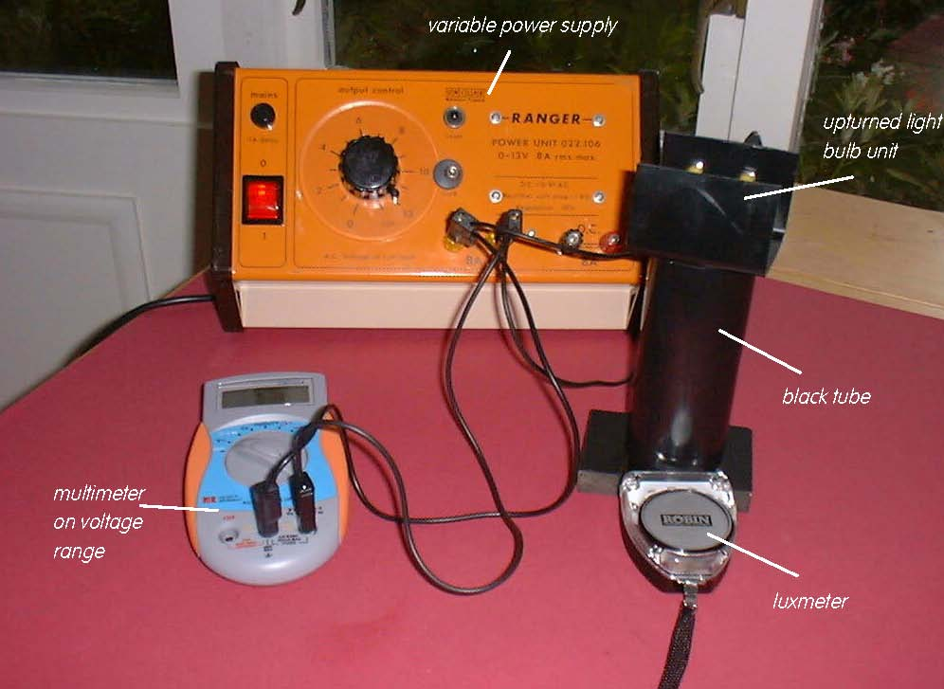

Set up to obtain a series of illuminance measurements

- First connect the light bulb to the a.c. or d.c. supply sockets of a variable power supply. Also connect a voltmeter or a multimeter on a voltage range (a.c. if you are using an a.c. supply, d.c. if you are using a d.c. supply), one lead into one of the sockets on the bulb holder and another lead into its other socket. Place the black tube over the Luxmeter’s sensor and upturn the bulb into this tube.

- Increase the illuminance from 0 lux to 1000 lux in 100 lux steps. Note the power supply voltage displayed on the voltmeter or multimeter for each illuminance and enter the values in Table 1.

Activity (i): Using a multimeter on its resistance range
L2.1B

Procedure

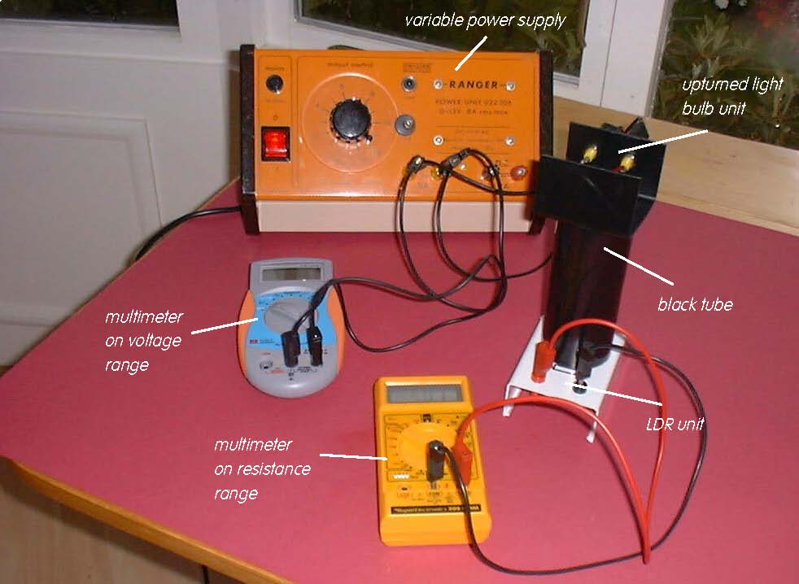
Set up of apparatus to measure the resistance of the LDR a t various illuminances

Calibration:

- Remove the Luxmeter and replace it by the Light Dependent Resistor (LDR) so that the bulb will be shining down the tube onto it. Connect this LDR to a multimeter on its Resistance range (initially 2MΩ).
- Use the supply voltage data in your first table to adjust the illuminances on the LDR to each of the values shown in Table2. For each illuminance note down in your table the resistance of the LDR shown on the multimeter. Unless you are using an autoranging meter you will need to change the resistance range of the meter as the illuminance increases. Note: 1MΩ = 1000kΩ.
- When you have completed recording your set of data switch off the power supply and meters.
- Now plot a graph of voltage (Y axis) versus lluminance (X-axis) and incorporate a best-fit line. You could do this manually or by entering your results into a graphing package or spreadsheet.

Using the LDR to provide a measure of illuminance:

You will now have calibrated the LDR, producing a graph or calibration ‘curve’ which you will be able to use to obtain values of the illuminance just from the resistance measurements obtained.

- Remove the tube and bulb from the LDR so that the LDR is just illuminated by the laboratory lighting. Using your calibration ‘curve’ note down what you think the illuminance on the LDR must be. Check this with the Luxmeter.

Activity (i): Using a multimeter on its resistance range
L2.1C

Results

Illuminance /lux | Power supply voltage /V
0
100
200
300
400
500
600
700
800
900
1000

Table 1

Illuminance /lux | Resistance of LDR /kΩ
0
100
200
300
400
500
600
700
800
900
1000

Table 2

Activity (i): Using a multimeter on its resistance range
L2.1D

Questions
Does your graph show the LDR’s resistance to be
(a) linearly related to the illuminance and
(b) directly proportional to the illuminance? Explain.

How close were the prediction for the illuminance and the actual illuminance (luxmeter reading)?

Why is it unlikely that a prediction for illuminance would be reliable if the resistance measured was way beyond those used to produce the calibration ‘curve’?

