Activity (i): Using a multimeter/millivoltmeter
F2.1A

Procedure
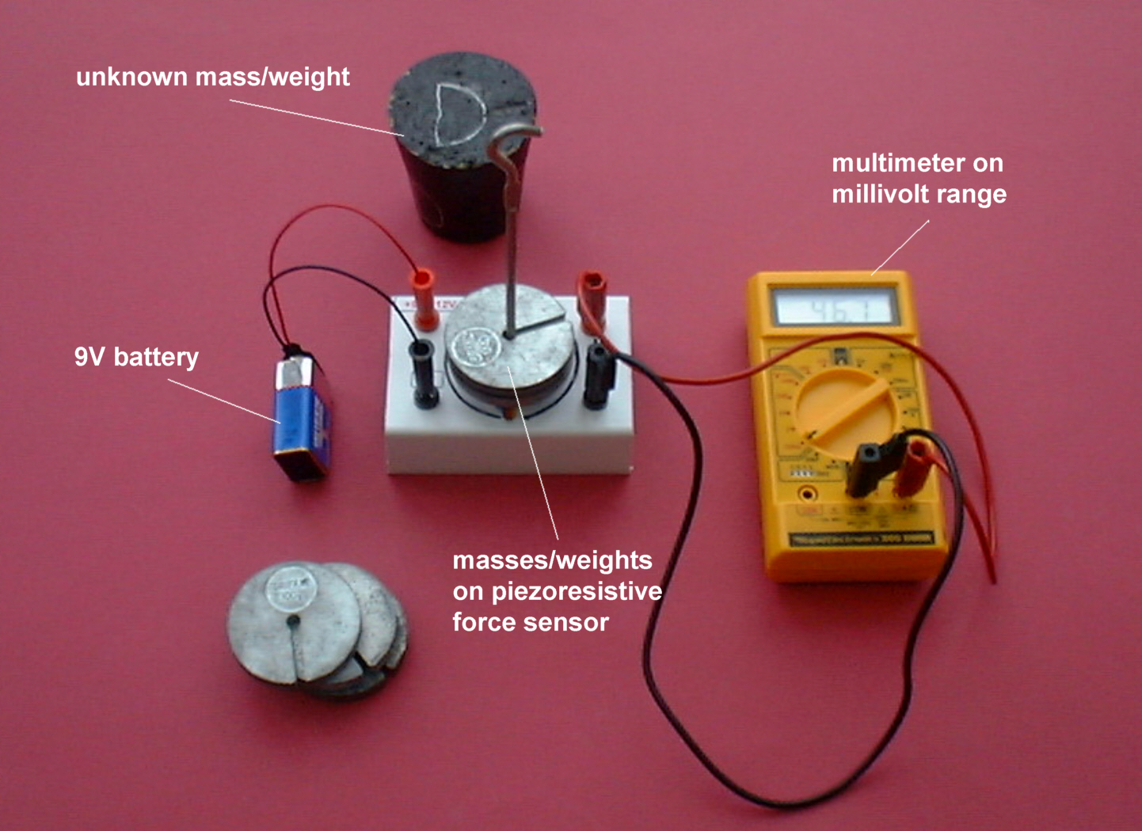

Piezoresistive force sensor with output linked to a multimeter/millivoltmeter

Calibration

- Connect the force sensor to a power supply or battery supplying between 9 and 12 volts. Connect a multimeter on its millivolt range (or a millivoltmeter) to its output sockets.

- Record the voltage output from the force sensor for each of the weights from 0N to 4.90N (masses 0g to 500g) placed on the sensor button. Leave the sensor platform empty when this has been completed.

- Now plot a graph of voltage output (Y-axis) against the weight (X-axis) and incorporate a best-fit line. You could do this manually or by entering your results into a graphing package or a spreadsheet .

Using the calibrated force sensor

You will now have calibrated the force sensor, producing a graph or calibration ‘curve’ which you will be able to use to help you find the value of an unknown weight.

- Place the unknown weight on the force sensor button and record the voltage output. Using your calibration ‘curve’, note down in the second column of the table, alongside ‘Unknown’, what you think its weight must be.

- Ask your teacher what the weight of your unknown mass actually is, or go and weigh it.

Activity (i): Using a multimeter/ millivoltmeter
F2.1B

Results

Mass /g | Weight /N | Voltage output /V
0 | 0
100 | 0.98
200 | 1.96
300 | 2.94
400 | 3.82
500 | 4.90
Unknown

Questions

Does your graph show the voltage output to be
- linearly related to the weight placed on the sensor platform
and
(b) directly proportional to the weight placed on the sensor platform? Explain.

How close was your estimate of the unknown weight?

Why wouldn’t a prediction of an unknown weight be so reliable if the resistance output obtained for it was way beyond those used to produce the calibration ‘curve’?

