Activity (i): Using a multimeter on a resistance range
F1.1A

Procedure

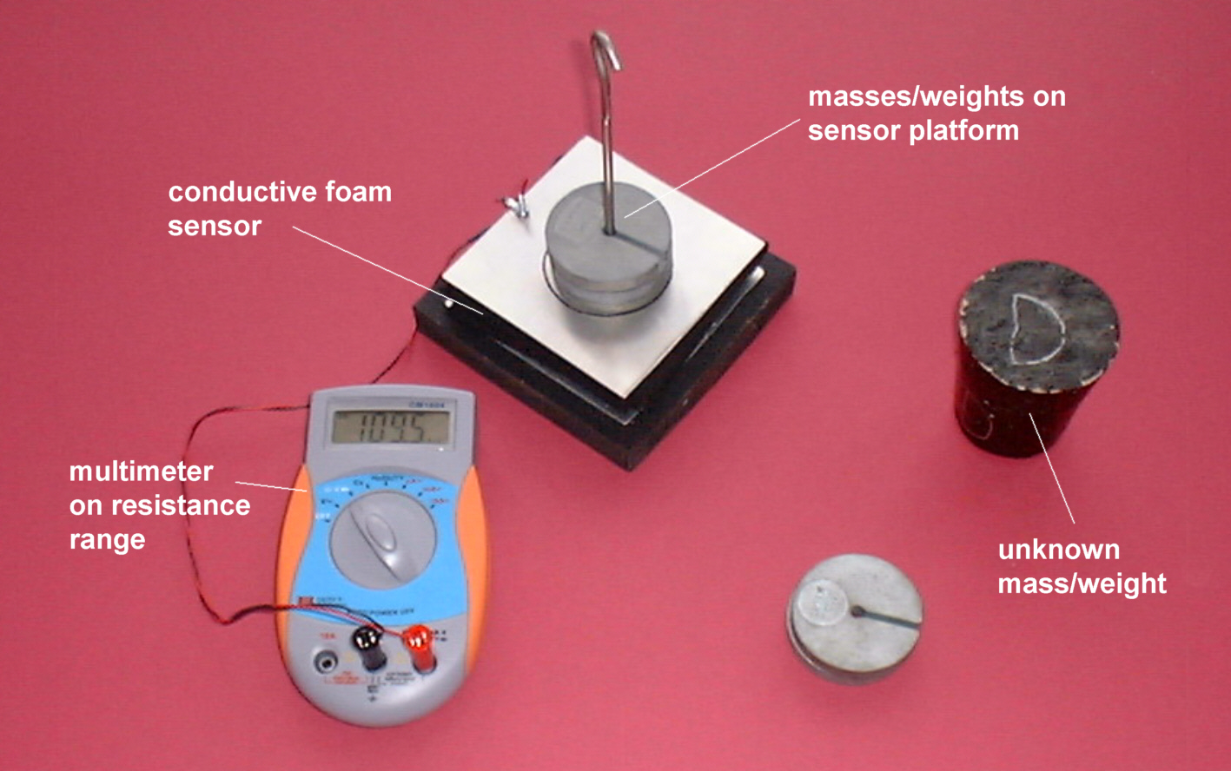

Conductive foam sensor connected to a multimeter on a resistance range

Calibration

- Connect the leads from the conductive foam sensor to a multimeter set on a megohm (MΩ) range.

- Record the resistance output from the sensor for each of the weights from 0N to 4.90N (masses 0g to 500g) placed centrally on it. The values may not be very stable so you will need to record ‘average’ values or those that are displayed ‘most often’.

- Now plot a graph of resistance output (Y-axis) against the weight (X-axis) and incorporate a best-fit line. You could do this manually or by entering your results into a graphing package or a spreadsheet.

Using the calibrated conductive foam force sensor

You will now have calibrated the conductive foam sensor, producing a graph or calibration ‘curve’ which you will be able to use to help you find the value of an unknown weight.

- Place the unknown weight on the sensor platform and record the resistance output. Using your calibration ‘curve’ note down in the second column of the table alongside ‘Unknown’ what you think its weight must be.

- Ask your teacher what the weight of your unknown mass actually is, or go and weigh it.

© GATSBY SCIENCE ENHANCEMENT PROGRAMME

Activity (i): Using a multimeter on a resistance range
F1.1B

Results

Mass /g | Weight /N | Resistance output /MΩ
0 | 0
100 | 0.98
200 | 1.96
300 | 2.94
400 | 3.82
500 | 4.90
Unknown

Questions

Does your graph show the resistance output to be
- linearly related to the weight placed on the sensor platform
and
(b) directly proportional to the weight placed on the sensor platform? Explain.

How close was your estimate of the unknown weight?

Why wouldn’t a prediction of an unknown weight be so reliable if the resistance output obtained for it was way beyond those used to produce the calibration ‘curve’?

