Activity (ii): Using a potential divider network
F1.2A

Procedure

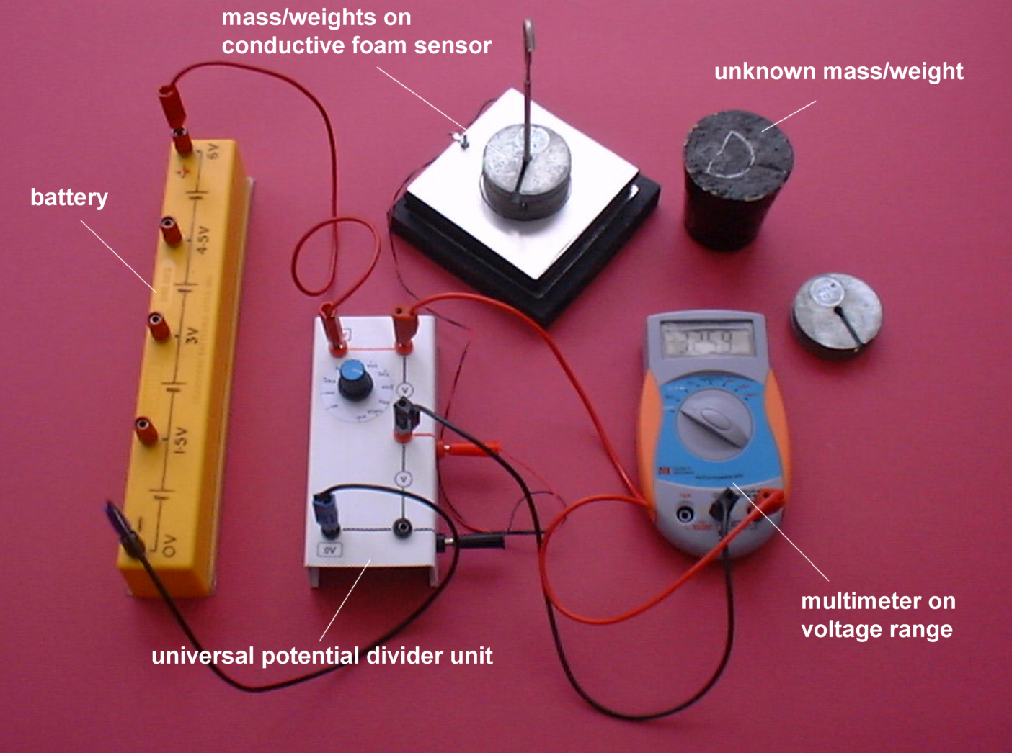

Conductive foam sensor set up for use in a potential divider network
Calibration
- First, rotate the switch on the universal potential divider to select the 100kΩ resistor.
- Plug the leads from the conductive foam sensor into the sockets on the edge of the universal potential divider unit.
- Connect a multimeter set on its 20V range (or a 5 or 10V voltmeter) across the upper pair of voltage output sockets, and a 6V battery across the 0V and +6V sockets.

- Record the voltage output from the force sensor for each of the weights from 0N to 4.90N (masses 0g to 500g) placed on the sensor platform. The values may not be very stable so you will need to record ‘average’ values or those that are displayed ‘most often’.

- Now plot a graph of voltage output (Y-axis) against the weight (X-axis) and incorporate a best-fit line. You could do this manually or by entering your results into a graphing package or a spreadsheet.

Using the calibrated conductive foam force sensor

You will now have calibrated the force sensor, producing a graph or calibration ‘curve’ which you will be able to use to help you find the value of an unknown weight.

- Place the unknown weight on the force sensor platform and record the Voltage output. Using your calibration ‘curve’ note down in the second column of the table alongside ‘Unknown’ what you think its weight must be.
- Ask your teacher what the weight of your unknown mass actually is, or go and weigh it.

Activity (ii): Using a potential divider network
F1.2B

Results

Mass /g | Weight /N | Voltage output /V
0 | 0
100 | 0.98
200 | 1.96
300 | 2.94
400 | 3.82
500 | 4.90
Unknown

Questions

Does your graph show the voltage output to be
- linearly related to the weight placed on the sensor platform
and
(b) directly proportional to the weight placed on the sensor platform? Explain.

How close was your estimate of the unknown weight?

Why wouldn’t a prediction of an unknown weight be so reliable if the voltage output obtained for it was way beyond those used to produce the calibration ‘curve’?

