Activity (iii): Using a potential divider network and Dr DAQ

F1.3A

This activity allows you to have the digital meter so that it reads directly as a weighing machine, giving a weight in newtons. (This is not possible with an ordinary multimeter or voltmeter).

Procedure

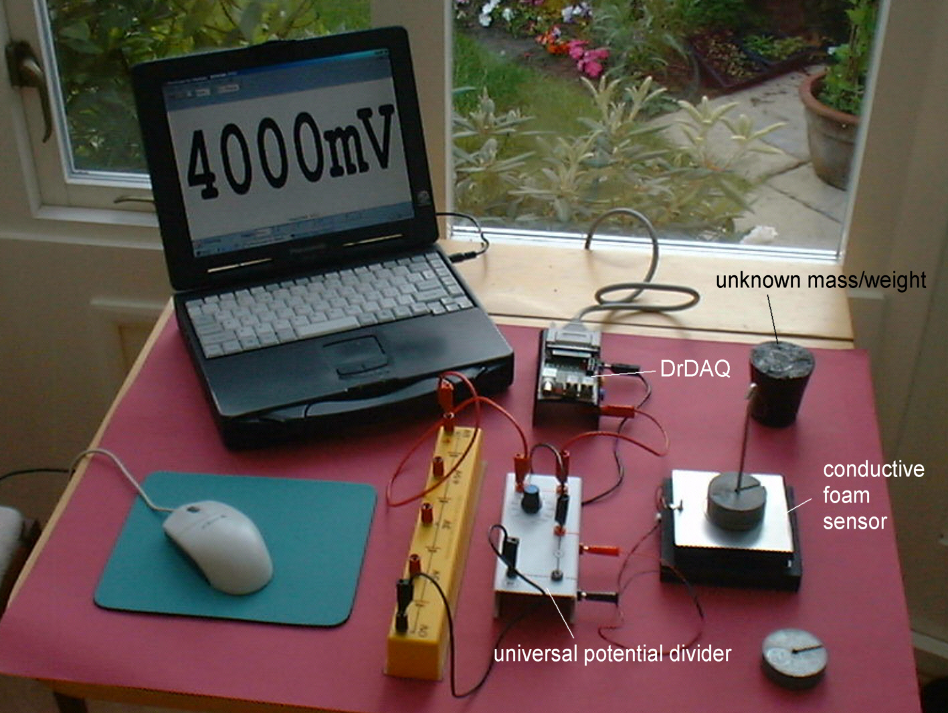

Conductive foam force sensor set up with a potential divider to use with PicoScope on DrDAQ

Calibration

Note: If you are connected via a network you may need to obtain additional instructions.

- Before the computer is switched on check that DrDAQ has been plugged into the computer.

- Now rotate the switch on the universal potential divider to select the 100kΩ resistor.
- Plug the leads from the conductive foam sensor into the sockets on the edge of the universal potential divider unit and connect a 6V battery across the 0V and +6V sockets.
- Connect a red lead from the upper (red) voltage output socket on the universal potential divider unit to the V socket on DrDAQ and a black lead from the middle (red) socket on the potential divider unit to the GND socket on DrDAQ.

Activity (iii): Using a potential divider network and Dr DAQ

F1.3B

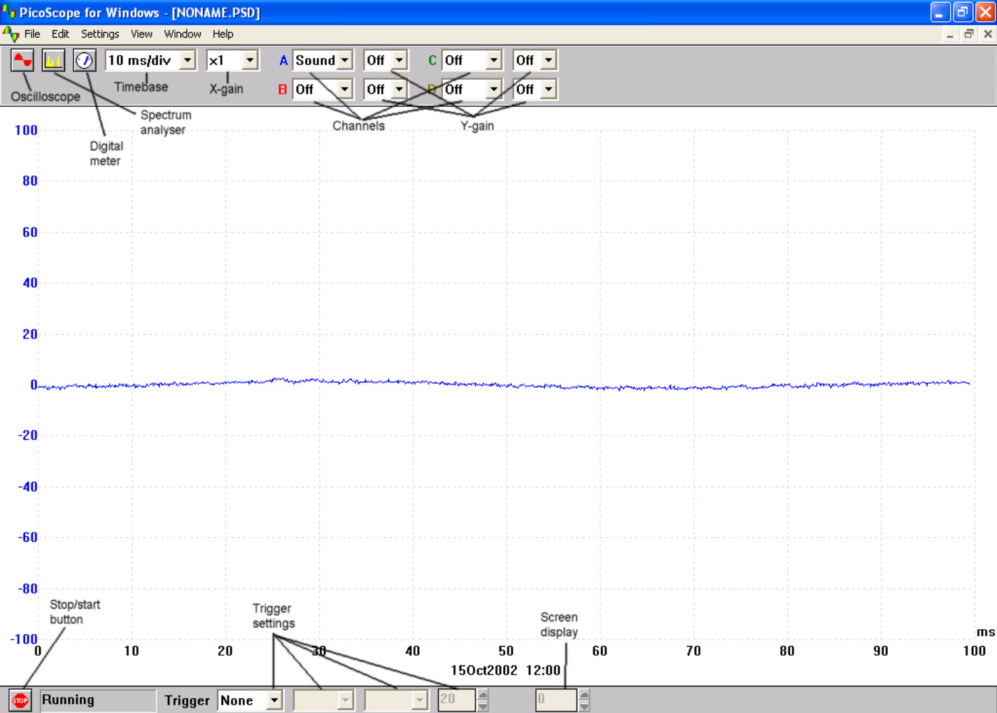  DrDAQ opening screen | - Switch on and load the PicoScope software. If necessary, enlarge by clicking the in the top right-hand corner of the screen to provide a full screen display as shown with the program already running.
 | Note: If the program appears to have frozen at any time then it can usually be unfrozen by pressing the F10 function key. If this does not succeed then close down the program by pressing the Ctrl, Alt and Delete keys simultaneously, and then restart the program.
- Click the STOP button in the bottom left-hand corner of the screen.
- Close down the Oscilloscope mode by clicking the lower of the two Xs in the top right-hand corner of the screen.
- Now click on the Digital Meter icon in the Toolbar, select Volts and DC Signal and then click the GO button to put PicoScope into Display Voltmeter mode.
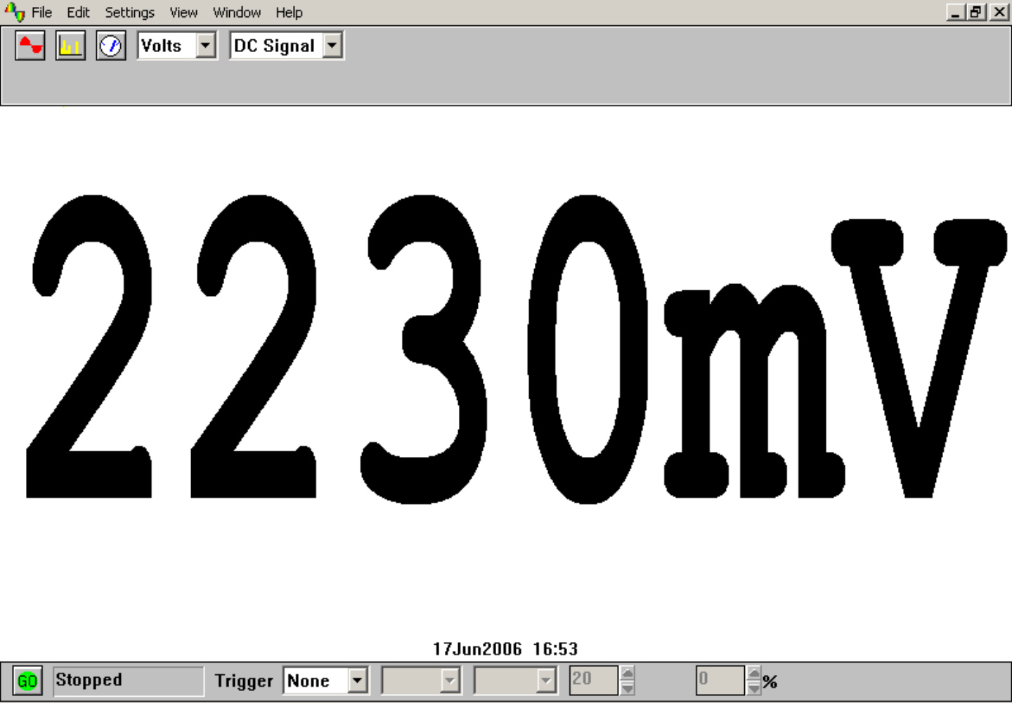  Digital Voltmeter display | - Place one 100g mass on the conductive foam force sensor to check that it is functioning and you should get a display like that shown, though not necessarily of that value.  - Record the voltage output from the force sensor for each of the weights from 0N (nothing placed on the force sensor) to 4.90N (masses up to 500g) placed on the sensor button. The values may not be very stable so you will need to record ‘average’ values or those that are displayed ‘most often’.  - Now plot a graph of voltage output (Y-axis) against the weight (X-axis) and incorporate a best-fit line. You could do this manually or by entering your results into a graphing package or a spreadsheet.

Activity (iii): Using a potential divider network and Dr DAQ

F1.3C

Using the calibrated force sensor

You will now have calibrated the force sensor, producing a graph or calibration ‘curve’ which you will be able to use to help you find the value of an unknown weight.

- Place the unknown weight on the force sensor platform and record the voltage output. Using your calibration ‘curve’ note down in the second column of the table alongside ‘Unknown’ what you think its weight must be.

- Ask your teacher what the weight of your unknown mass actually is, or go and weigh it.

In everyday life, it would be unusual to find an instrument which had not been calibrated for direct use. With a computer-based device it is often possible to calibrate it so that it automatically displays the quantity you wish to measure directly on the screen. In this case you would want to get the computer to ‘convert’ the voltage input to give a weight display on the screen. With PicoScope this is easily done by setting up a Custom Range.

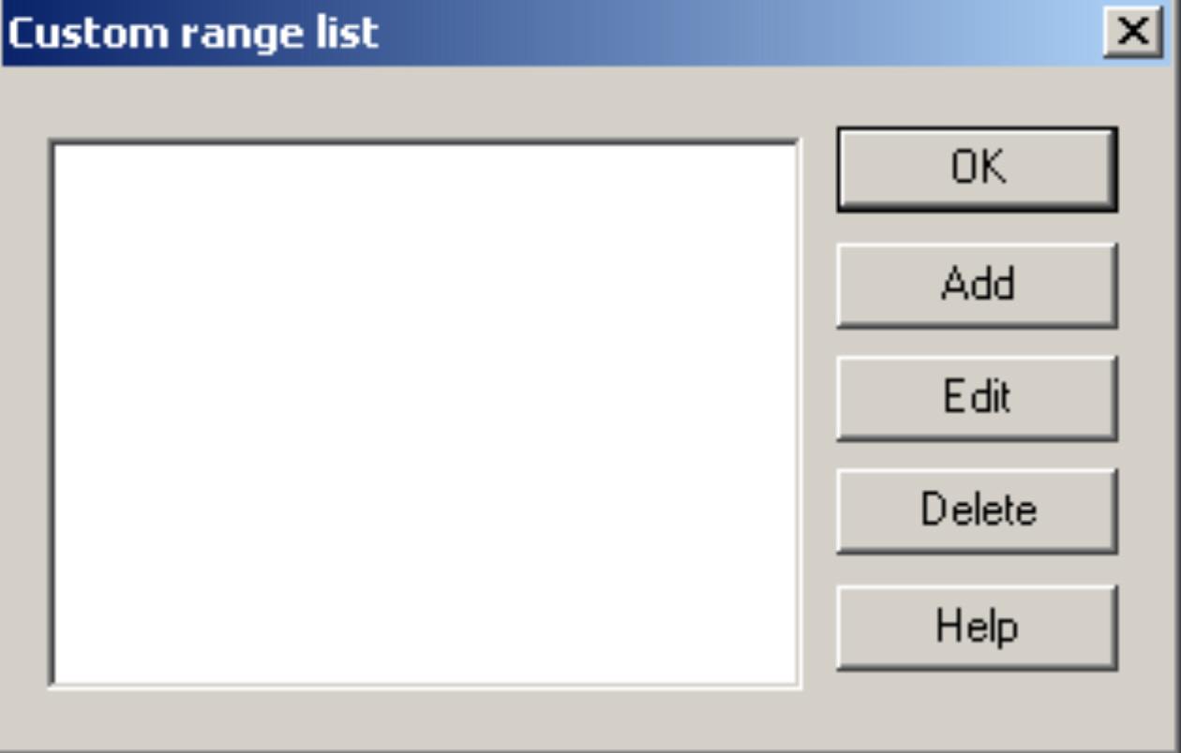  Custom range list | - Click the STOP button. Now click on Settings in the Menu bar and then on Custom ranges in the drop-down menu to display the Custom range list as shown.
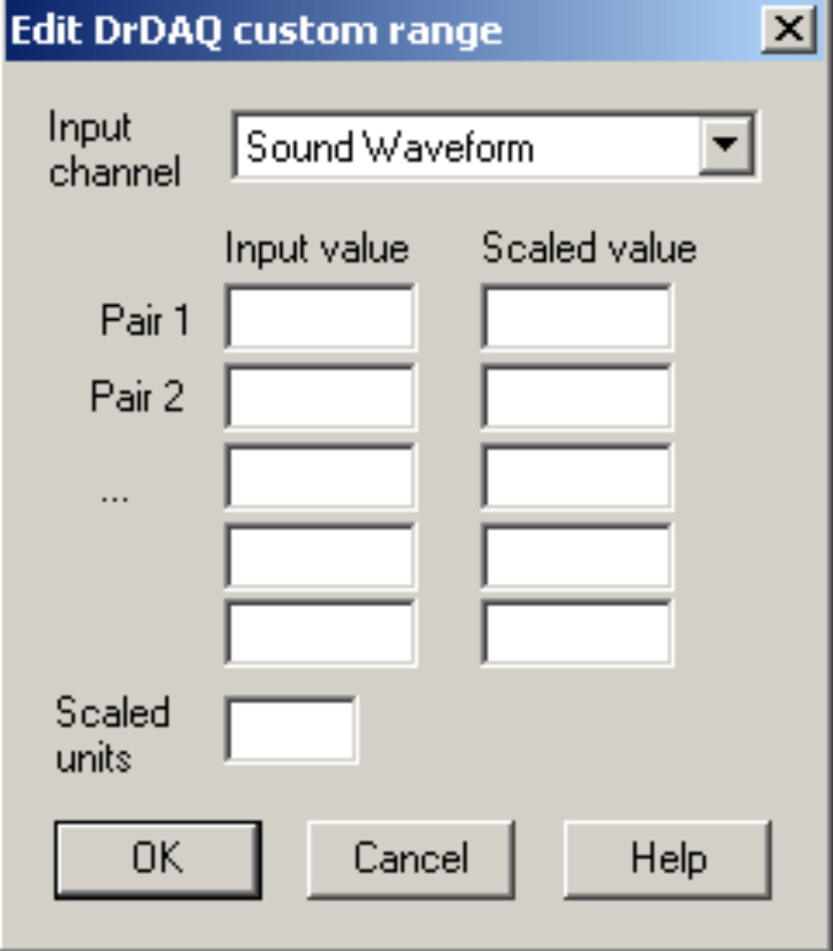  Edit Dr DAQ custom range | - Click on Add to display the Edit DrDAQ custom range box.

Activity (iii): Using a potential divider network and Dr DAQ

F1.3D

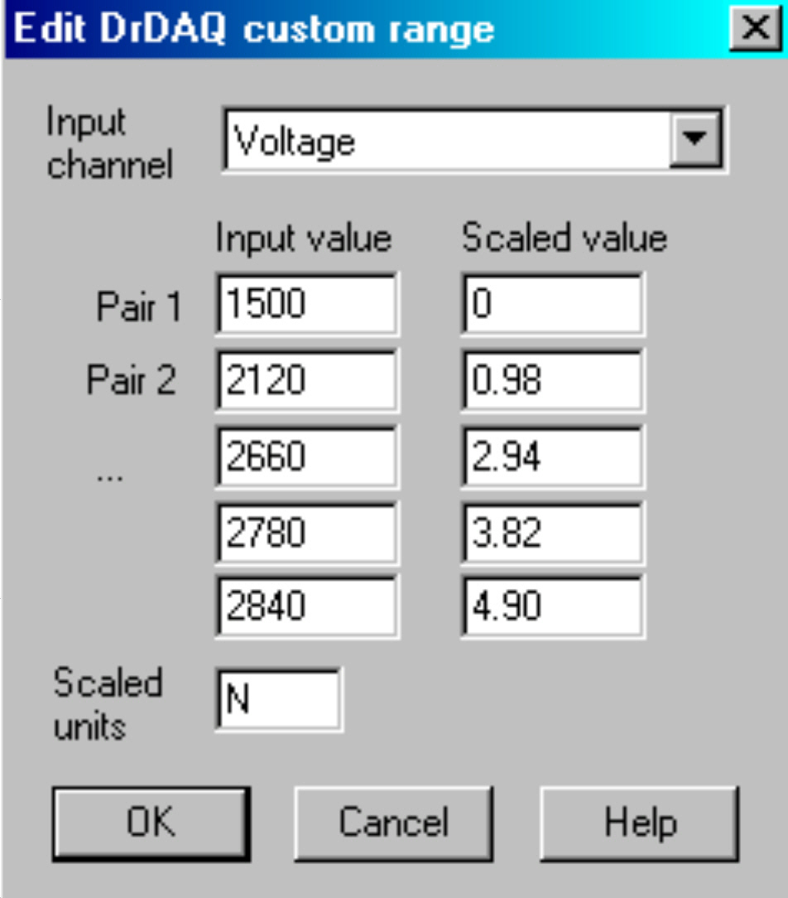  Add values and scaled units | - Select the Input channel ‘Voltage’ by clicking on the down arrow alongside. Now type in your pairs of data into the two columns – output voltages into the Input value column and the weights into the Scaled value column. Ensure that you input a zero weight (0N) and the Output voltage that this produced.
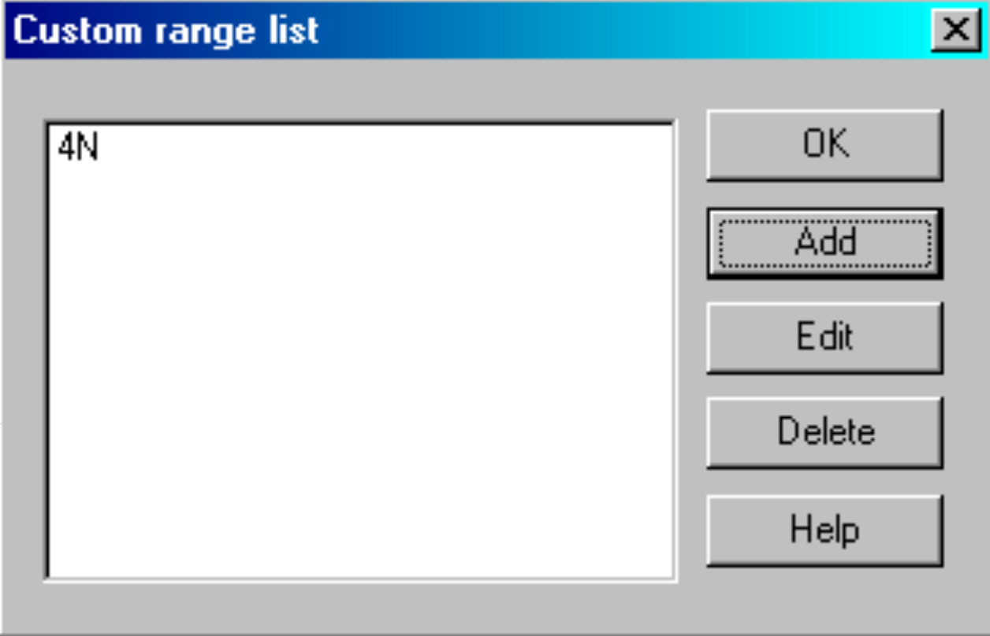  Custom range list with new range added | - Type ‘N’ (for newtons) into the Scaled units box.  - Click the OK button. You should now see a ‘4N’ range appear in the Custom range list :
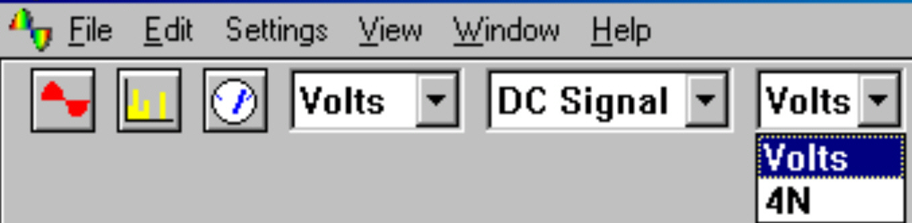  New range to select | - Highlight this new range and click OK.  - Click on the down-arrow next to the right-hand ‘volts’: you should see an extra box for this new range.

Activity (iii): Using a potential divider network and Dr DAQ

F1.3E

Unknown weight displayed in newtons | - Select this new range, place the unknown weight on the force sensor and then click the GO button. You should now see a digital meter reading displayed directly as a weight.  - Compare this displayed value for the weight with the actual weight.  - Click the STOP button.

- To return the program to its original state first click the down-arrow next to ‘4N’ and return to the ‘Volts’ range. Now click on Settings in the Menu bar and then on Custom ranges in the drop-down menu to display the Custom range list. Highlight the newly added range and click the Delete button to remove it and then click the OK button.

- To finish with the program click File on the Menu bar and Exit in its drop-down menu to leave the program.

Note: When you keyed your data into the ‘Input value’ and ‘Scaled value’ columns you were giving the computer information from which it could estimate other values that occur in between – it interpolates. It is doing the same job that you do with a graph and best-fit line. If the relationship between the data is a linear one then only two pairs of data items are needed.

Activity (iii): Using a potential divider network and Dr DAQ

F1.3F

Results

Mass /g | Weight /N | Voltage output /V
0 | 0
100 | 0.98
200 | 1.96
300 | 2.94
400 | 3.82
500 | 4.90
Unknown

Questions

Does your graph show the voltage output to be
- linearly related to the weight placed on the sensor platform
and
(b) directly proportional to the weight placed on the sensor platform? Explain.

How close was your estimate of the unknown weight?

Why wouldn’t a prediction of an unknown weight be so reliable if the voltage output obtained for it was way beyond those used to produce the calibration ‘curve’?

How well did the displayed value of the weight match with the actual value?

