Conductive foam sensor
F1.0

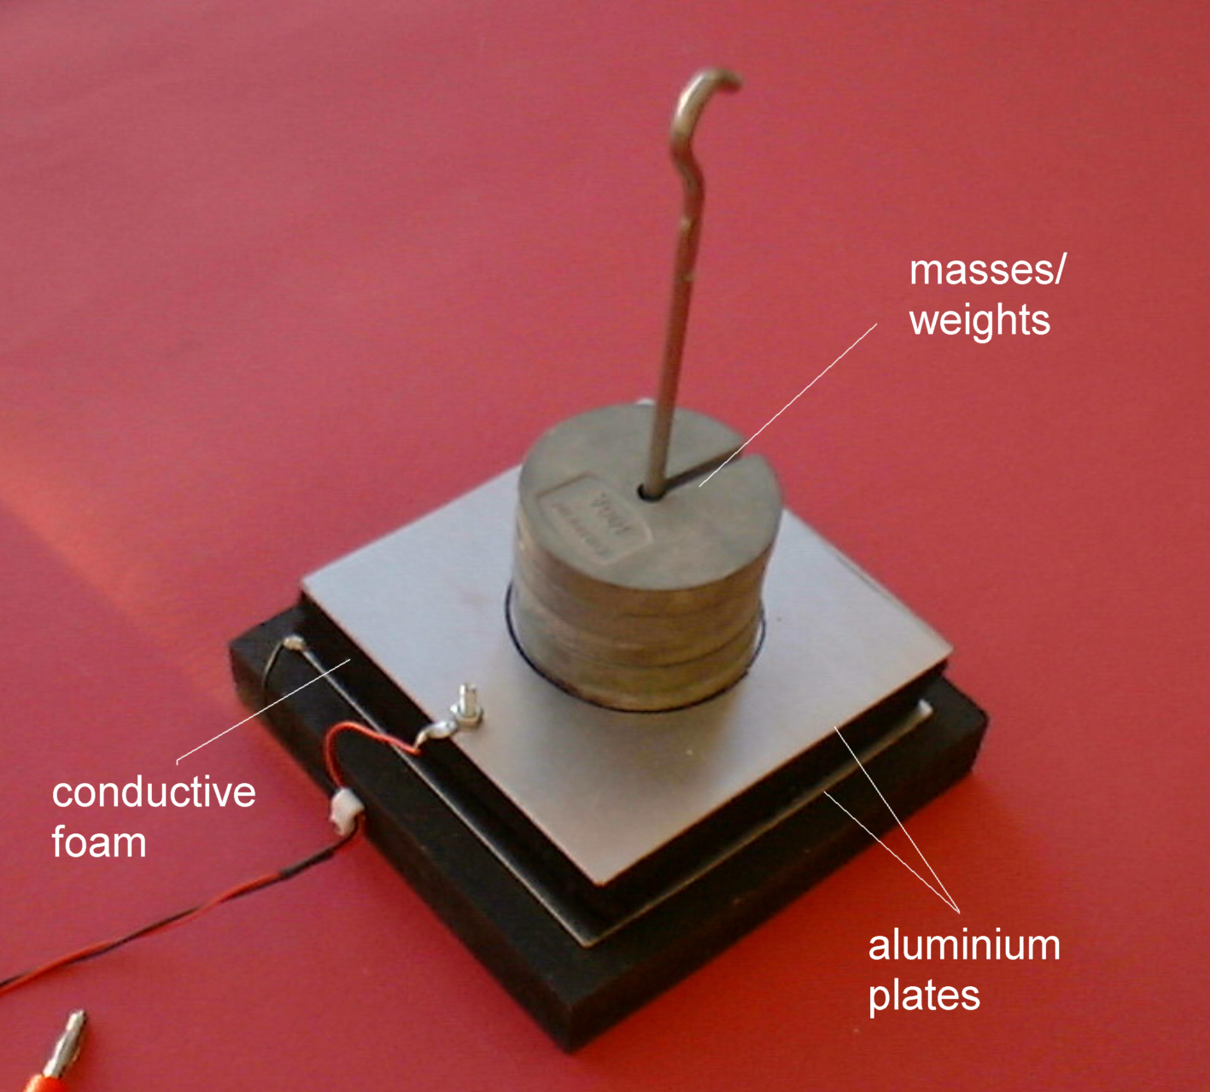

The slightly conductive foam that you will be using is most commonly used to package integrated circuits (i.c.) as partial protection against electrostatic hazards. It is also used in robotics to make touch and bump sensors. Your task is to see how such a material could be used to make a force sensor.

As the foam gets compressed under the weight of the object resting on it, its resistance gets lower. We could explain this in two ways: (i) if it is acting like a piece of resistance wire then it is now shorter and so will have less resistance or, (ii) as it compresses the foam’s hole walls make better electrical contact with each other with some ‘shorting’ across the hole walls, and so the overall resistance is less.

