Activity (i): Mean frequency method using a multimeter or frequency meter
FL2.1A

Procedure

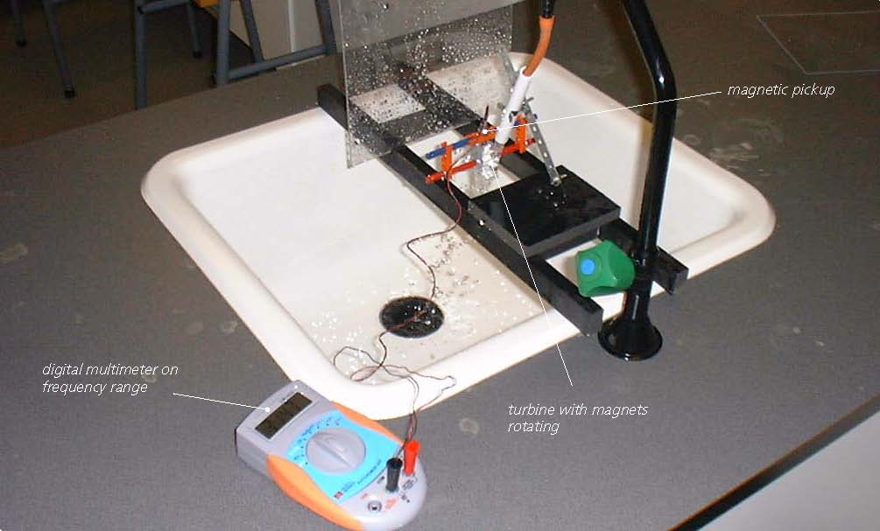

Turbine with magnetic pickup linked to a multimeter

Calibration:

- Arrange the turbine in the flow of liquid, most conveniently water from a steadily flowing tap. Connect the leads from the magnetic pickup to a digital multimeter set on its frequency range, or to a frequency meter.

Record the mean frequency displayed for the first selected flow rate in your results table. You may well need to take this as the displayed value that appears most often as it might well vary slightly with time.

Without switching off the tap, remove the rubber tubing from the plastic pipe, direct the flow into a measuring beaker and record how long it takes to collect one litre of water.

Repeat this timing twice more, recording the value each time, calculating an average time, and then an average flow rate. If you collected 1.0 litres of water in 12.8 seconds, then the flow rate would be 1.0 ÷ 12.8 = 0.078 litres/second. Do this for five different flow rates.
- Now plot a graph of mean frequencies (Y-axis) against their respective average flow rates (X-axis) and incorporate a best-fit line.

Using the calibrated flow meter:

You will now have calibrated the flow meter, producing a graph or calibration ‘curve’ which you will be able to use to obtain values of flow rates just from the frequency measurements obtained.

- Turn on the tap until a frequency measurement is obtained which is within the range of values obtained previously, but not equal to any of them.
- Using your calibration ‘curve’, note down what you think the flow rate must be. Check this by again measuring how long it takes to collect a litre of water.

Activity (i): Mean frequency method using a multimeter or frequency meter
FL2.1B

Results

Mean frequency /Hz | Time to collect 1 litre of water  /s |  |  |  | Average flow rate /l s⁻¹
Mean frequency /Hz | 1st trial | 2nd trial | 3rd trial | Average | Average flow rate /l s⁻¹

Questions

Does your graph show the mean frequency to be
(a) linearly related to the flow rate
and
(b) directly proportional to the flow rate? Explain.

How close were the prediction for the flow rate and the actual flow rate?

Why wouldn’t a prediction for a flow rate be likely to be reliable if the frequency measured was way beyond those used to produce the calibration ‘curve’?

