Activity (ii): Mean frequency method using PicoScope on DrDAQ
FL2.2A

Procedure

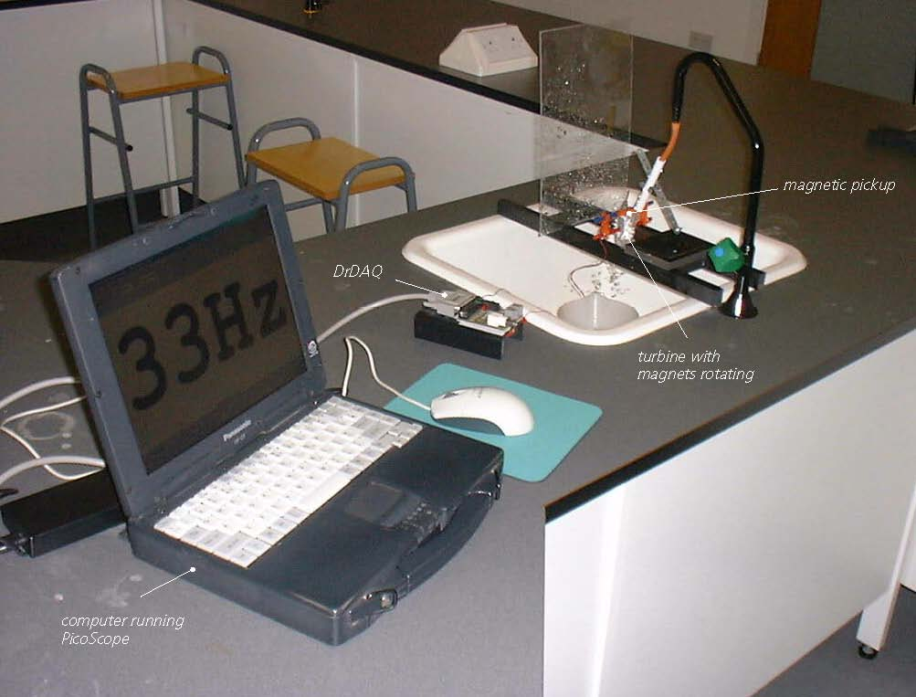

Turbine meter set up with DrDAQ

Calibration:

NOTE: If you are connected via a network you may need to obtain additional instructions.

- Before the computer is switched on, check that DrDAQ has been plugged into the computer. Connect the magnetic pickup’s red lead to the V socket on DrDAQ and its black lead to the GND socket.

Activity (ii): Mean frequency method using PicoScope on DrDAQ
FL2.2B

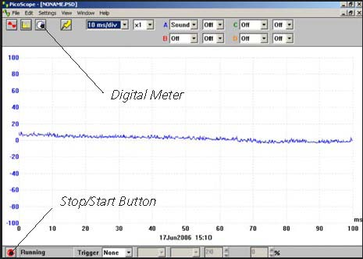  DrDAQ opening screen | - Switch on and load the PicoScope software. If necessary, enlarge by clicking the in the top right-hand corner of the screen to provide a full screen display as shown with the program already running.  Note: If the program appears to have frozen at any time then it can usually be unfrozen by pressing the F10 function key. If this does not succeed, then close down the program by pressing the Ctrl, Alt and Delete keys simultaneously, and then restart the program.
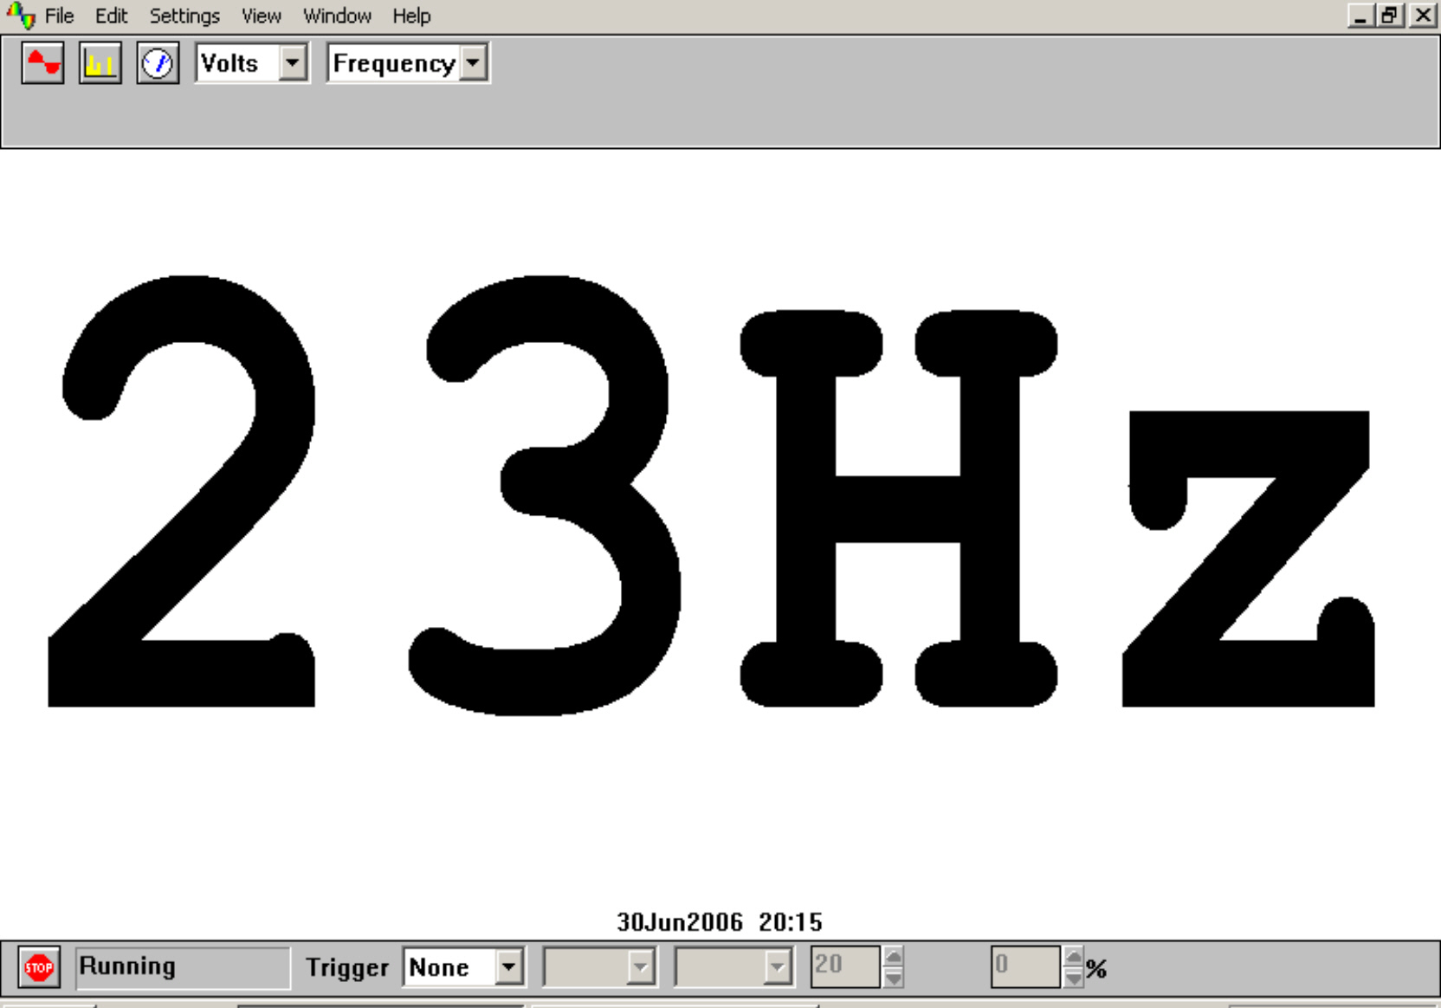  Digital Frequency Meter display | - Click the STOP button in the bottom left-hand corner of the screen. Close down the Oscilloscope mode by clicking the lower of the two Xs in the top right-hand corner of the screen. Now click on the Digital Meter icon in the Toolbar, select Volts and Frequency and then click the GO button to put PicoScope into Frequency Meter mode. Arrange the turbine in the flow of liquid, most conveniently water from a steadily flowing tap, and you should get a display like that shown.  Record the mean frequency displayed on the screen for the first selected flow rate. You may well need to take this as the displayed value that appears most often as it might well vary slightly with time.  Without switching off the tap, remove the rubber tubing from the plastic pipe, direct the flow into a measuring beaker and record how long it takes to collect one litre of water.  Repeat this timing twice more, recording the value each time, calculating an average time, and then an average flow rate. If you collected 1.0 litres of water in 12.8 seconds, then the flow rate would be 1.0 ÷ 12.8 = 0.078 litres/second.  Do this for five different flow rates.

Now plot a graph of mean frequencies (Y-axis) against their respective average flow rates (X-axis) and incorporate a best-fit line.

Activity (ii): Mean frequency method using PicoScope on DrDAQ
FL2.2C

Using the calibrated flow meter with a calibration ‘curve’:

You will now have calibrated the flow meter, producing a graph or calibration ‘curve’ which you will be able to use to obtain values of flow rates just from the frequency measurements obtained.

- Turn on the tap until a frequency measurement is obtained which is within the range of values obtained previously, but not equal to any of them.
- Using your calibration ‘curve’, note down what you think the flow rate must be.
- Check this by again measuring how long it takes to collect a litre of water.

- To finish with the program first click on the STOP button. Now click File on the Menu bar and Exit in its drop-down menu.

Activity (ii): Mean frequency method using PicoScope on DrDAQ
FL2.2D

Results

Mean frequency /Hz | Time to collect 1 litre of water  /s |  |  |  | Average flow rate /l s⁻¹
Mean frequency /Hz | 1st trial | 2nd trial | 3rd trial | Average | Average flow rate /l s⁻¹

Questions

Does your graph show the mean frequency to be
(a) linearly related to the flow rate
and
(b) directly proportional to the flow rate? Explain.

How close were the prediction for the flow rate and the actual flow rate?

Why wouldn’t a prediction for a flow rate be likely to be reliable if the frequency measured was way beyond those used to produce the calibration ‘curve’?

