Activity (i): Mean e.m.f. method with a multimeter
FL1.1A

Procedure
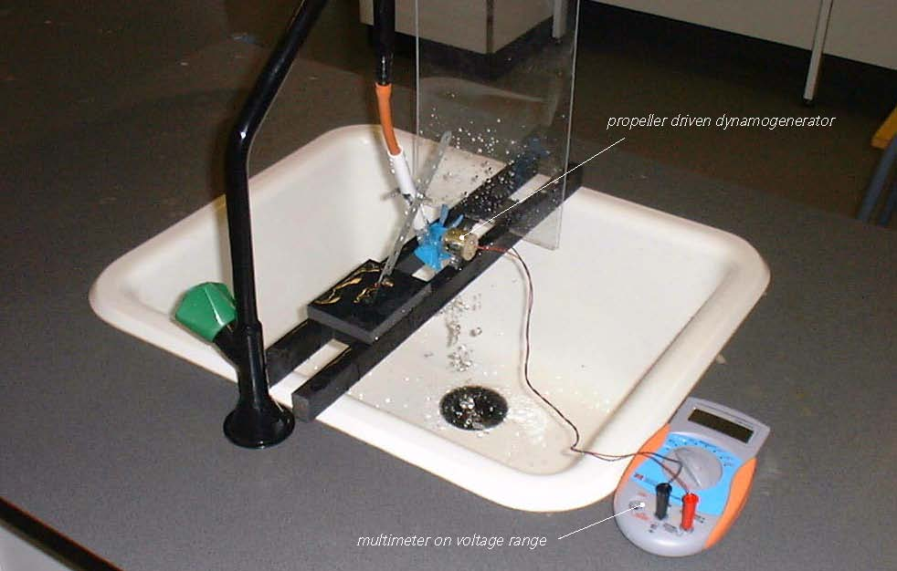

Propeller dynamo/generator linked to a multimeter

Calibration

Arrange the dynamo/generator with its propeller in the flow of liquid (such as water from a steadily flowing tap). Connect its leads to a digital multimeter set on a millivolt range.

Record the mean e.m.f. (voltage) displayed for the first selected flow rate. You may well need to take this as the displayed value that appears most often, as it might well vary slightly with time.

Without switching off the tap, remove the rubber tubing from the plastic pipe, direct the flow into a measuring beaker and record how long it takes to collect one litre of water.

Repeat this timing twice more, recording the value each time. Calculate an average time, and then an average flow rate. (If you collected 1.0 litre of water in 12.8 seconds, then the flow rate would be 1.0 ÷ 12.8 = 0.078 litres/second, for example). Do this for five different flow rates.
- Now plot a graph of mean e.m.f.s (Y-axis) against their respective average flow rates (X-axis) and incorporate a best-fit line. You could do this manually or by entering your results into a graphing package or a spreadsheet.

Using the calibrated flow meter

You will now have calibrated the flow meter, producing a graph or calibration ‘curve’ which you will be able to use to obtain values of flow rates just from the e.m.f. (voltage) measurements obtained.

- Turn on the tap until an e.m.f. (voltage) measurement is obtained which is within the range of values obtained previously, but not equal to any of them.
- Using your calibration ‘curve’ note down what you think the flow rate must be.
- Check this by measuring again how long it takes to collect a litre of water.

Activity (i): Mean e.m.f. method with a multimeter
FL1.1B

Results

Mean e.m.f /mV | Time to collect 1 litre of water  /s |  |  |  | Average flow rate /l s⁻¹
Mean e.m.f /mV | 1st trial | 2nd trial | 3rd trial | Average | Average flow rate /l s⁻¹

Questions

Does your graph show the mean e.m.f. to be
(a) linearly related to the flow rate and
(b) directly proportional to the flow rate? Explain.

How close were the prediction for the flow rate and the actual flow rate?

Why wouldn’t a prediction for a flow rate be likely to be reliable if the e.m.f. (voltage) measured was way beyond those used to produce the calibration ‘curve’?

