Activity (ii): Mean e.m.f. method with PicoScope on DrDAQ
FL1.2A

This activity allows you to have the digital meter so that it reads directly as a flow rate meter. (This is not possible with an ordinary multimeter or millivoltmeter)

Procedure

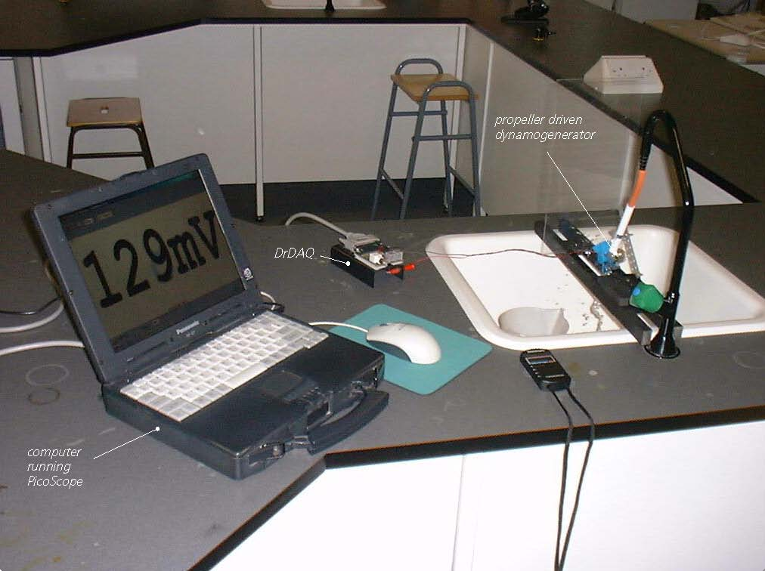

Propeller dynamo/generator method using PicoScope on DrDAQ

Calibration

Note: If you are connected via a network you may need to obtain additional instructions.

- Before the computer is switched on check that DrDAQ has been plugged into the computer.
- Connect the magnetic pickup’s red lead to the V socket on DrDAQ and its black lead to the GND socket.

Activity (ii): Mean e.m.f. method with PicoScope on DrDAQ
FL1.2B

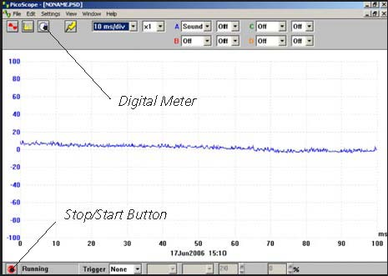  DrDAQ opening screen | - Switch on and load the PicoScope software. If necessary, enlarge by clicking the in the top right-hand corner of the screen to provide a full screen display as shown with the program already running.
 | Note: If the program appears to have frozen at any time then it can usually be unfrozen by pressing the F10 function key. If this does not succeed then close down the program by pressing the Ctrl, Alt and Delete keys simultaneously, and then restart the program.
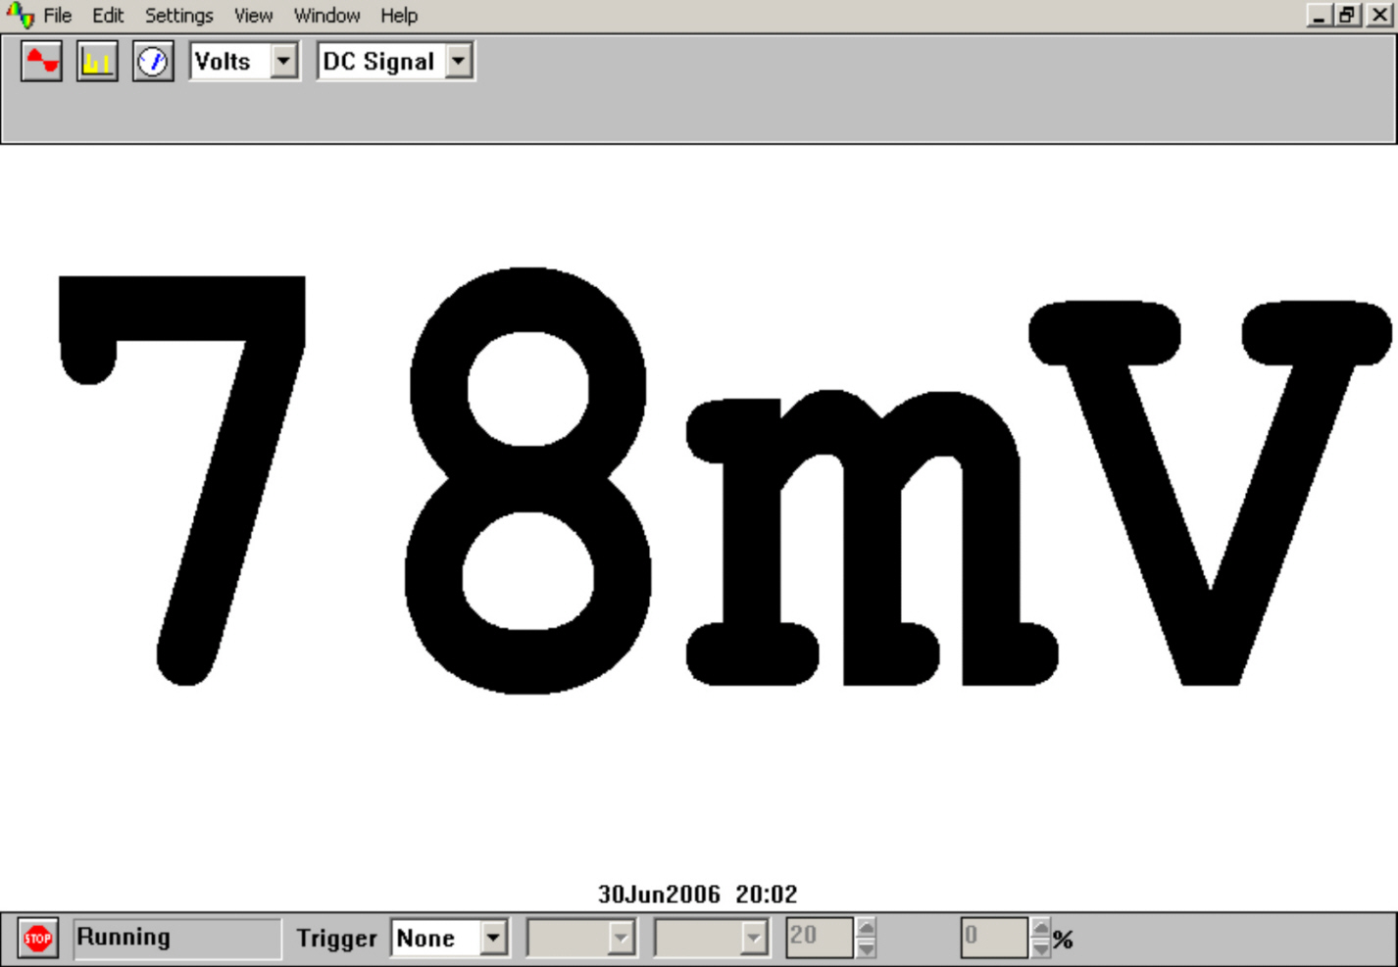  Digital Voltmeter display | - Click the STOP button in the bottom left-hand corner of the screen.  - Close down the Oscilloscope mode by clicking the lower of the two Xs in the top right-hand corner of the screen.  - Now click on the Digital Meter icon in the Toolbar, select Volts and DC Signal and then click the GO button to put PicoScope into Display Voltmeter mode.  - Arrange the propeller in the flow of liquid (such as water from a steadily flowing tap) and you should get a display like that shown.  - Record the mean e.m.f. (voltage) displayed for the first selected flow rate. You may need to take this as the displayed value that appears most often as it might well vary slightly with time.  - Without switching off the tap, remove the rubber tubing from the plastic pipe, direct the flow into a measuring beaker and record how long it takes to collect one litre of water.  - Repeat this timing twice more, recording the value each time. Calculate an average time, and then an average flow rate. (If you collected 1.0 litres of water in 12.8 seconds, then the flow rate would be 1.0 ÷ 12.8 = 0.078 litres/second, for example). Do this for five different flow rates.  - Now plot a graph of mean e.m.f. (voltage) on the Y-axis against the respective average flow rate on the X-axis and incorporate a best-fit line. You could do this manually or by entering your results into a graphing package or a spreadsheet.

Activity (ii): Mean e.m.f. method with PicoScope on DrDAQ
FL1.2C

Using the calibrated flow meter with a calibration ‘curve’

You will now have calibrated the flow meter, producing a graph or calibration ‘curve’ which you will be able to use to obtain values of flow rates just from the e.m.f. (voltage) measurements obtained.

- Turn on the tap until an e.m.f. (voltage) measurement is obtained which is within the range of values obtained previously, but not equal to any of them.
- Using your calibration ‘curve’, note down what you think the flow rate must be.
- Check this by again measuring how long it takes to collect a litre of water.

Calibrating the computer to automatically display flow rates

It would be unusual to find an instrument which had not been calibrated for direct use. With a computer-based device it is often possible to calibrate it so that it automatically displays the quantity you wish to measure directly on the screen. In this case you would want to get the computer to ‘convert’ the e.m.f. (voltage) input to give a flow rate display on the screen. With PicoScope this is easily done by setting up a Custom Range.

Activity (ii): Mean e.m.f. method with PicoScope on DrDAQ
FL1.2D

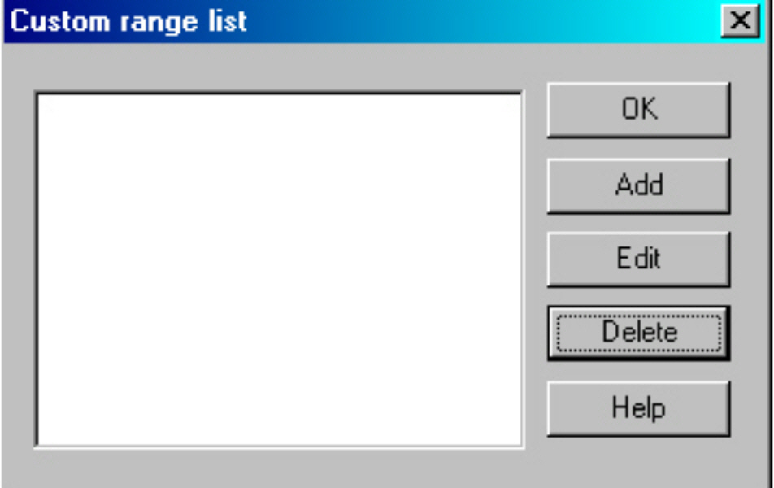  Custom range list | - Click the STOP button. Now click on Settings in the Menu bar and then on Custom ranges in the drop-down menu to display the Custom range list.
 | - Click on Add to display the Edit DrDAQ custom range box.
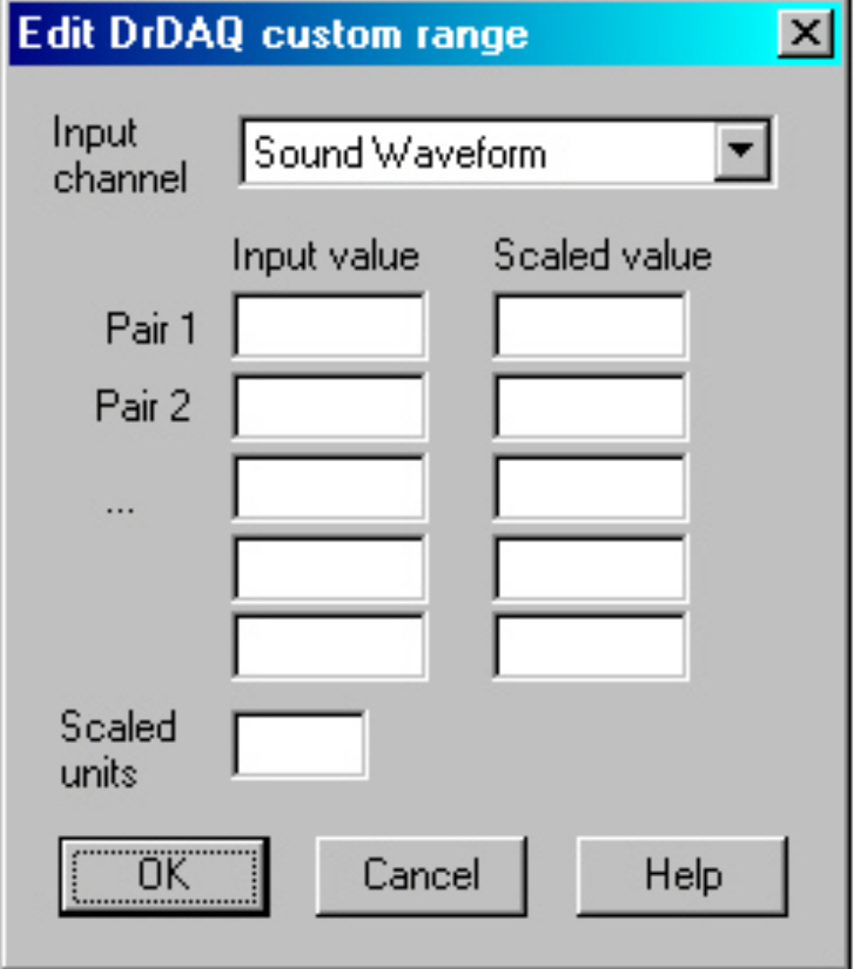  Edit DrDAQ Custom range box | - Select the Input channel ‘Voltage’ by clicking on the down arrow alongside. Now type in your pairs of data into the two columns – e.m.f.s into the Input value column and the average flow rates into the Scaled value column – adding in a voltage of 0V for a Flow rate of 0.00 l s⁻

Activity (ii): Mean e.m.f. method with PicoScope on DrDAQ
FL1.2E

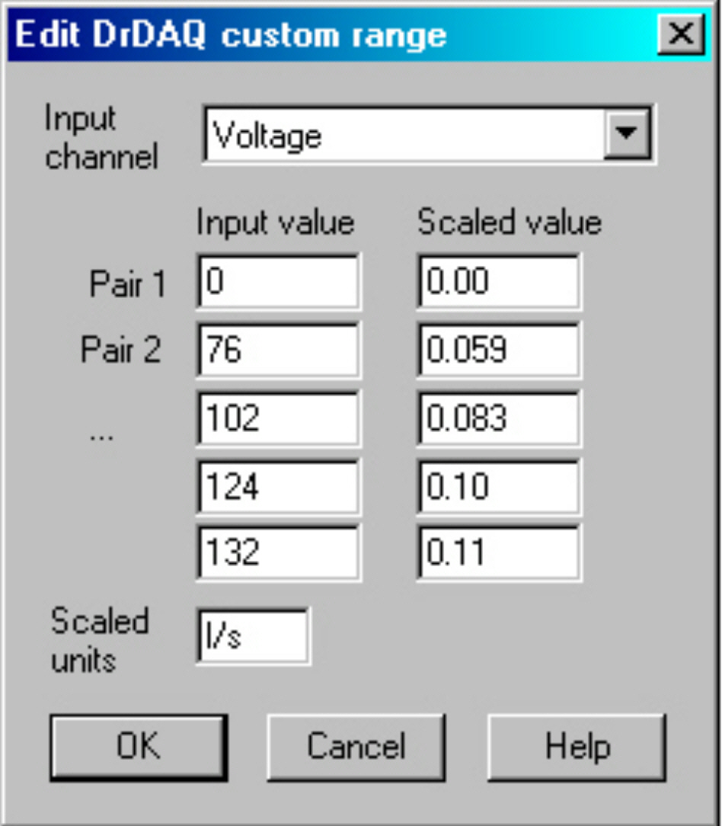  Add values and scaled units | - Type ‘l/s’ (for litres per second) into the Scaled units box.  - Click the OK button. You should now see a ‘0l/s’ range appear in the Custom range list.
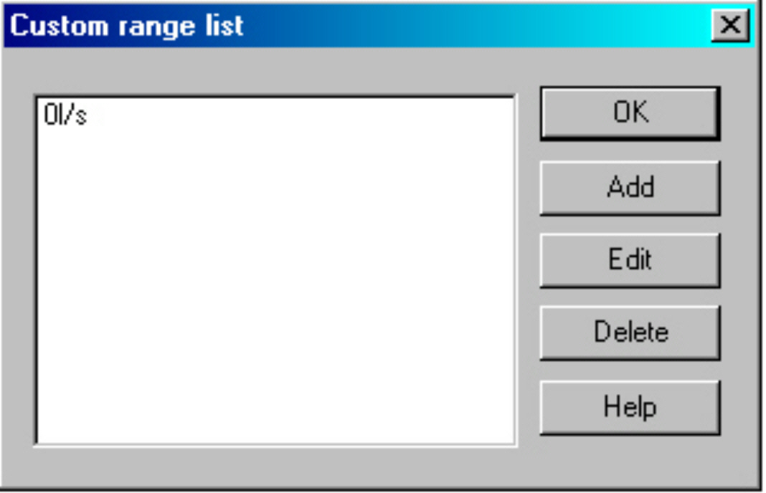  Custom range list with new range added | - Highlight this new range and click the OK button.
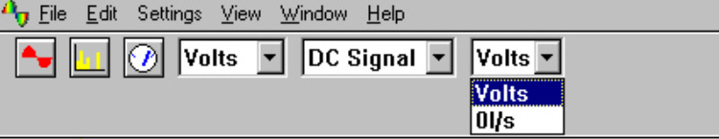  New range to select | - Click on the down-arrow next to the right-hand ‘volts’: you should see an extra box for this new range as shown.

Activity (ii): Mean e.m.f. method with PicoScope on DrDAQ
FL1.2F

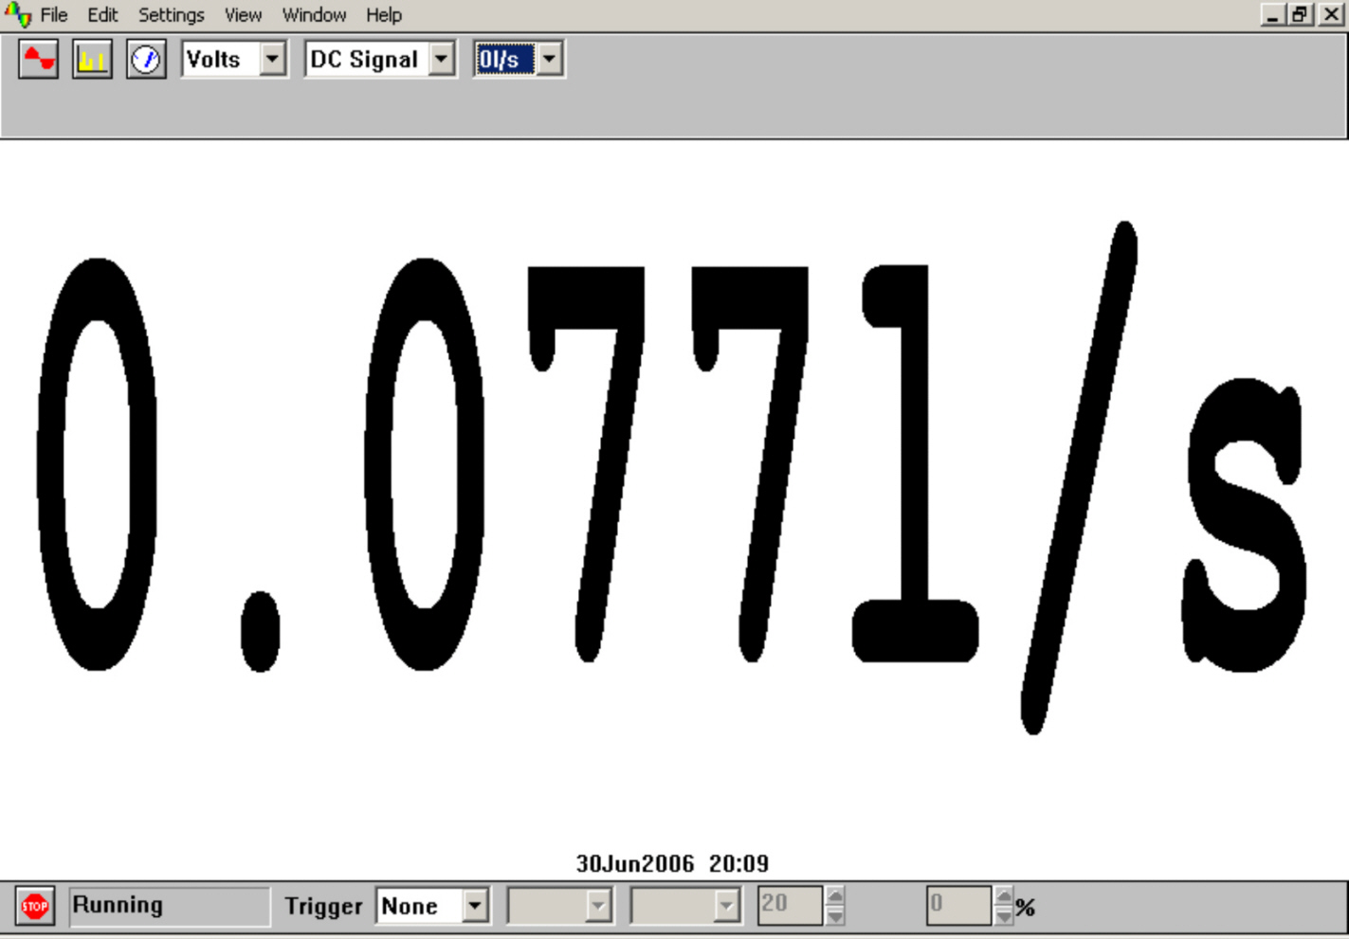  Flow rate display in l/s (litres/second) | - Select this new range and then click the GO button. With water flowing, you should now see a digital meter reading displayed directly as a flow rate.  - Measure the flow rate using a measuring beaker and stopwatch: compare this value to the displayed value.  - Click the STOP button.

- To return the program to its original state, click the down arrow alongside ‘0l/s’ and select Volts. Now click on Settings in the Menu bar and then on Custom ranges in the drop-down menu to display the Custom range list. Highlight the newly added range and click the Delete button to remove it, then click on the OK button.

- To finish with the program, click File on the Menu bar and Exit in its drop-down menu to leave the program.

Note: When you keyed your data into the ‘Input value’ and ‘Scaled value’ columns you were giving the computer information from which it could estimate other values that occur in between – it interpolates. It is doing the same job that you do with a graph and best-fit line. If the relationship between the data is a linear one then only two pairs of data items are needed.

Activity (ii): Mean e.m.f. method with PicoScope on DrDAQ
FL1.2G

Results

Mean e.m.f.  /mV | Time to collect 1 litre of water  /s |  |  |  | Average flow rate /l s⁻¹
Mean e.m.f.  /mV | 1st trial | 2nd trial | 3rd trial | Average | Average flow rate /l s⁻¹

Questions

Does your graph show the mean e.m.f. (voltage) to be
(a) linearly related to the flow rate and
(b) directly proportional to the flow rate? Explain.

How close were the prediction for the flow rate and the actual flow rate?

Why wouldn’t a prediction for a flow rate be likely to be reliable if the e.m.f. (voltage) measured was way beyond those used to produce the calibration ‘curve’?

How well does this value match with a measured value obtained by timing how long it takes to collect one litre of water at this same flow rate?

